|  |  |
| --- | --- |
| To: | Ronda Rippley |
| From: | Feng Yang, Lisa Lin |
| CC: | John Davis, Thomas Di Cioccio |
| Date: | Jan-10-2019 |
| Re: | R3918-HV-1659 |

Memo

Hi, Ronda:

Please find attached the summary of PK/PD analysis and supporting tables and figures based on the dataset from the R3918-HV-1659 following the study database lock on September 27, 2018. The goal of this memo is to provide the sources information for an integrated key result memo for Sr. Management review. It is a collective effort between Biostatistics and Data Management (BDM), Precision Medicine, and Pharmacometrics. It could also be used in the subsequent interaction with regulatory agencies.

Regards,

|  |  |  |  |
| --- | --- | --- | --- |
|  |  |  |  |
|  |  |  |  |
|  | |  |  |
| Feng Yang Fellow, Quantitative Pharmacology | |  | Date |

|  |  |  |
| --- | --- | --- |
|  |  |  |
| Lisa Lin R&D Specialist, Quantitative Pharmacology |  | Date |

|  |  |  |  |
| --- | --- | --- | --- |
|  |  |  |  |
| **APPROVED BY:** |  |  |  |
|  |  |  |  |
|  |  |  |  |
|  | |  |  |
| Ronda Rippley Sr. Director, Quantitative Pharmacology | |  | Date |

1. Summary
   1. Objectives

This memo provides the top-line summary of FIH study R3918-HV-1659. In particular,

1. Provide descriptive assessment of concentrations of total pozelimab, total C5 and CH50, as well as explore exposure-response relationships;
2. Develop a preliminary population pharmacokinetic (PopPK) model to estimate the population and individual predicted PK parameters of pozelimab. Identify and characterize the clinically relevant sources of variability in PK parameters;
3. Characterize the post-hoc estimates of exposure and the variance from the studied population, as well as the descriptive statistics of exposure for these subjects;
4. To support the rationale for the clinical dose regimen, simulate concentration-time profiles and calculate the corresponding exposure metrics for a regimen of 800 mg SC QW in a population with typical body weight and baseline C5, and in a population with extreme body weight and C5 level at baseline.
   1. Data

This PK/PD analysis was based on the data collected from study R3918-HV-1659 following the database lock on September 27, 2018, including total concentration of pozelimab, total C5 and CH50. A pooled NONMEM (version 7.4, ICON Development Solutions, Ellicott City, Maryland) dataset was constructed using R (Version 3.4.2, <http://www.r-project.org>). The final model and associated dataset were included in the Appendix B of this memo.

* 1. Methods

Descriptive representation and summary statistics were used to assess the characteristics of PK of pozelimab. Exposure-response relationships were also explored.

A population-based PK analysis was then performed. A two-compartment model with zero-order IV infusion, parallel linear and nonlinear (Michaelis-Menten) elimination was selected as the population PK structural model. Given that body weight is typically an influential covariate on monoclonal antibody (mAb) clearance parameters (CL and Q) and volume of distribution (Vss), body weight was incorporated into the base structural model.

The final base model was extended to evaluate the covariate effects. Baseline C5 and body weight were identified as the most important covariates. All pre-specified covariate-parameter relationships were simultaneously estimated and their impacts on key model parameters were assessed in this population analysis.

* 1. Results

The PK profiles of pozelimab exhibited a short distribution phase (within a week) and a log-linear elimination phase followed by a concentration-dependent elimination phase, consistent with target-mediated elimination. However, the degree of non-linearity was modest.

Pozelimab concentrations increased in a greater than dose-proportional manner, and the highest exposure was observed at a single dose of 30 mg/kg IV or following multiple doses of 400 mg QW SC. Following the SC administration, Cmax was observed a week post drug administration. Estimated CL slightly decreased with increasing dose, consistent with nonlinear PK presumably due to target-mediated drug elimination.

In general, changes in total C5 concentrations paralleled the kinetics of pozelimab concentrations, indicating target engagement. It is not clear whether target saturation was achieved as a sustained plateau was not observed at a single dose of 30 mg/kg IV or multiple doses of 400 mg QW SC.

CH50 data showed complete inhibition of C5 activity at pozelimab concentrations of 100 mg/L or higher. These data indicated a direct PK/PD relationship between pozelimab concentration and CH50 inhibition.

No subjects tested positive for ADA post treatment.

Two-compartment model with parallel linear and Michaelis-Menten elimination as well as zero-order IV infusion and first-order absorption for SC administration was selected as an appropriate and adequate structural model. As expected, baseline body weight and baseline C5 were identified to be statistically significant covariates on PK parameters. In particular, increasing body weight and increasing baseline C5 level result in reduced exposure of pozelimab and reduced steady-state Ctrough after multiple administrations, compared to typical values of baseline C5 and weight observed in FIH study. Based on simulation, at the proposed dose of 800 mg SC QW, all patients in a similar population are expected to have Ctrough above 100 mg/L, including those with upper extreme of baseline body weight and baseline C5 experienced in the FIH study. In conclusion, this population-based PK/PD analysis supports the proposed dose regimen of 30 mg/kg IV load followed by 800 mg SC QW for subsequent studies in patients with similar baseline C5 and body weight characteristics as the subjects in study R3918-HV-1659.

1. Introduction

Study pozelimab-HV-1659 was a phase I randomized, double-blind, placebo-controlled, single ascending dose and multiple dose study of the safety, tolerability, pharmacokinetics, and pharmacodynamics of intravenously and subcutaneously administered human monoclonal antibody pozelimab in healthy volunteers. Directed against the terminal complement protein C5, pozelimab is intended to inhibit terminal complement activation thereby blocking the formation of the Membrane Attack Complex (MAC–C5b-9), a structure mediating cell lysis. pozelimab is being developed for the treatment of paroxysmal nocturnal hemoglobinuria (PNH) and other diseases in which tissue damage is mediated by terminal complement pathway activity.

1. PK/PD Population and Samples

A total of 57 subjects were randomized with an overall total of 43 subjects randomized to pozelimab and 14 subjects randomized to placebo. One subject (R3918-HV-1659-826-001-127) was randomized to pozelimab within Cohort 2a but withdrew consent following randomization on day 1 and did not administer any study drug. A replacement subject was utilized to complete this cohort. The remaining 56 subjects that were randomized received all their intended study treatments and all completed the study through the Day 113 end-of-study visit.

A total of 56 subjects that received pozelimab treatment or placebo had at least one non-missing total pozelimab concentration available for this analysis (Table 1).

Table : Summary of Subjects and PK Samples by Study and Treatment Group (R3918-HV-1659)

| **Group** | **Number of Subjects(*)** | | **Number of**  **All Samples** | | **Number of Pre-dose Samples (%)** | **Number of Post-dose Quantifiable Samples (%)** | **Number of Post-dose BLQ Samples (%)** |
| --- | --- | --- | --- | --- | --- | --- | --- |
| Placebo | | 14(0) | | 280 | 14(5.00%) | 0(0%) | 266(100%) |
| 1 mg/kg IV | | 6(6) | | 120 | 6(5.00%) | 95(79.2%) | 19(16.7%) |
| 3 mg/kg IV | | 6(6) | | 120 | 6(5.00%) | 105(87.5%) | 9(7.89%) |
| 10 mg/kg IV | | 6(6) | | 119 | 6(5.04%) | 113(95.0%) | 0(0%) |
| 30 mg/kg IV | | 6(6) | | 120 | 6(5.00%) | 114(95.0%) | 0(0%) |
| 600 mg SC | | 6(6) | | 120 | 6(5.00%) | 107(89.2%) | 7(6.14%) |
| 300 mg SC | | 6(6) | | 120 | 6(5.00%) | 92(76.7%) | 22(19.3%) |
| 400 mg SC QW | | 6(6) | | 120 | 6(5.00%) | 114(95.0%) | 0(0%) |
| Total | | 56(42) | | 1119 | 56(5.00%) | 740(66.1%) | 323(30.4%) |

*: Number of subjects with at least one quantifiable sample.

QW = Once a week; IV = Intravenous; SC = Subcutaneous. A loading dose of 15 mg/kg was used in the dose group of 400 mg SC QW.

Table 2: Summary of Subjects and Total C5 Samples by Study and Treatment Group (R3918-HV-1659)

| **Group** | **Number of Subjects(*)** | **Number of**  **All Samples** | **Number of Post-dose Samples (%)** | **Number of Post-dose Quantifiable Samples (%)** | **Number of Post-dose BLQ Samples (%)** |
| --- | --- | --- | --- | --- | --- |
| Placebo | 14(14) | 306 | 42(13.7%) | 306(100%) | 0(0%) |
| 1 mg/kg IV | 6(6) | 132 | 18(13.6%) | 132(100%) | 0(0%) |
| 3 mg/kg IV | 6(6) | 132 | 18(13.6%) | 132(100%) | 0(0%) |
| 10 mg/kg IV | 6(6) | 131 | 18(13.7%) | 131(100%) | 0(0%) |
| 30 mg/kg IV | 6(6) | 131 | 18(13.7%) | 131(100%) | 0(0%) |
| 600 mg SC | 7(7) | 133 | 19(14.3%) | 133(100%) | 0(0%) |
| 300 mg SC | 6(6) | 131 | 17(13.0%) | 131(100%) | 0(0%) |
| 400 mg SC QW | 6(6) | 132 | 18(13.6%) | 132(100%) | 0(0%) |
| Total | 57(57) | 1228 | 168(13.7%) | 1228(100%) | 0(0%) |

*: Number of subjects with at least one quantifiable sample.

QW = Once a week; IV = Intravenous; SC = Subcutaneous. A loading dose of 15 mg/kg was used in the dose group of 400 mg SC QW.

Table 3: Summary of Subjects and CH50 Samples by Study and Treatment Group (R3918-HV-1659)

| **Group** | **Number of Subjects(*)** | | **Number of**  **All Samples** | **Number of Post-dose Samples (%)** | **Number of Post-dose Quantifiable Samples (%)** | **Number of Post-dose BLQ Samples (%)** |
| --- | --- | --- | --- | --- | --- | --- |
| Placebo | | 14(14) | 307 | 42(13.7%) | 305(99.3%) | 2(0.755%) |
| 1 mg/kg IV | | 6(6) | 132 | 18(13.6%) | 132(100%) | 0(0%) |
| 3 mg/kg IV | | 6(6) | 132 | 18(13.6%) | 117(88.6%) | 15(13.2%) |
| 10 mg/kg IV | | 6(6) | 131 | 18(13.7%) | 73(55.7%) | 58(51.3%) |
| 30 mg/kg IV | | 6(6) | 132 | 18(13.6%) | 56(42.4%) | 76(66.7%) |
| 600 mg SC | | 7(7) | 129 | 19(14.7%) | 128(99.2%) | 0(0%) |
| 300 mg SC | | 6(6) | 132 | 18(13.6%) | 132(100%) | 0(0%) |
| 400 mg SC QW | | 6(6) | 133 | 19(14.3%) | 49(36.8%) | 84(73.7%) |
| Total | | 57(57) | 1228 | 170(13.8%) | 992(80.8%) | 235(22.2%) |

*: Number of subjects with at least one quantifiable sample.

QW = Once a week; IV = Intravenous; SC = Subcutaneous. A loading dose of 15 mg/kg was used in the dose group of 400 mg SC QW.

Table 4: Summary of Anti-Pozelimab Antibody Serum Samples by Treatment Group, Titer Category, and Overall (Study R3918-HV-1659)

| **Titer Category** | **Placebo** | | **1 mg/kg IV** | | **3 mg/kg IV** | | **10 mg/kg IV** | | **30 mg/k IV** | | **300 mg SC** | | **600 mg SC** | | **400 mg SC QW** | | **Overall** |
| --- | --- | --- | --- | --- | --- | --- | --- | --- | --- | --- | --- | --- | --- | --- | --- | --- | --- |
| **n** | **%** | **n** | **%** | **n** | **%** | **n** | **%** | **n** | **%** | **n** | **%** | **n** | **%** | **n** | **%** |  |
| **Negative** | 28 |  | 12 |  | 12 |  | 12 |  | 12 |  | 12 |  | 12 |  | 11 |  | 111 |
| **Low** |  |  |  |  |  |  |  |  |  |  |  |  |  |  | 1 |  | 1 |
| **Moderate** |  |  |  |  |  |  |  |  |  |  |  |  |  |  |  |  |  |
| **High** |  |  |  |  |  |  |  |  |  |  |  |  |  |  |  |  |  |
| **Overall** | 28 |  | 12 |  | 12 |  | 12 |  | 12 |  | 12 |  | 12 |  | 12 |  | 112 |

SC = Subcutaneous; IV = Intravenous; n = Number of samples  
Note: If the initial screening results from ADA samples were negative, or the confirmatory results were not drug specific, titers are reported as negative. If Titer <1,000 then Titer is defined as 'Low', if 1,000≤ Titer ≤10,000 then Titer is defined as 'Moderate', if Titer >10,000 then Titer is defined as 'High’.

Table : Summary of Baseline Demographic Characteristics, Laboratory and Disease Status Variables (R3918-HV-1659)

| **Covariate** | **Statistics** | **R3918-HV-1659** |
| --- | --- | --- |
| Age (year) | N | 57 |
| Mean | 35.0 |
| SD | 9.68 |
| SE | 1.28 |
| Median(range) | 34.0(19.0-50.0) |
| Weight  (kg) | N | 57 |
| Mean | 71.4 |
| SD | 12.0 |
| SE | 1.59 |
| Median(range) | 70.1(53.4-108) |
| Height (cm) | N | 57 |
| Mean | 170 |
| SD | 8.81 |
| SE | 1.17 |
| Median(range) | 170(154-195) |
| BMI (kg/m2) | N | 57 |
| Mean | 24.6 |
| SD | 2.67 |
| SE | 0.353 |
| Median(range) | 24.2(19.0-29.7) |
| Baseline C5 (mg/L) | N | 57 |
| Mean | 81.8 |
| SD | 15.5 |
| SE | 2.06 |
| Median(range) | 81.2(27.3-137) |
| Baseline CH50 (U/mL) | N | 57 |
| Mean | 232 |
| SD | 57.7 |
| SE | 7.64 |
| Median(range) | 221(132-394) |
| Ethnicity | Hispanic/Latino | 1(1.75%) |
| Not Hispanic/Latino | 56(98.2%) |
| Race | Alaska native/Indian | 1(1.75%) |
| Asian | 4(7.02%) |
| Black | 6(10.5%) |
| Other | 1(1.75%) |
| White | 45(78.9%) |
| Sex | Female | 31(54.4%) |
| Male | 26(45.6%) |

One subject R3918-HV-1659-826-001-127 was randomized to pozelimab within Cohort 2a but withdrew consent following randomization on day 1 and did not administer any study drug. This subject was not included in this table.

1. Results
   1. Descriptive Assessment of Concentrations of Total Pozelimab, Total C5 and CH50
      1. Concentrations of Total Pozelimab

Total pozelimab concentrations in serum versus nominal/actual sampling week are presented by treatment group and by subject in Figure 1 through Figure 4.

The PK profiles of pozelimab exhibited a short distribution phase (within a week) and a linear elimination phase followed by a concentration-dependent elimination phase, consistent with target-mediated elimination. However, the non-linearity was modest. Pozelimab concentrations increased in a greater than dose-proportional manner, and the highest exposure was observed at a single dose of 30 mg/kg IV or multiple doses of 400 mg QW SC. Following the SC administration, Cmax was observed a week post drug administration.

Following 4 consecutive 400 mg weekly SC doses after a loading dose of 15 mg/kg IV, steady-state concentrations were 200-300 mg/L. The concentrations were above 100 mg/L for 6 weeks in all 6 subjects of this dose group. After a single IV dose of 30 mg/kg, the duration of pozelimab concentrations maintained 100 mg/L above was about 4 weeks, and the concentrations were still detectable after 16 weeks.

Figure : Mean (±SE) Concentration of Total Pozelimab in Serum vs Nominal Sampling Week Following Subcutaneous or Intravenous Dose(s) of Pozelimab (Study R3918-HV-1659)

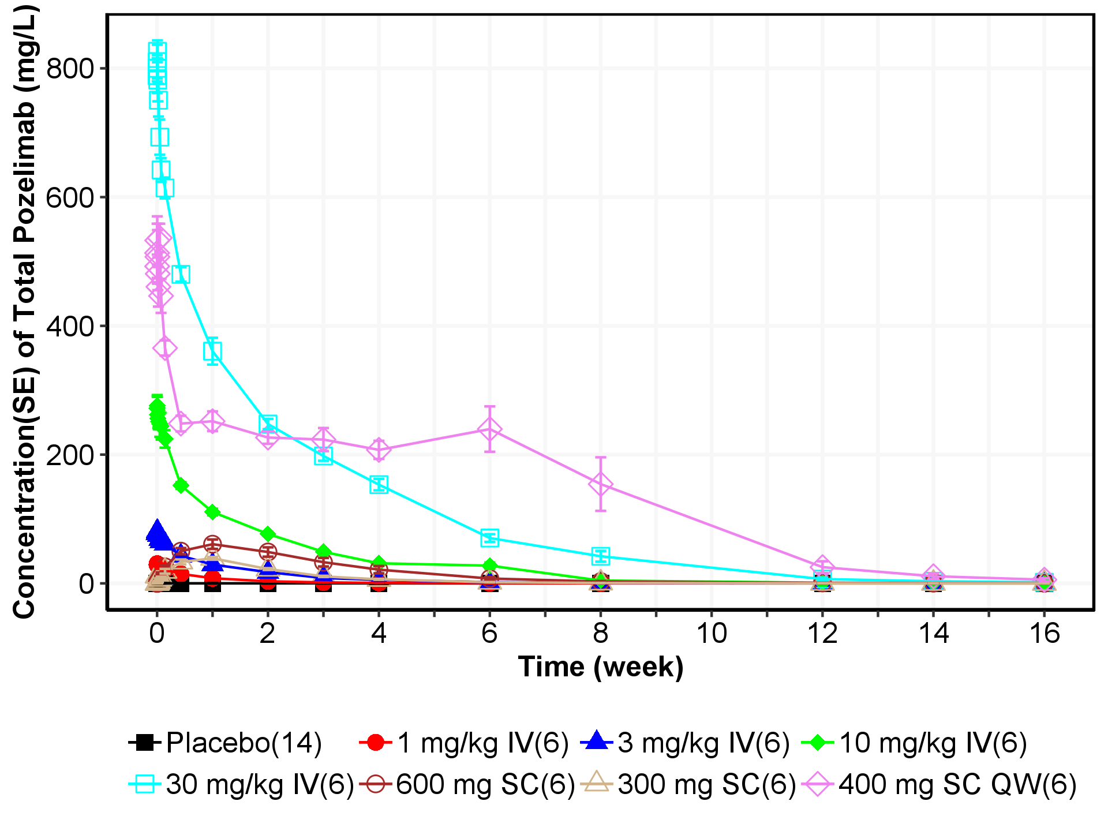

QW = Once a week; IV = Intravenous; SC = Subcutaneous

Note: Concentrations below the lower limit of quantification (LLOQ = 0.078 mg/L) are set to zero. A loading dose of 15 mg/kg was used in the dose group of 400 mg SC QW.

Figure : Mean (±SE) Log-scaled Concentration of Total Pozelimab in Serum vs Nominal Sampling Week Following Subcutaneous or Intravenous Dose(s) of Pozelimab (Study R3918-HV-1659)

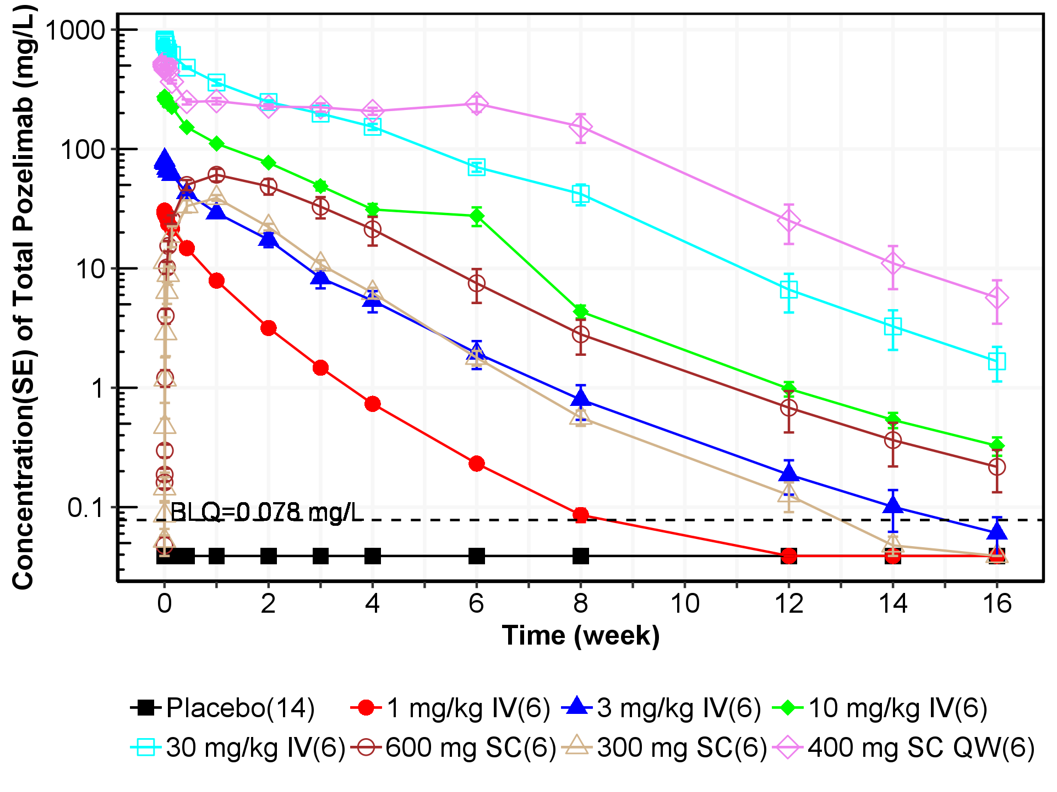

QW = Once a week; IV = Intravenous; SC = Subcutaneous   
Note: Concentrations below the lower limit of quantification (LLOQ, horizontal dotted line = 0.078 mg/L) are imputed as LLOQ/2 = 0.039 mg/L. A loading dose of 15 mg/kg was used in the dose group of 400 mg SC QW.

Figure : Individual Log-scaled Concentration of Total Pozelimab in Serum vs Actual Sampling Week Following Subcutaneous or Intravenous Dose(s) of Pozelimab (Study R3918-HV-1659)

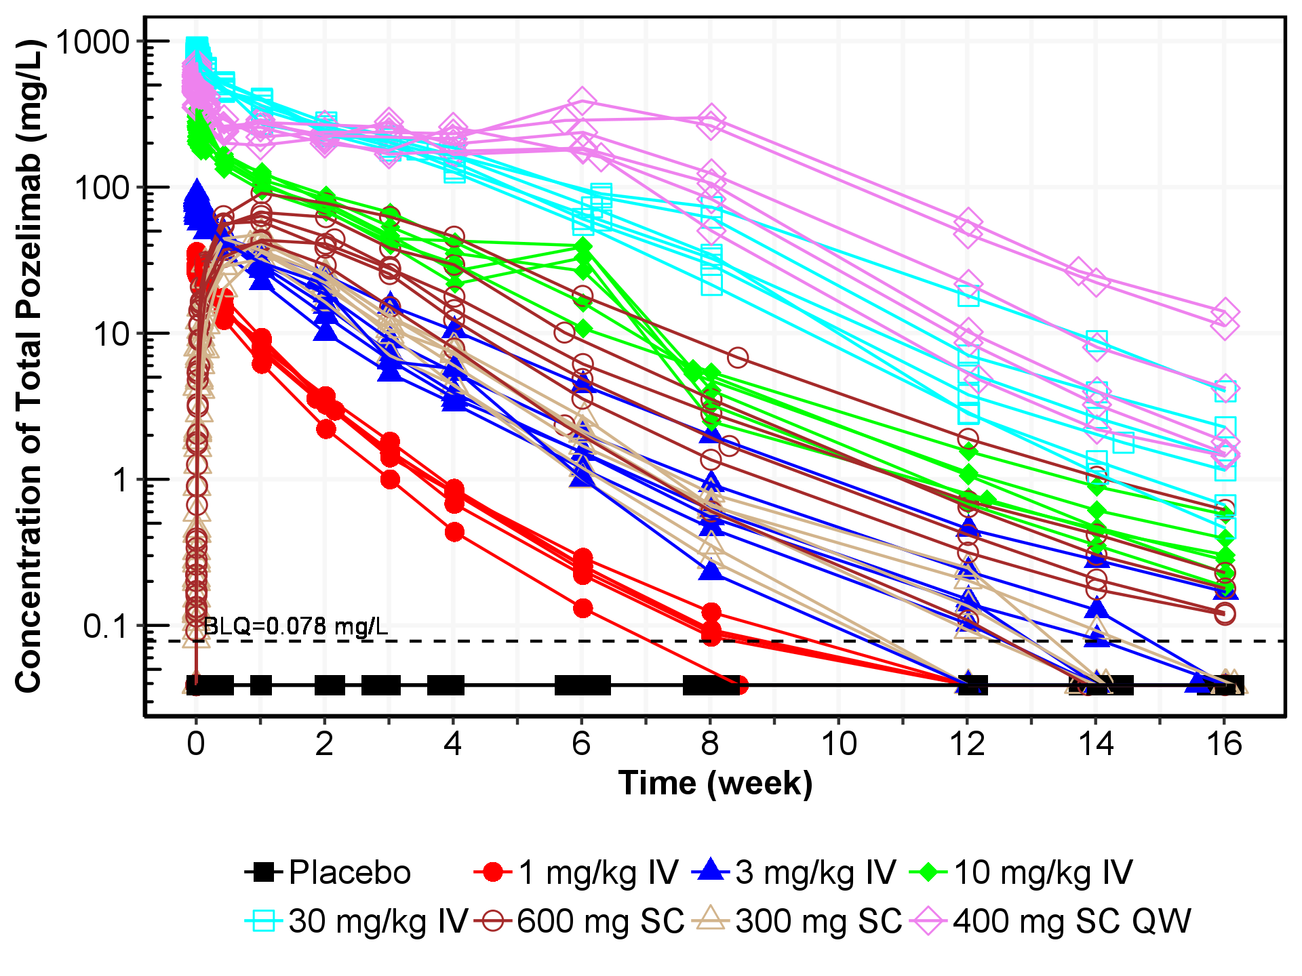

QW = Once a week; IV = Intravenous; SC = Subcutaneous   
Note: Concentrations below the lower limit of quantification (LLOQ, horizontal dotted line = 0.078 mg/L) are imputed as LLOQ/2 = 0.039 mg/L. A loading dose of 15 mg/kg was used in the dose group of 400 mg SC QW.

Figure : Individual Log-scaled Concentration of Total Pozelimab in Serum vs Actual Sampling Week Following Subcutaneous or Intravenous Dose(s) of Pozelimab by Dose Group (Study R3918-HV-1659)

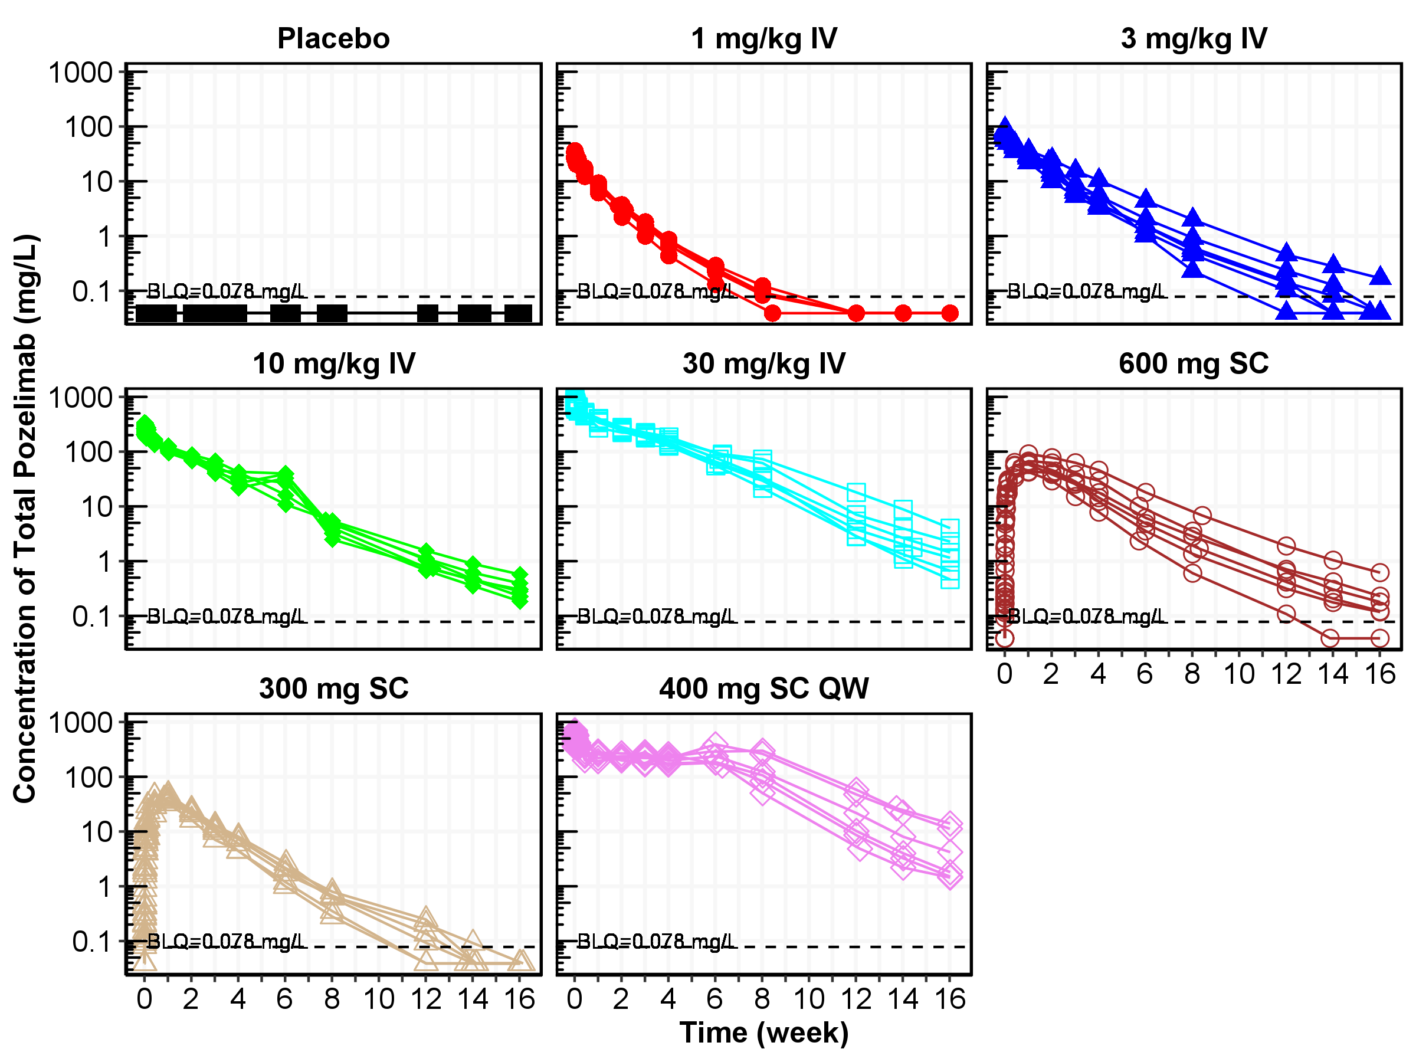

QW = Once a week; IV = Intravenous; SC = Subcutaneous   
Note: Concentrations below the lower limit of quantification (LLOQ, horizontal dotted line = 0.078 mg/L) are imputed as LLOQ/2 = 0.039 mg/L. A loading dose of 15 mg/kg was used in the dose group of 400 mg SC QW.

* + 1. Concentrations of Total C5

Mean and individual total C5 concentrations in serum versus nominal/actual sampling week are presented by treatment group in Figure 5 and Figure 6, respectively.

At baseline, the total C5 concentrations were comparable across treatment groups. Immediately following SC or IV administrations of pozelimab, dose-dependent increases in total C5 concentrations were observed, indicating target engagement. After a single 30 mg/kg IV dose, the maximum concentration was reached around 28 days following pozelimab administration. Subsequently, concentrations of total C5 declined, coinciding with the declining pozelimab concentrations.

With 4 weekly 400 mg SC doses after a loading dose of 15 mg/kg IV, total C5 concentrations increased until the end of the last SC dose at Day 28. A plateau phase for total C5 concentrations was not observed, suggesting an absence of target saturation with a sustained duration at this highest dose evaluated. This is consistent with the nonlinear, target-mediated pozelimab disposition observed for the dose range evaluated in this study.

Figure : Mean (±SE) Concentration of Total C5 in Serum vs Nominal Sampling Week Following Subcutaneous or Intravenous Dose(s) of Pozelimab (Study R3918-HV-1659)

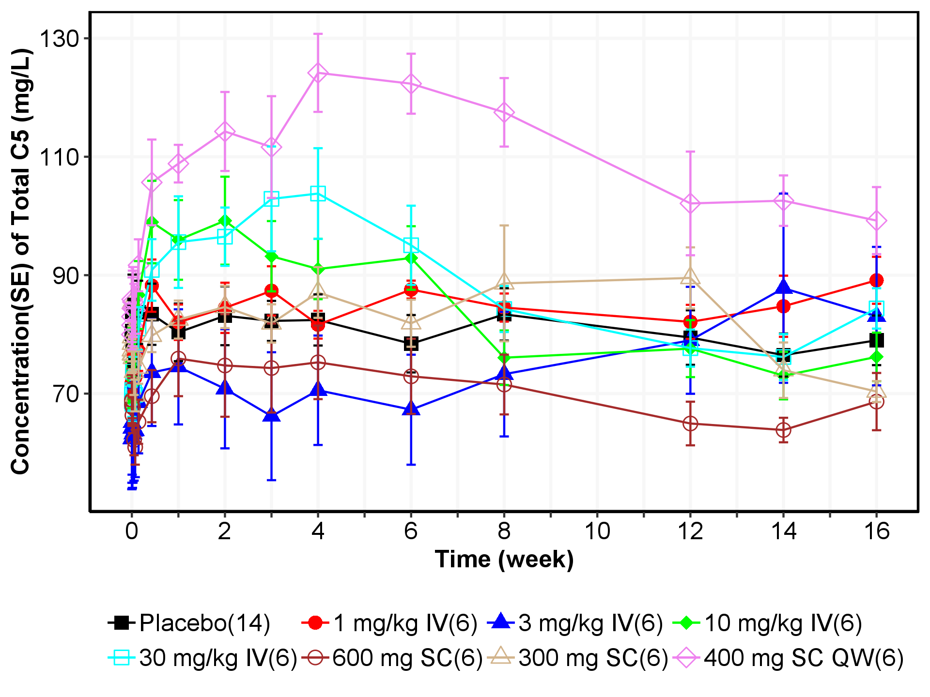

QW = Once a week; IV = Intravenous; SC = Subcutaneous   
Note: A loading dose of 15 mg/kg was used in the dose group of 400 mg SC QW.

Figure : Individual Concentration of Total C5 in Serum vs Actual Sampling Week Following Subcutaneous or Intravenous Dose(s) of Pozelimab (Study R3918-HV-1659)

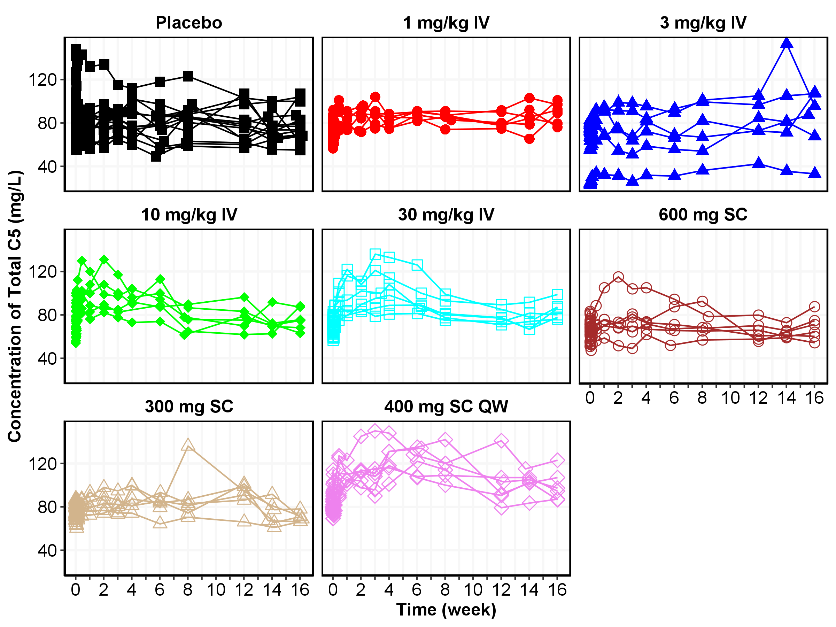

QW = Once a week; IV = Intravenous; SC = Subcutaneous   
Note: A loading dose of 15 mg/kg was used in the dose group of 400 mg SC QW.

* + 1. Time Profiles of CH50

Mean and individual CH50 assay versus nominal/actual sampling week by treatment group are presented in Figure 7 and Figure 8, respectively. Mean and individual percent change from baseline in CH50 versus nominal/actual sampling day are presented in Figure 9 and Figure 10, respectively.

Baseline CH50 was comparable across treatment groups with a median of 221 U/mL. pozelimab exposure led to dose-dependent inhibition and duration of inhibition of hemolytic activity as measured by CH50 sheep Red Blood Cell (sRBC) assay. Reduction occurred immediately after drug administration, with maximal reduction achieved concomitantly with peak pozelimab concentrations. Complete suppression of hemolysis was achieved transiently with ≥ 3 mg/kg IV dosing. At 30 mg/kg IV, complete suppression of hemolysis was maintained over 4 weeks, consistent with observed prolonged pozelimab concentrations following this dose. In the multiple dose cohort 5, complete suppression of CH50 was observed over a 6-week period. When pozelimab concentrations began to decline, CH50 started to return to baseline.

Figure : Mean (±SE) CH50* vs Nominal Sampling Week Following Subcutaneous or Intravenous Dose(s) of Pozelimab (Study R3918-HV-1659)

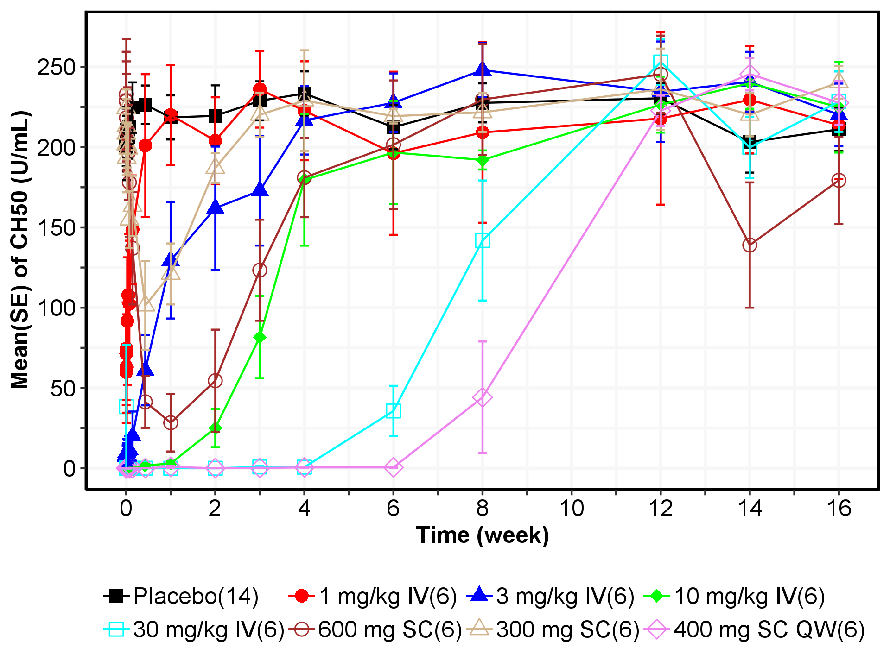

QW = Once a week; IV = Intravenous; SC = Subcutaneous

*CH50: assay of hemolytic activity. A loading dose of 15 mg/kg was used in the dose group of 400 mg SC QW.

Figure : Individual CH50* vs Actual Sampling Week Following Subcutaneous or Intravenous Dose(s) of Pozelimab (Study R3918-HV-1659)

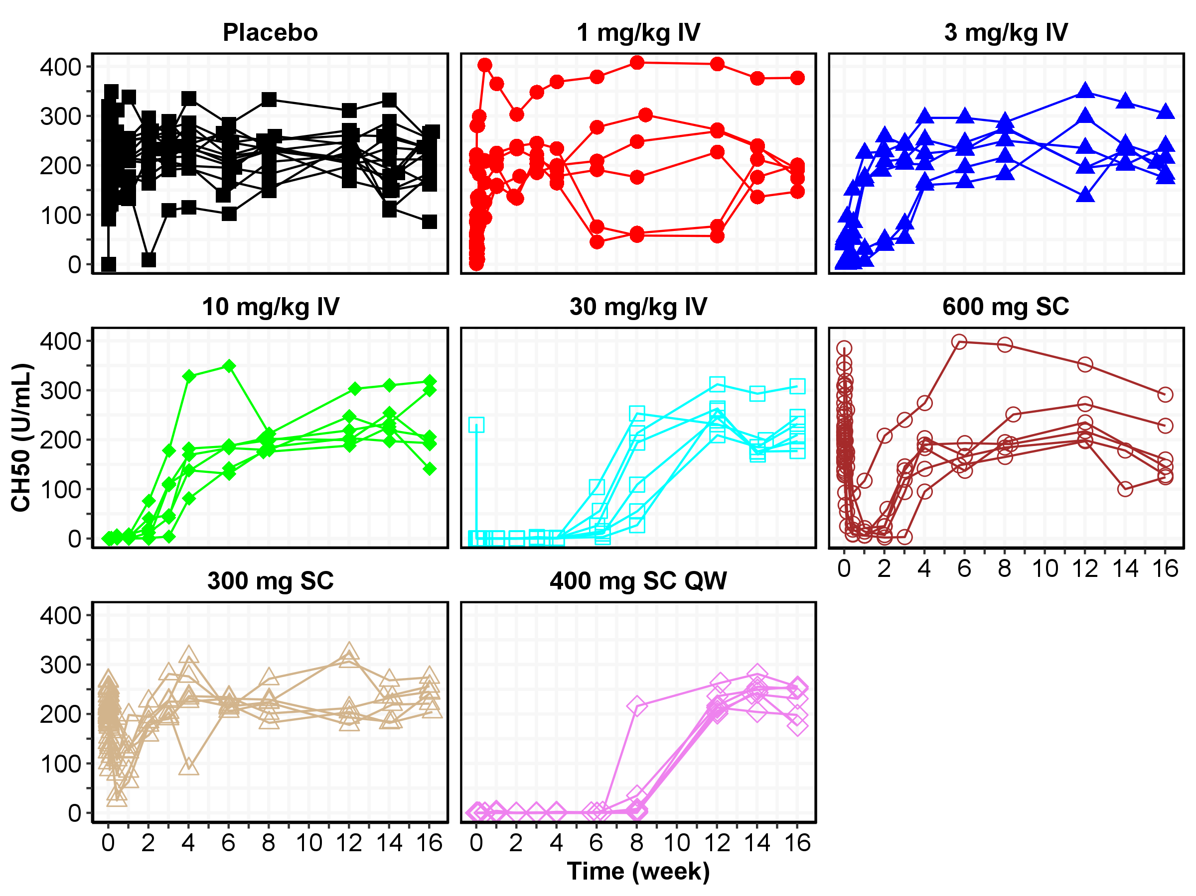

QW = Once a week; IV = Intravenous; SC = Subcutaneous

*CH50: assay of hemolytic activity. A loading dose of 15 mg/kg was used in the dose group of 400 mg SC QW.

Figure : Mean (±SE) Percent Change from Baseline in CH50* vs Nominal Sampling Week Following Subcutaneous or Intravenous Dose(s) of Pozelimab (Study R3918-HV-1659)

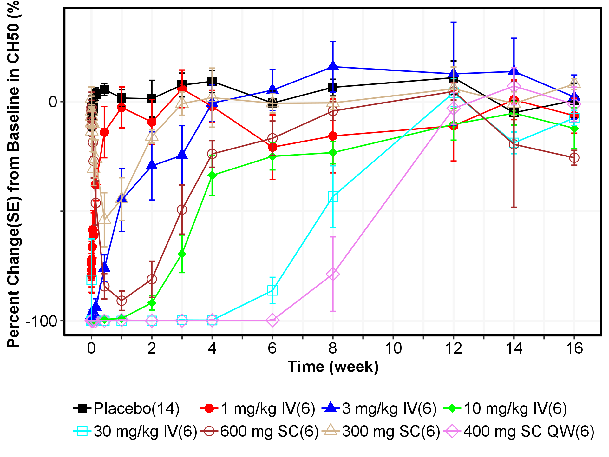

QW = Once a week; IV = Intravenous; SC = Subcutaneous

*CH50: assay of hemolytic activity. A loading dose of 15 mg/kg was used in the dose group of 400 mg SC QW.

Figure : Individual Percent Change from Baseline in CH50* vs Actual Sampling Week Following Subcutaneous or Intravenous Dose(s) of Pozelimab (Study R3918-HV-1659)

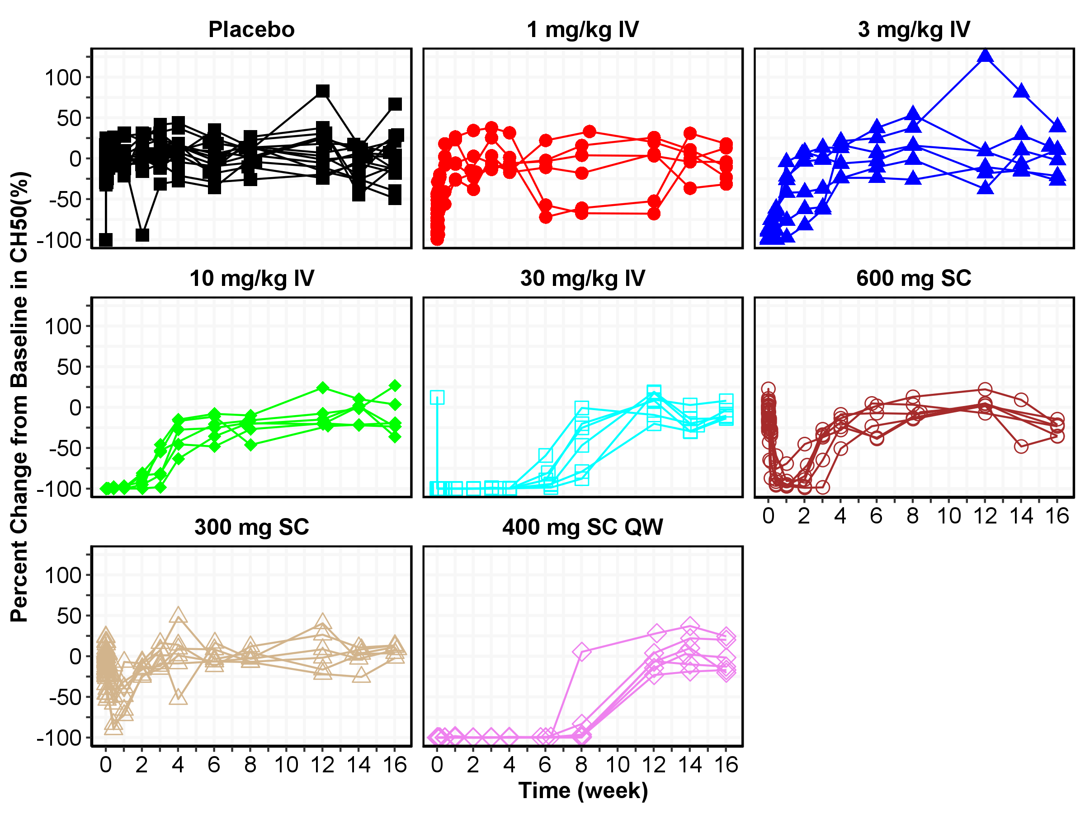

QW = Once a week; IV = Intravenous; SC = Subcutaneous

*CH50: assay of hemolytic activity. A loading dose of 15 mg/kg was used in the dose group of 400 mg SC QW.

* + 1. Pharmacokinetic/Pharmacodynamic Relationships

Mean percent (%) change from baseline in CH50 versus concentration of total pozelimab in serum disregarding dose or time point, are presented treatment group in Figure 11. Hysteresis plot of mean percent change from baseline in CH50 vs mean concentration by treatment group is presented in Figure 12. Individual hysteresis plot of percent change from baseline in CH50 vs concentration of total pozelimab are presented in Figure 13 to Figure 14.

CH50 reduction occurred immediately following drug administration. In general, the reduction was dose-dependent with regards to magnitude and duration of reduction. Maximal CH50 reduction was generally achieved immediately after the highest drug concentration was reached, and CH50 started to return to baseline when the drug concentration began to decline. The greatest CH50 reduction of ~100% was achieved at drug concentrations of >100 mg/L and IC50 was determined to be around 20-30 mg/L. Figure 12 illustrates there is no hysteresis in the CH50 response, indicating a direct relationship between pozelimab concentration and inhibition of hemolytic activity, consistent with expectations for a target in systemic circulation.

Figure : Percent Change from Baseline in CH50* vs Concentration of Total Pozelimab Regardless of Time Points and Dose Groups in Semi-Log Scale (Study R3918-HV-1659)

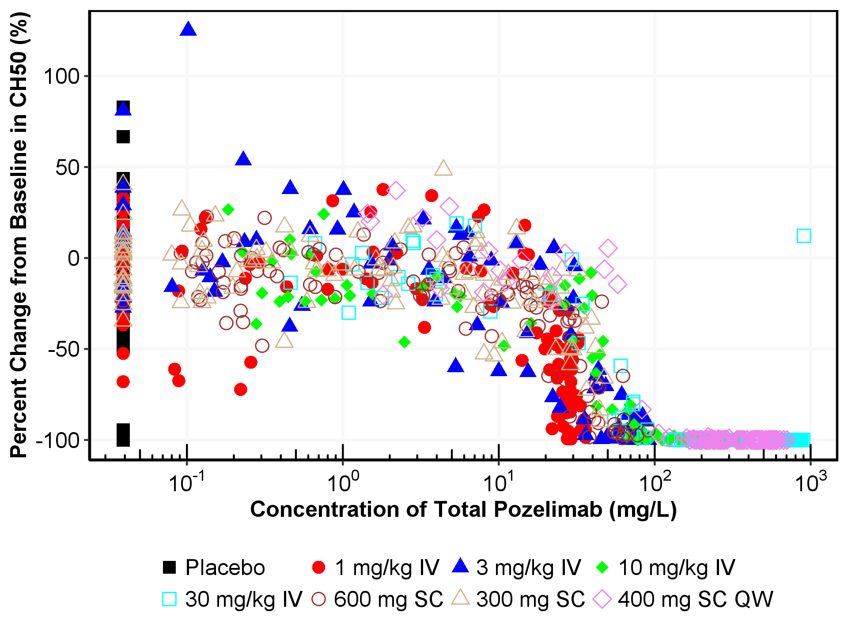

*CH50: assay of hemolytic activity

QW = Once a week; IV = Intravenous; SC = Subcutaneous. A loading dose of 15 mg/kg was used in the dose group of 400 mg SC QW.

Figure : Hysteresis Plot of Mean Percent Change from Baseline in CH50 vs Mean Concentration of Total Pozelimab by Treatment Group

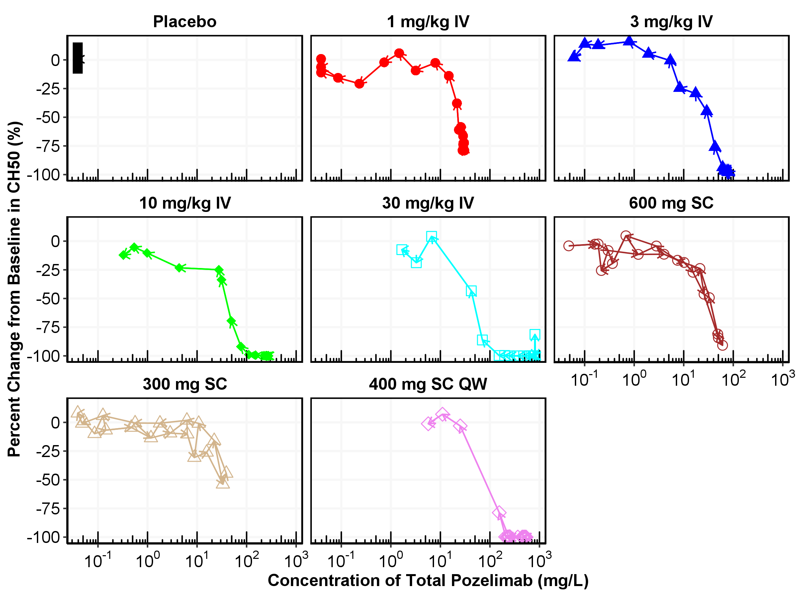

Figure : Individual Hysteresis Plot of Percent Change from Baseline in CH50 vs Concentration of Total Pozelimab by Treatment Group

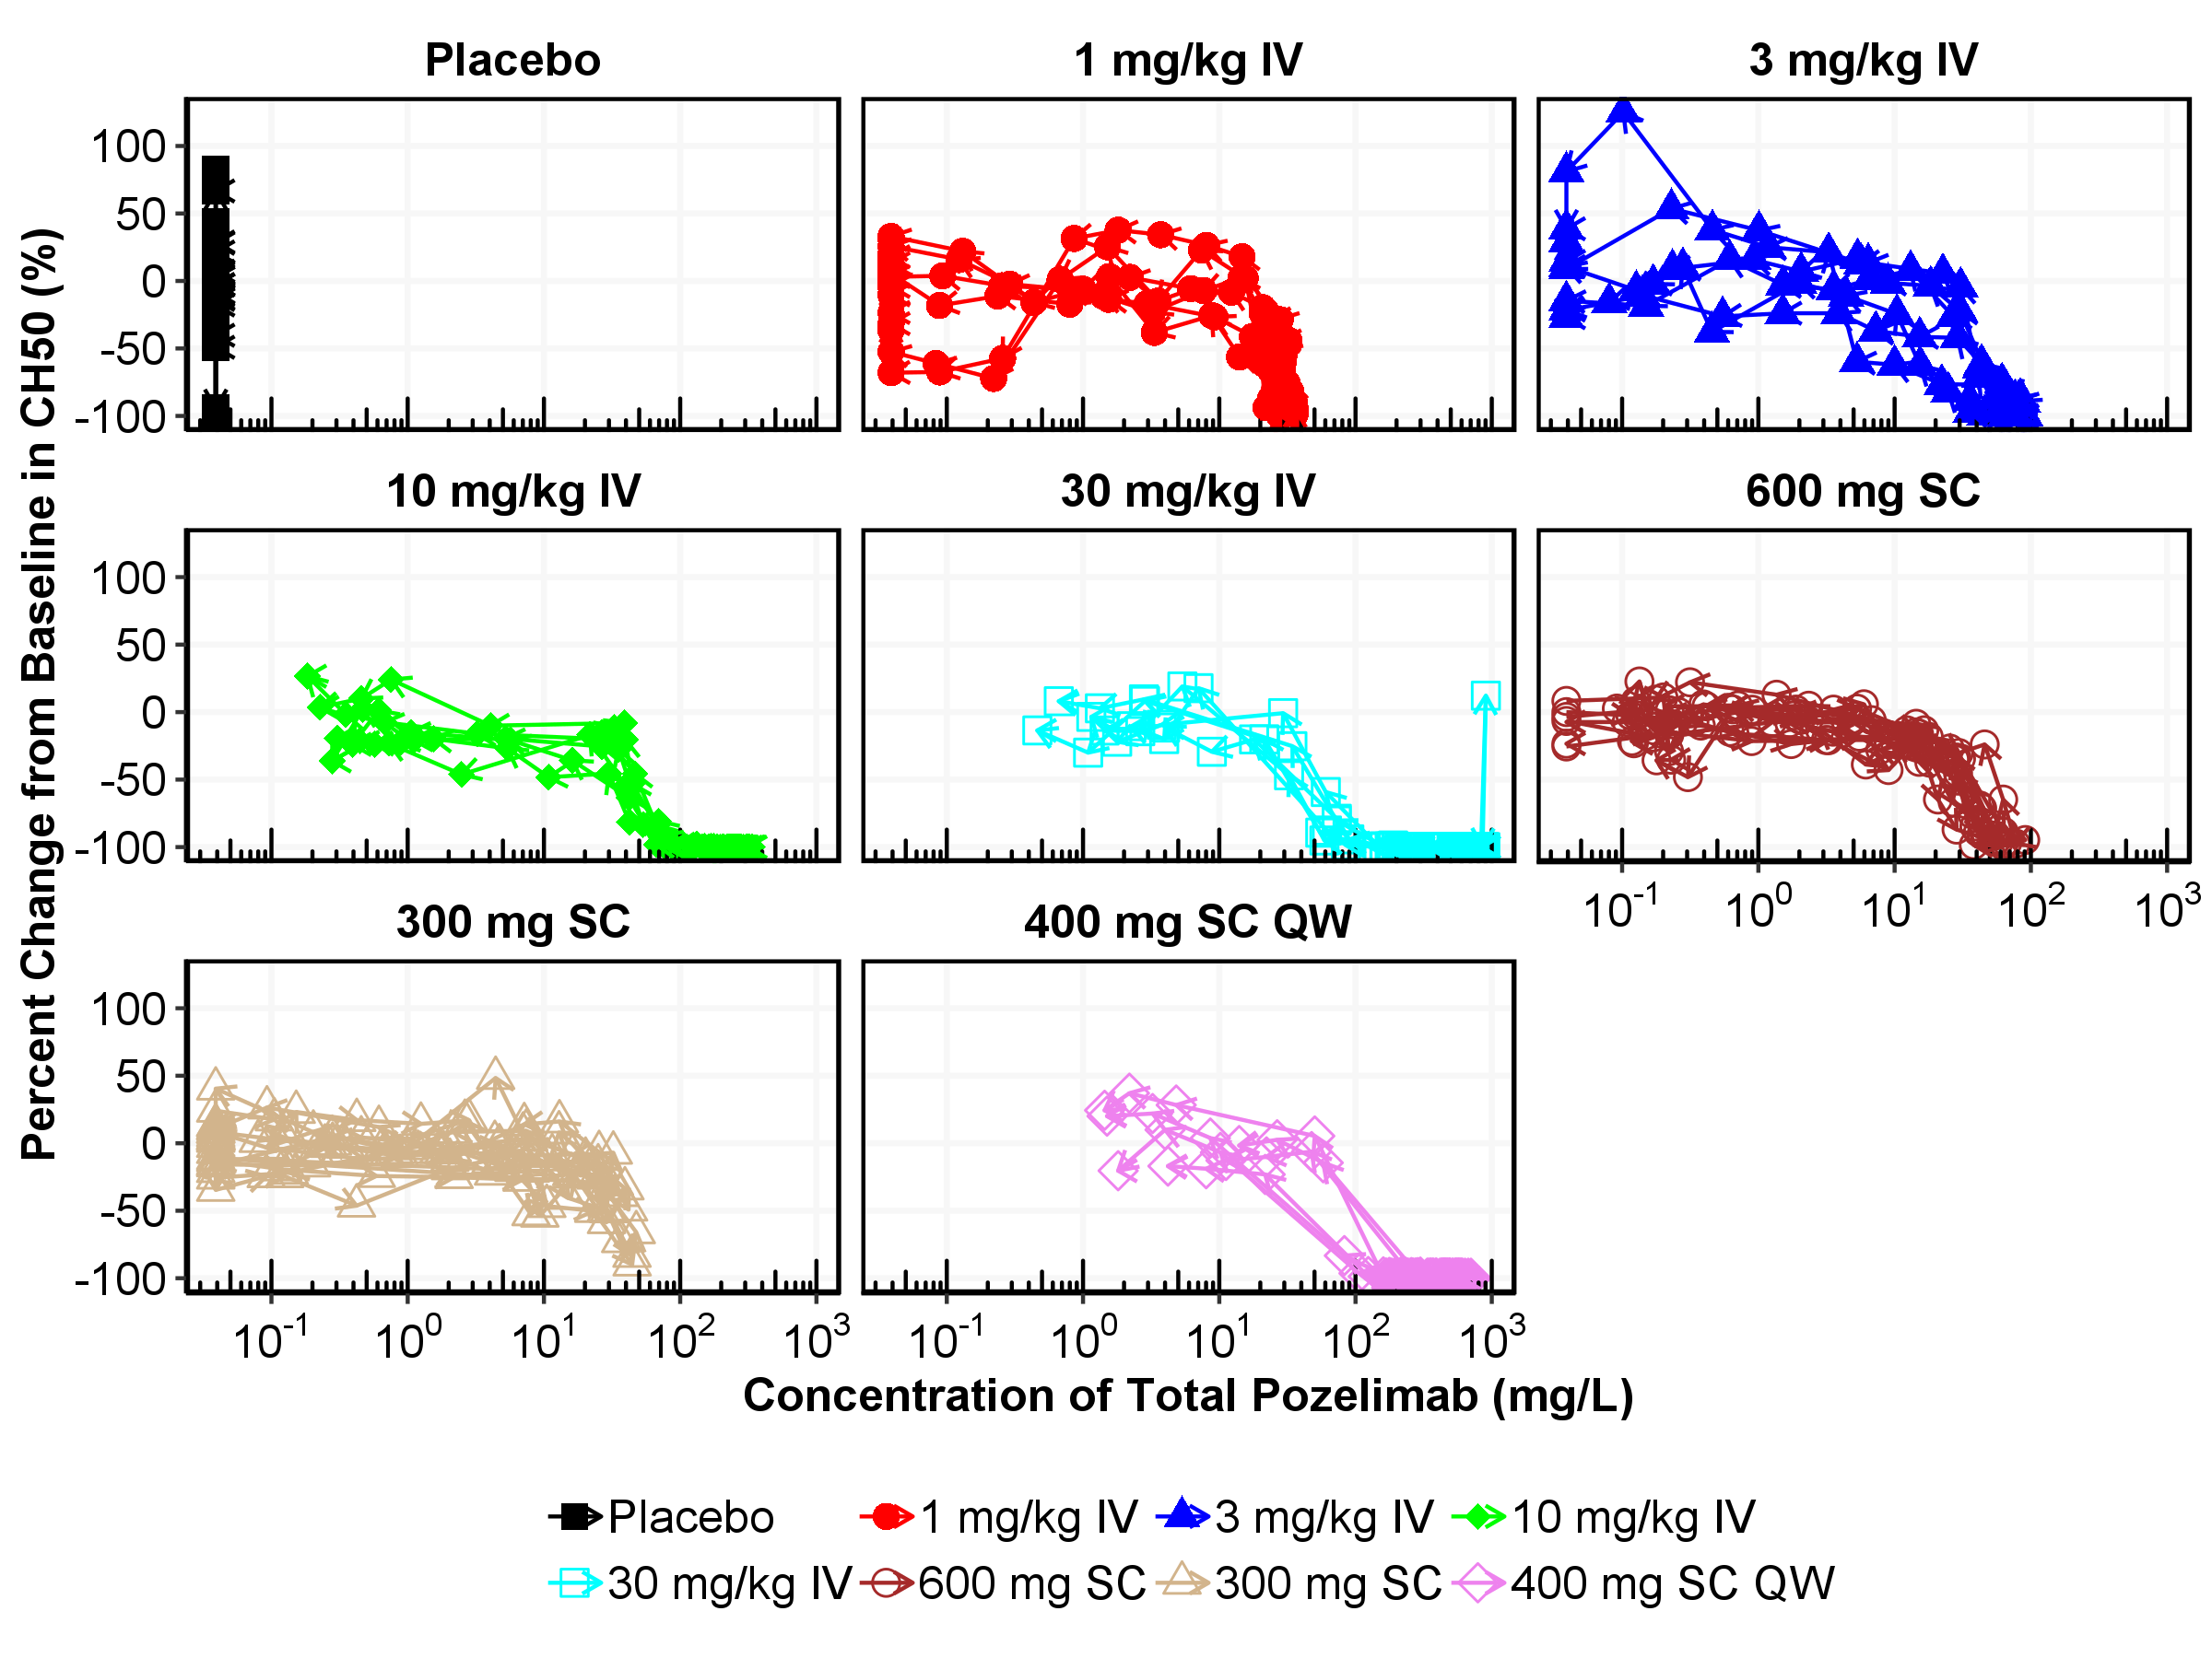

Figure : Individual Hysteresis Plot of Percent Change from Baseline in CH50 vs Concentration of Total Pozelimab by Each Subject

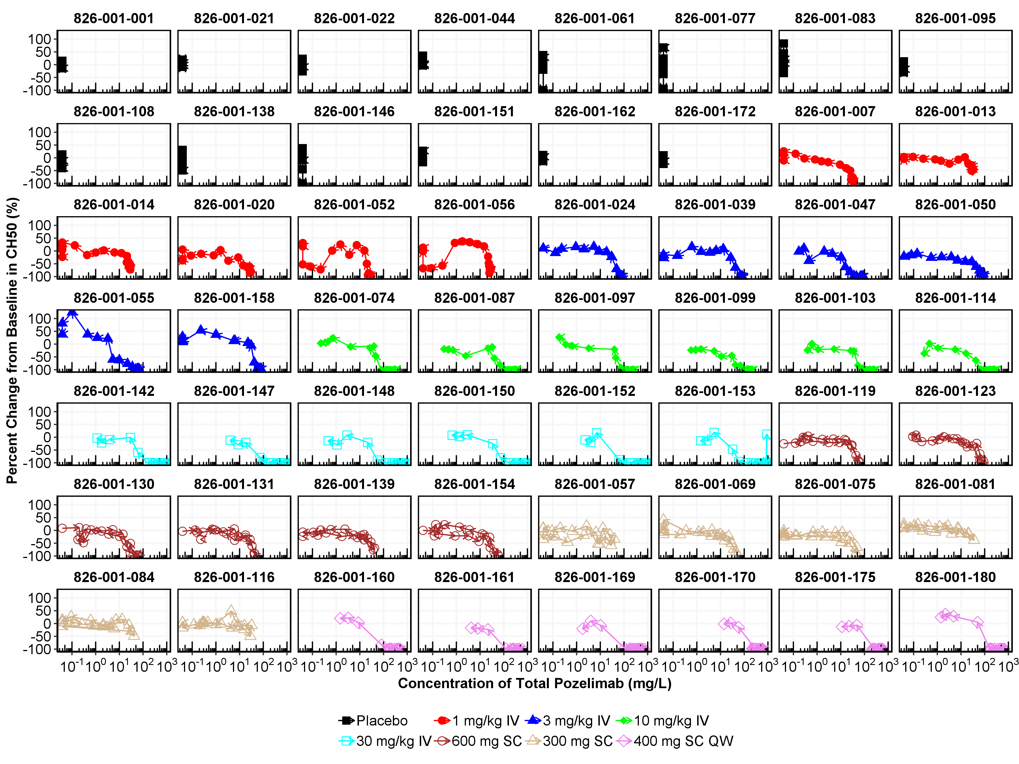

* + 1. Pharmacokinetic/Target Relationships

Total C5 vs concentration of total pozelimab in serum disregarding dose or time point, are presented in Figure 15, and by treatment group (Figure 16). Hysteresis plot of total C5 vs concentration of total pozelimab by treatment group and by individual subject are presented in Figure 17 to Figure 21.

Figure 17 shows that concentration of total C5 keeps increasing under the multiple administration of pozelimab. A plateau phase for total C5 concentrations was not observed, suggesting an absence of target saturation with a sustained duration at this highest dose evaluated. This is consistent with the nonlinear, target-mediated pozelimab disposition observed for the dose range evaluated in this study.

Figure : Concentration of Total C5 vs Concentration of Total Pozelimab Regardless of Time Points and Dose Groups (Study R3918-HV-1659)

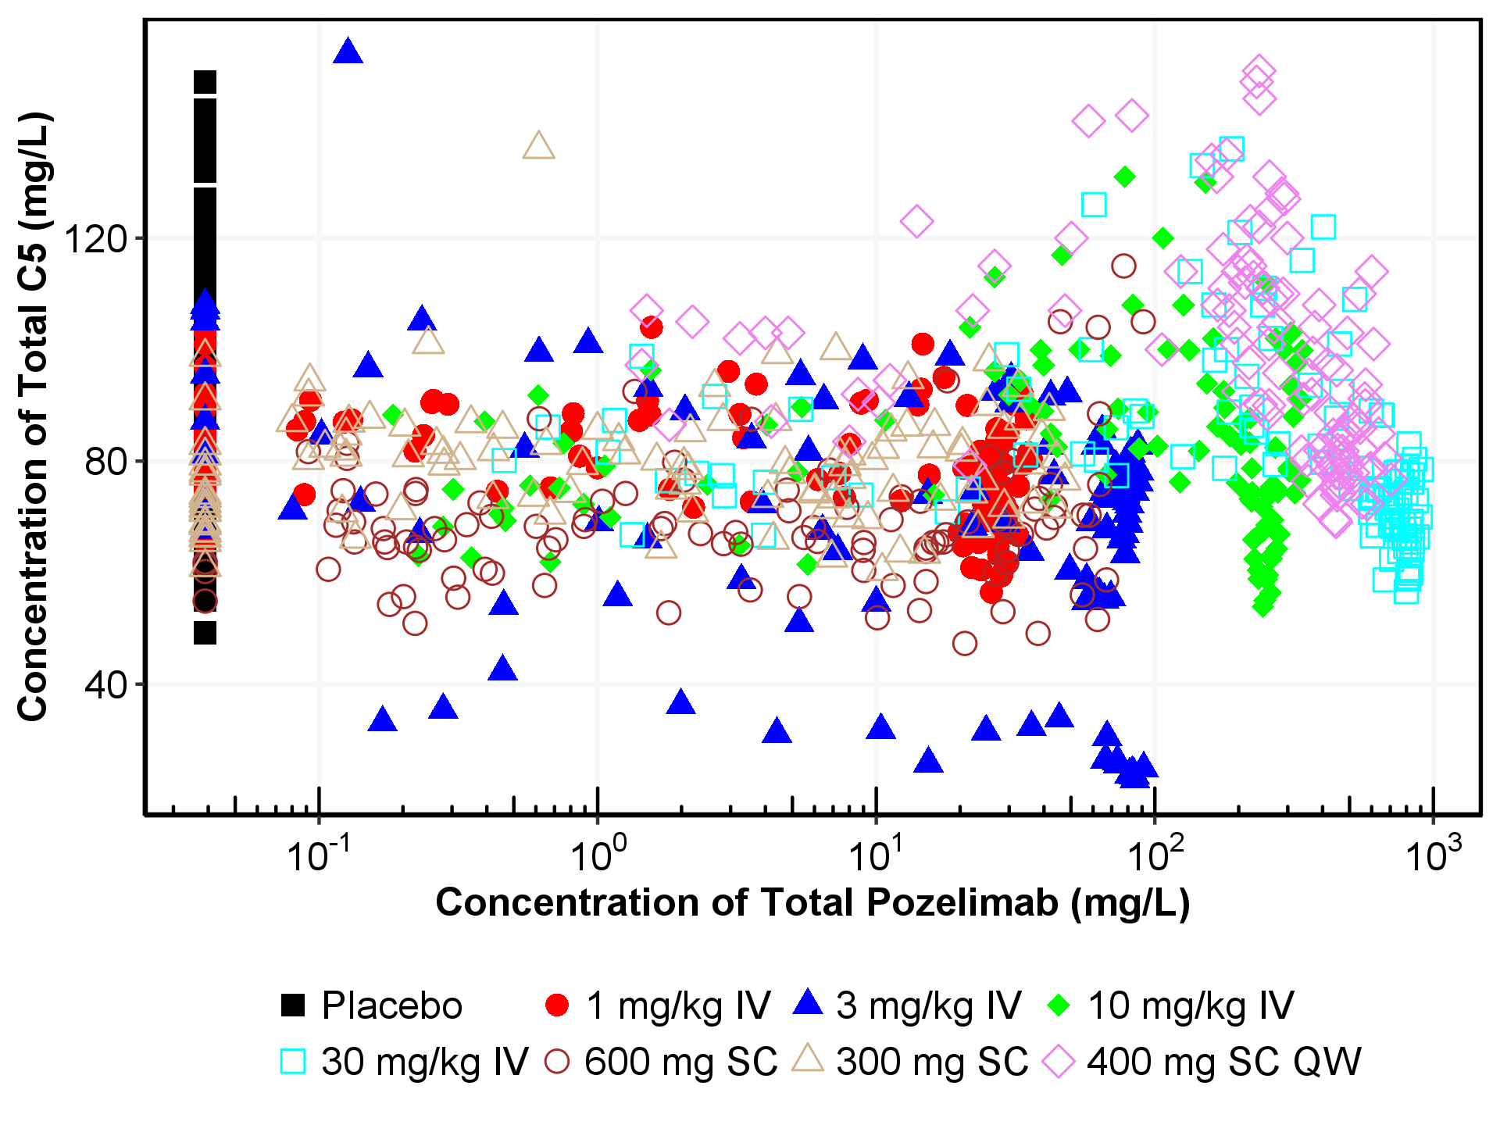

*CH50: hemolytic assay

QW = Once a week; IV = Intravenous; SC = Subcutaneous. A loading dose of 15 mg/kg was used in the dose group of 400 mg SC QW.

Figure : Concentration of Total C5 vs Concentration of Total Pozelimab by Treatment Group Regardless of Time Points (Study R3918-HV-1659)

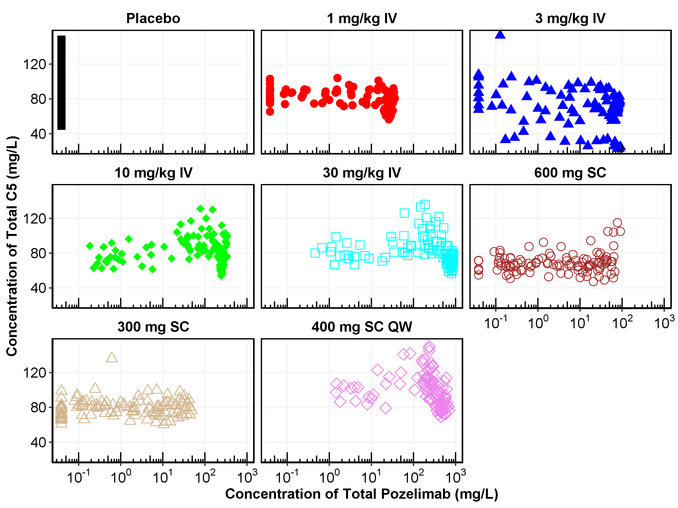

Figure : Hysteresis Plot of Mean Concentration of Total C5 vs Mean Concentration of Total Pozelimab by Treatment Group

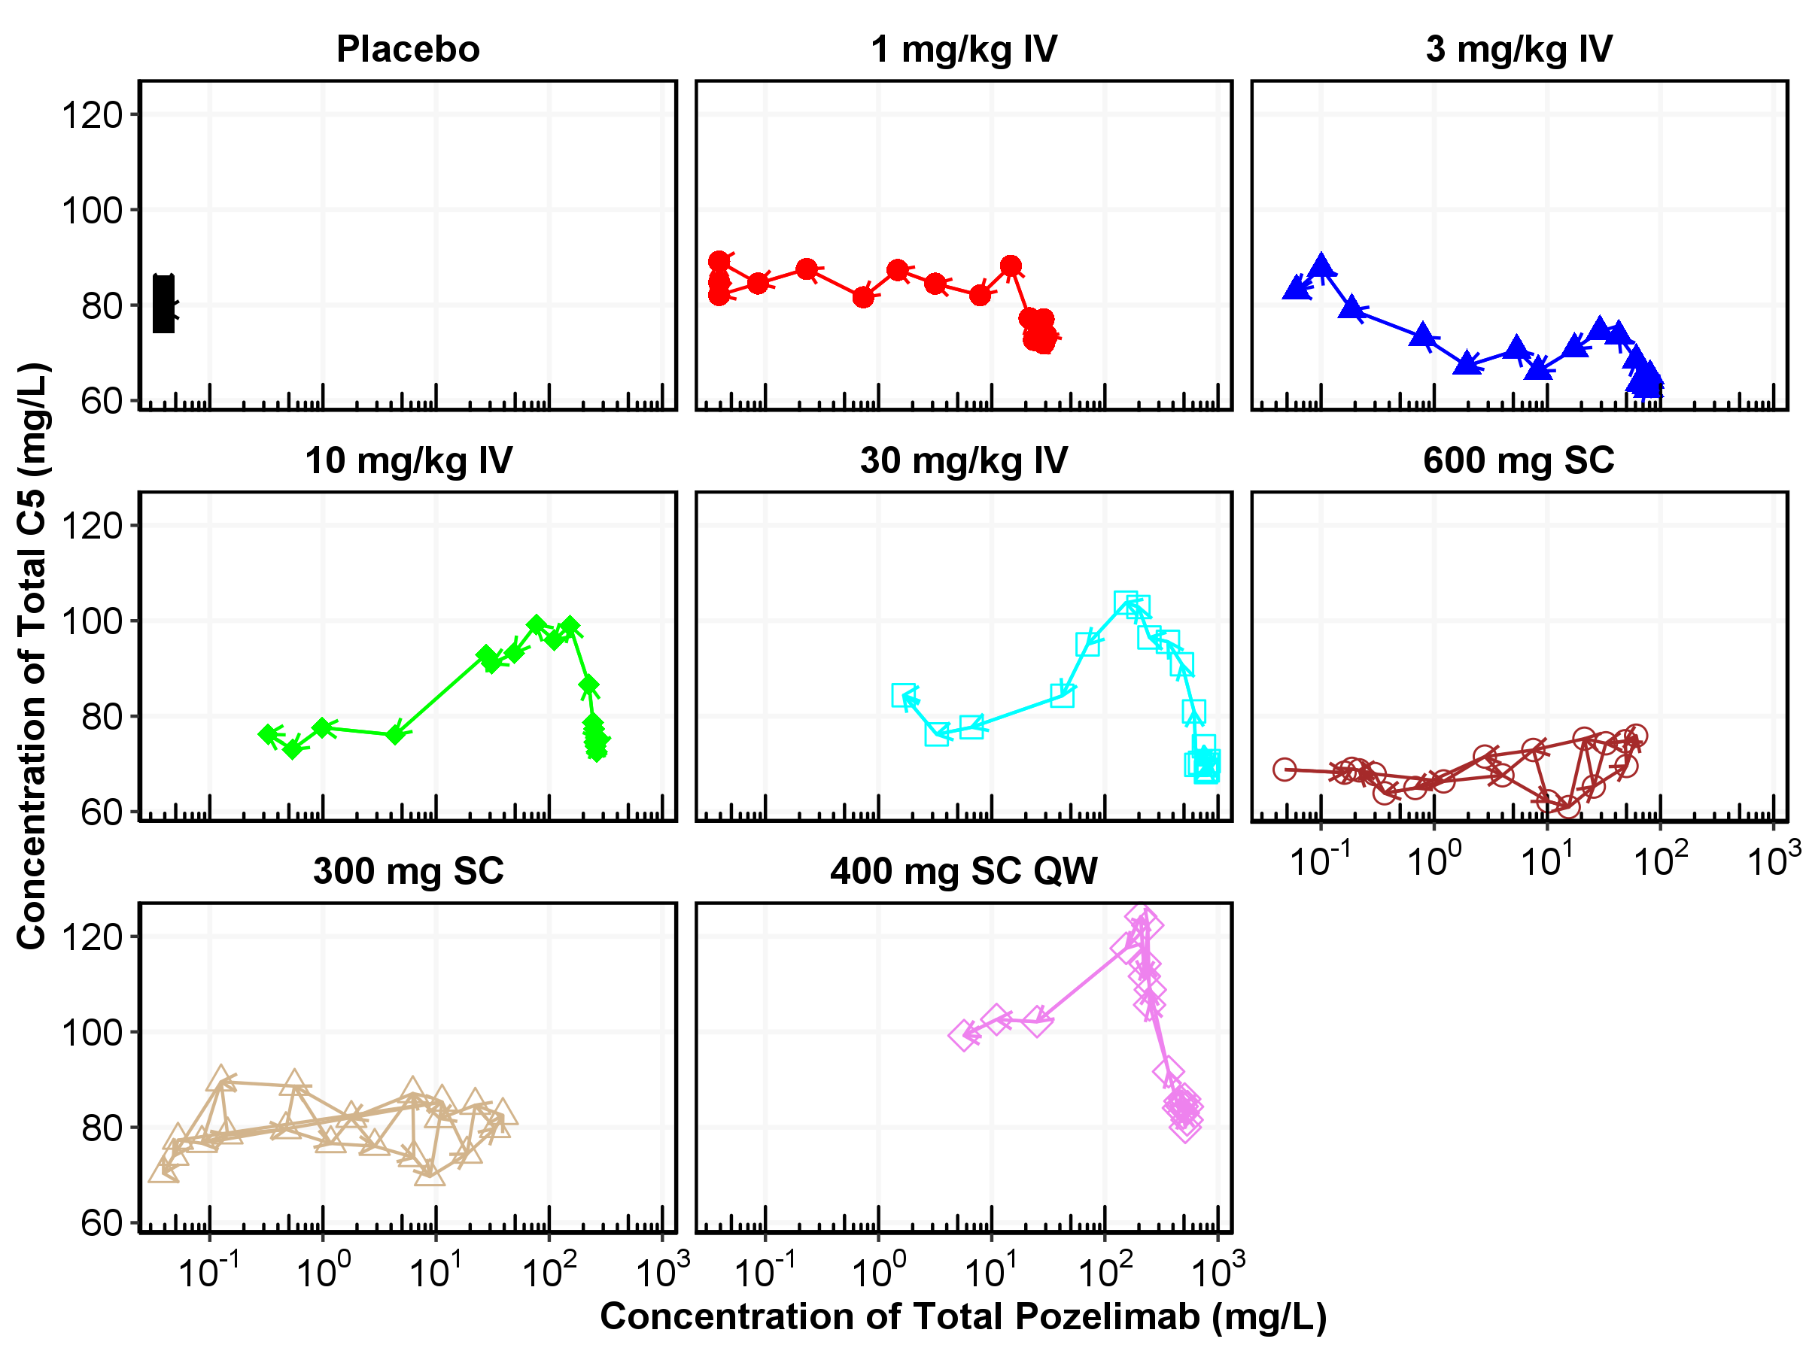

Figure : Individual Hysteresis Plot of Concentration of Total C5 vs Concentration of Total Pozelimab by Treatment Group

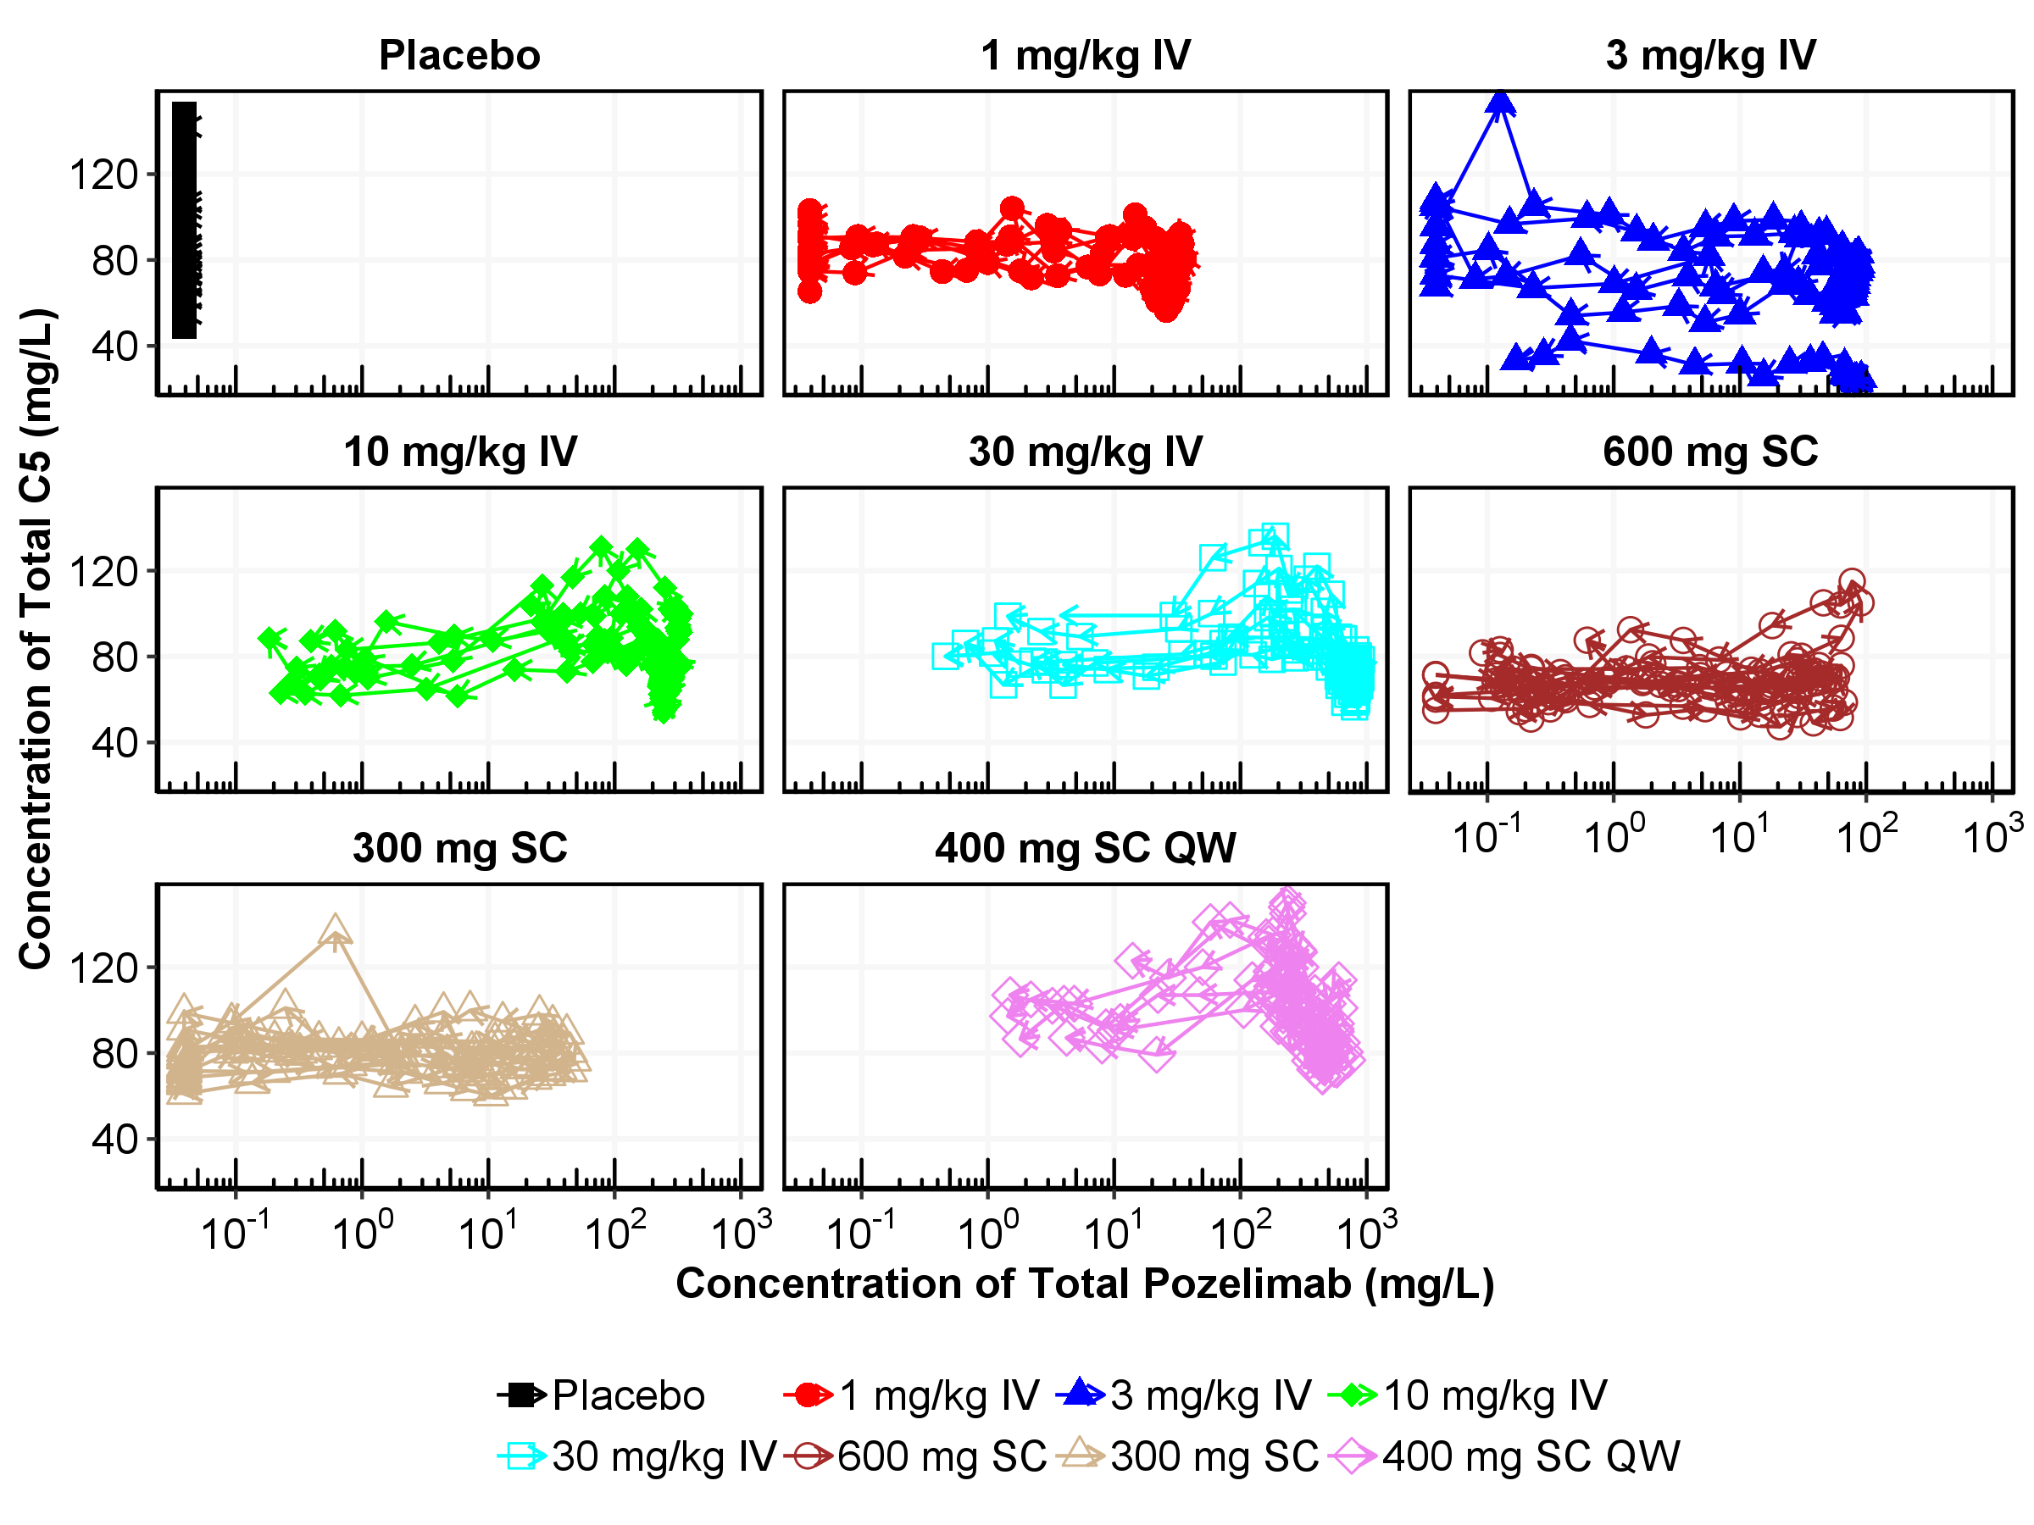

Figure : Individual Hysteresis Plot of Concentration of Total C5 vs Concentration of Total Pozelimab by Each Subject

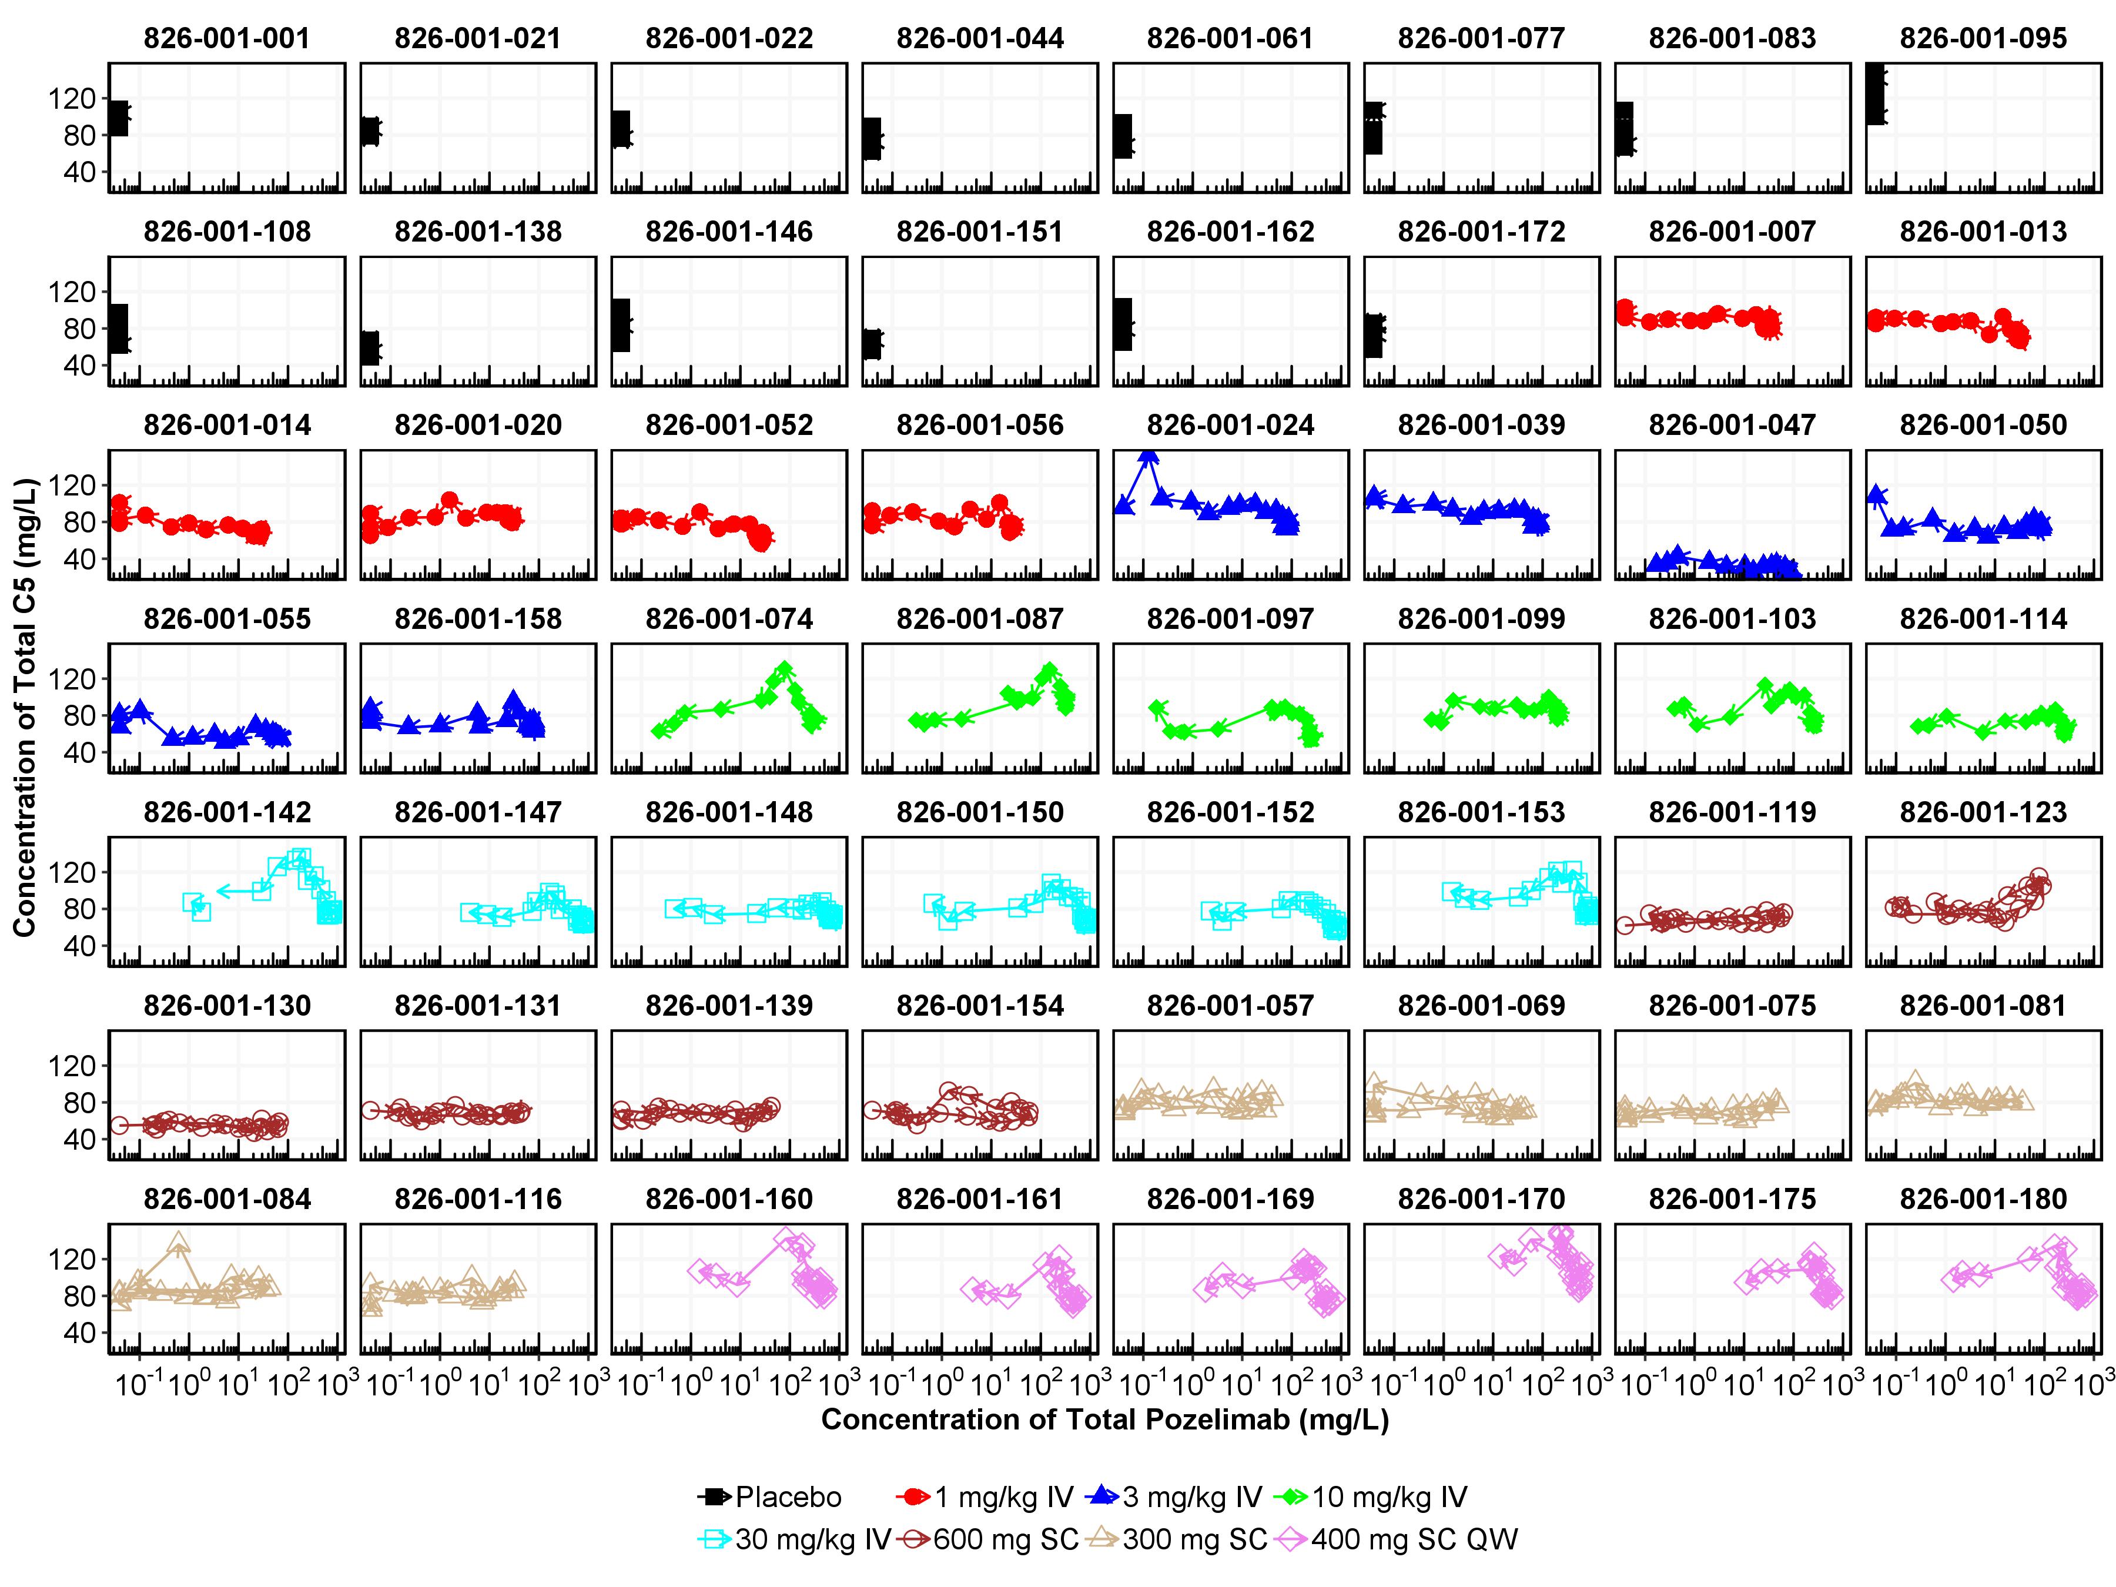

Figure : Individual Hysteresis Plot of Concentration of Total C5 vs Concentration of Total Pozelimab in the Treatment Group of 15 mg/kg IV Loading Dose Followed by 400 mg SC QW

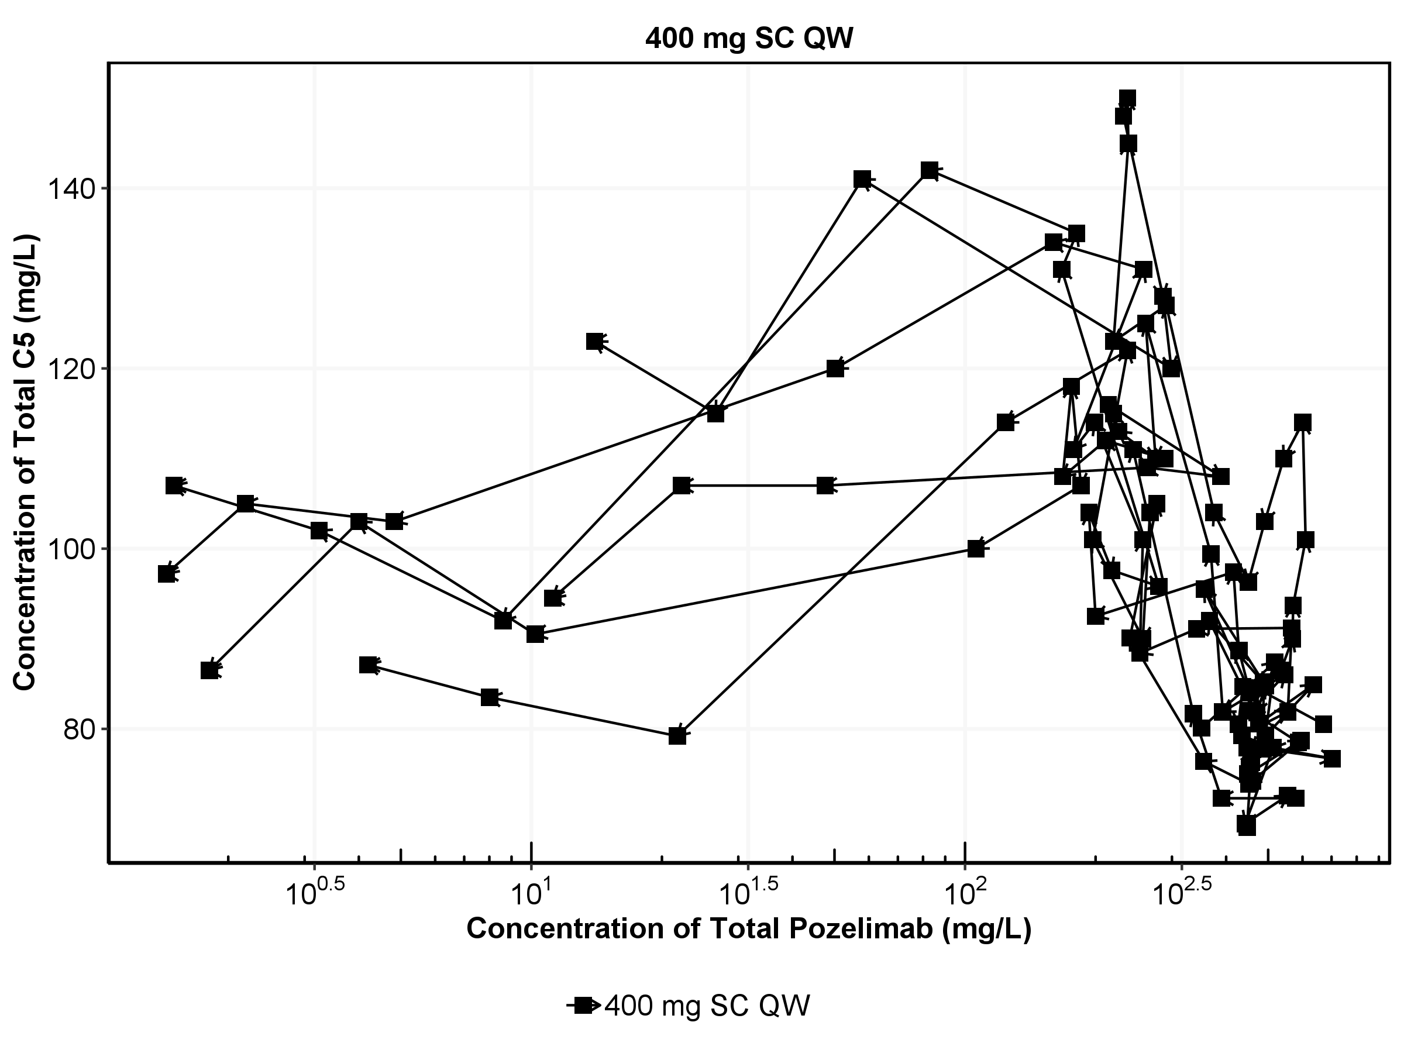

Figure : Individual Hysteresis Plot of Concentration of Total C5 vs Concentration of Total Pozelimab by Each Subject in the Treatment Group of 15 mg/kg IV Loading Dose Followed by 400 mg SC QW

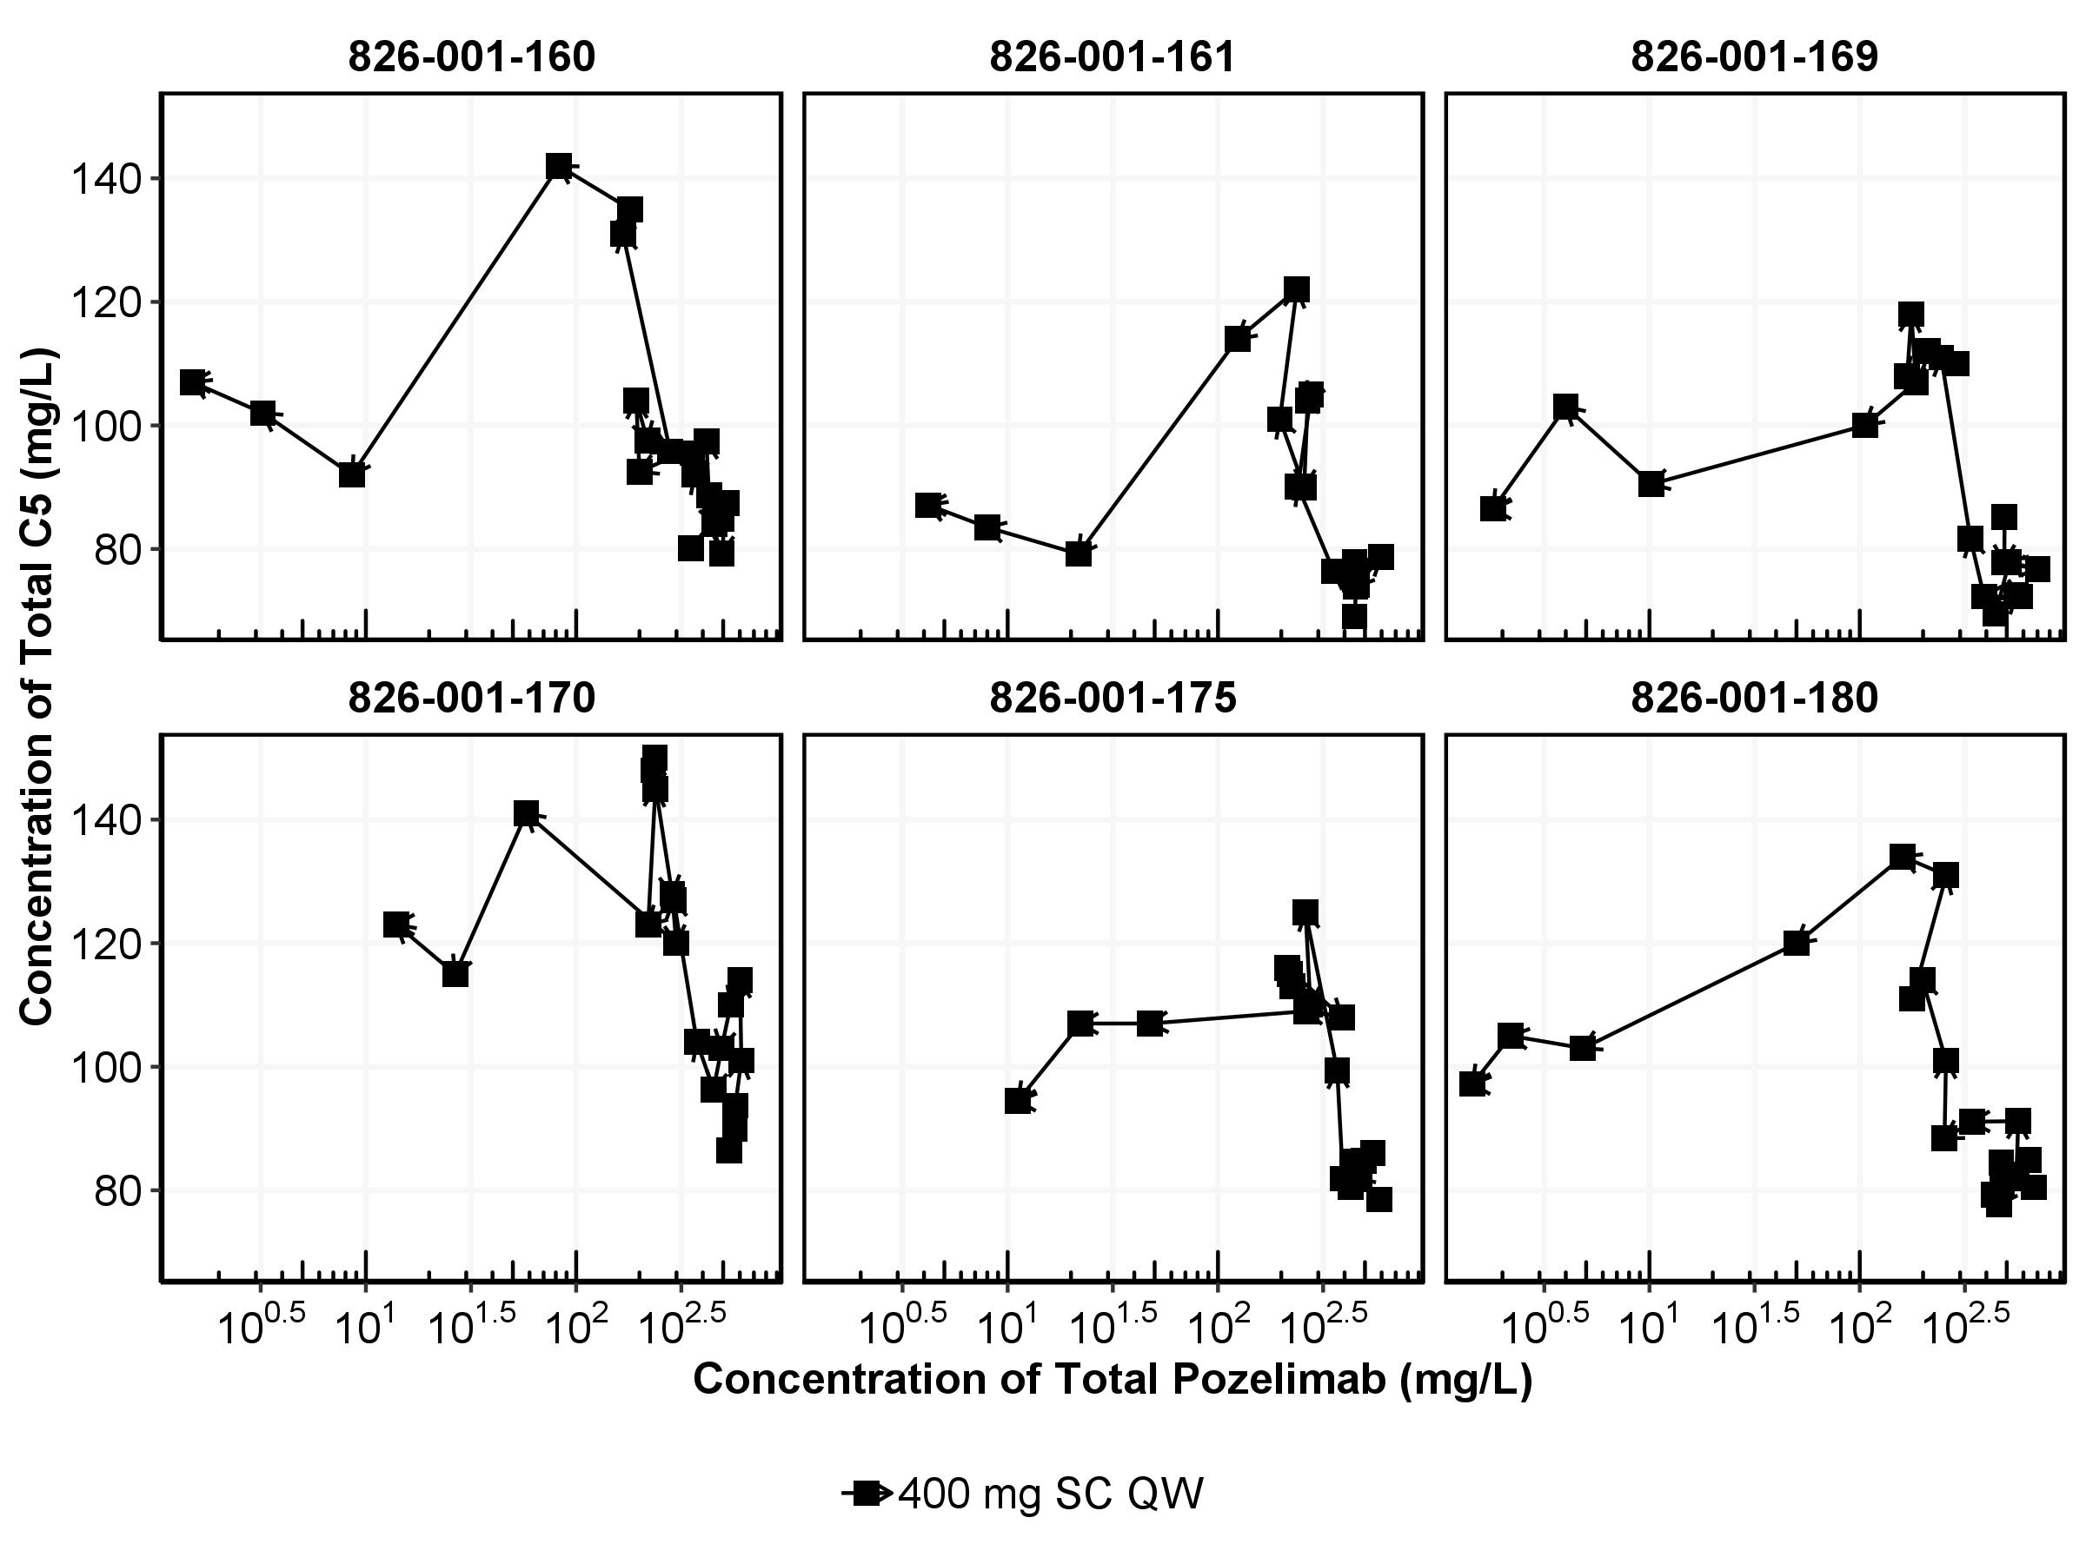

* + 1. Anti-Pozelimab Antibody Analysis

No subjects tested positive for ADA post treatment.

One sample from one subject in Cohort 5 (400 mg SC QW) had a positive response in the ADA assay at baseline (Day 1), with a titer of 50. All subsequent post-dose samples from this subject were negative in the ADA assay, indicating there was no treatment-emergent ADA response.

* 1. Model Development
     1. Base Model

Base model development consisted of the development of a structural model, an inter-individual variability (IIV) model, and a residual error model. The goal of this step was to develop a stable and parsimonious model to describe pozelimab serum concentration–time data without considering covariate effects.

As discussed earlier, the pharmacokinetics of pozelimab can be characterized as non-linear with parallel linear and target-mediated elimination, supporting the appropriateness of using a two-compartment model with zero-order IV infusion, parallel linear and nonlinear (Michaelis-Menten) elimination as the population PK structural model. A schematic illustration of this model and the corresponding parameterization is presented in Figure 26 (Appendix A).

Given that body weight is typically an influential covariate on monoclonal antibody (mAb) clearance parameters (CL and Q) and volume of distribution (Vss), body weight was incorporated into the base structural model.

* + 1. Covariate Model

The final base model identified in Section 4.2.1 was extended to evaluate the covariate effects and all pre-specified covariate-parameter relationships were simultaneously estimated.

In particular, baseline C5 and body weight were identified as the statistically significant covariates for both pharmacokinetics of pozelimab. The impact of these covariates on key model parameters (CL, Vss, VMAX, and KM) was assessed in this preliminary population analysis.

Both clearance (CL) and inter-compartment clearance (Q) were found to be body-weight dependent according to the principle of allometric scaling, with an exponent of 1.54, whereas the exponent of both central and peripheral volumes was found to be 0.75, indicating a statistically significant impact of body weight on the pharmacokinetics of pozelimab.

The covariate analyses also showed that baseline C5 had no impact on CL or Q but did have positive effect on VMAX and KM (with a covariate effect of ~0.49 and 0.33, respectively), which is consistent with target-mediated elimination of pozelimab. In particular, this analysis indicates that pozelimab clearance is greater in individuals with high C5 levels relative to a typical individual in the overall population, especially at pozelimab concentrations below 25 mg/L. However, at high dose (400 mg SC QW) concentrations of pozelimab were well above the range where target-mediated elimination predominates. Therefore, the impact of baseline C5 on exposure of pozelimab or percent change from baseline in CH50 was not significant.

* + 1. Final Model

The final model parameters were presented in Table 6.

Table : Parameter Estimates of the Final Model

| **Name** | **Description** | **Unit** | **Estimate(RSE%)** | **CV(%)** |
| --- | --- | --- | --- | --- |
| TVCL | Typical clearance | L/day | 0.125 (12.5) | 19.8 |
| TVV2 | Typical central volume of distribution | L | 2.67(4.38) | 9.47 |
| TVQ | Typical inter-compartmental clearance | L/day | 0.0754(22.4) | 19.8 |
| TVV3 | Typical peripheral volume of distribution | L | 1.13(12.4) | 9.47 |
| F1 | Bioavailability | unitless | 0.648(7.68) |  |
| TVKA | Typical absorption rate | 1/day | 0.155(22.3) | 36.6 |
| TVVMAX | Maximum elimination clearance in Michael-Menten clearance | (mg/day) | 7.83(34.6) | 19.4 |
| TVKM | Concentration at half of VMAX | mg/L | 24.1(40.3) | 0.00845 |
| RUVCV | proportional error | unitless | 0.0935 |  |
|  |  |  |  |  |
| EMAX | Typical maximum effect in sigmoid model | U/mL | 201 |  |
| IC50 | Typical concentration to achieve  half of the maximum effect | mg/L | 6.86 |  |
| GAMMA | Sigmoidicity shape parameter of the concentration-response relationship | unitless | 20.7 |  |
|  |  |  |  |  |
| WGT_ON_CLQ | Weight on CLQ (CL and Q) |  | 1.54 (28.6) |  |
| WGT_ON_VSS | Weight on Vss (V2 and V3) |  | 0.75 (40.2) |  |
| C5_ON_VMAX | Weight on VMAX |  | 0.493 |  |
| C5_ON_KM | Weight on KM |  | 0.326 |  |
|  |  |  |  |  |
| IIV_CLQ | IIV on CL/Q |  | 0.0391 |  |
| IIV_VSS | IIV of Vss |  | 0.00896 |  |
| IIV_KA | IIV of KA |  | 0.134 |  |
| IIV_VMAX | IIV of VMAX |  | 0.0377 |  |
| IIV_EMAX | IIV of Emax |  | 0.103 |  |
| IIV_IC50 | IIV of IC50 |  | 0.377 |  |
| IIV_GAMMA | IIV of GAMMA |  | 2.13 |  |
| OMEGA.2.1. | IIV between CLQ and VSS |  | 0.00665 |  |

IIV = Inter-individual variability, RSE = relative standard error, CV=coefficient of variation.

* 1. Population PK Model Application
     1. Post-hoc Exposure Metrics of Pozelimab

The final Pop PK model was used to generate the post-hoc estimates of individual PK parameters and exposure metrics for each subject. As would be expected, steady-state Ctrough is the most important exposure metric given that a direct relationship between pozelimab concentration and inhibition of hemolytic activity was observed.

Pharmacokinetic parameters obtained from the population PK analysis are presented in the following sections.

* + - 1. Absorption and Distribution

Pozelimab was administered both IV and SC; bioavailability was estimated to be 0.65. Peak concentrations were achieved one week after via SC administration of pozelimab. Based on population PK analysis, the total volume of distribution is 3.80 L, indicating that pozelimab is primarily distributed in the vascular system as is typical for mAbs.

* + - 1. Elimination

The pharmacokinetics of pozelimab was characterized as non-linear with parallel linear and target-mediated elimination. Based on the population model estimate of Km, target-mediated elimination predominates at concentrations below about 25 mg/L. However, the nonlinearity observed is modest.

* + - 1. Dose-Proportionality

Following a single dose of pozelimab, mean exposure generally increased in a greater than dose proportional manner over the dose range of pozelimab studied (1 mg/kg to 30 mg/kg, Table 7).

* + - 1. Steady-State and Accumulation

As illustrated in Figure 22, with a loading dose of 15 mg/kg IV, a regimen of 400 mg SC QW immediately achieved steady-state concentrations of ~200-300 mg/L. Simulations show that time to steady state is about 16 weeks in the absence of a loading dose (See Figure 23).

Table 7: Descriptive Statistics of Post-hoc Estimates of Pharmacokinetic Parameters of Pozelimab

| **Metrics** | **Dose** | **N** | **Mean(CV)** | **SE** | **SD** | **Median(CI95)** | **GEOmean(SD)** |
| --- | --- | --- | --- | --- | --- | --- | --- |
| Clearance (L/day) | 1 mg/kg IV | 6 | 0.153 (22.1%) | 0.0138 | 0.0338 | 0.154(0.106-0.197) | 0.150(0.119-0.188) |
| 3 mg/kg IV | 6 | 0.135 (25.5%) | 0.0141 | 0.0345 | 0.130(0.0948-0.194) | 0.132(0.103-0.169) |
| 10 mg/kg IV | 6 | 0.106 (23.6%) | 0.0102 | 0.0250 | 0.111(0.0665-0.139) | 0.103(0.0798-0.134) |
| 30 mg/kg IV | 6 | 0.118 (28.7%) | 0.0138 | 0.0338 | 0.114(0.0845-0.179) | 0.114(0.0875-0.149) |
| 300 mg SC | 6 | 0.123 (21.7%) | 0.0109 | 0.0267 | 0.125(0.0931-0.169) | 0.121(0.0980-0.149) |
| 600 mg SC | 6 | 0.127 (19.5%) | 0.0101 | 0.0248 | 0.119(0.102-0.158) | 0.125(0.104-0.152) |
| 400 mg SC QW | 6 | 0.171 (32.1%) | 0.0224 | 0.0548 | 0.164(0.102-0.241) | 0.163(0.117-0.228) |
| Volume of distribution (L) | 1 mg/kg IV | 6 | 4.08 (8.03%) | 0.134 | 0.328 | 3.93(3.82-4.55) | 4.07(3.76-4.40) |
| 3 mg/kg IV | 6 | 3.72 (13.8%) | 0.210 | 0.515 | 3.62(3.04-4.56) | 3.69(3.22-4.23) |
| 10 mg/kg IV | 6 | 3.86 (12.1%) | 0.191 | 0.468 | 3.99(3.07-4.45) | 3.84(3.38-4.36) |
| 30 mg/kg IV | 6 | 3.64 (2.40%) | 0.0357 | 0.0874 | 3.65(3.51-3.74) | 3.64(3.55-3.72) |
| 300 mg SC | 6 | 3.88 (8.88%) | 0.141 | 0.345 | 3.89(3.49-4.36) | 3.87(3.54-4.23) |
| 600 mg SC | 6 | 3.74 (10.4%) | 0.158 | 0.388 | 3.72(3.17-4.21) | 3.72(3.35-4.13) |
| 400 mg SC QW | 6 | 3.76 (12.2%) | 0.187 | 0.457 | 3.70(3.30-4.54) | 3.74(3.32-4.21) |
| Cmax (mg/L) | 1 mg/kg IV | 6 | 24.6 (29.1%) | 2.93 | 7.17 | 22.5(17.1-34.8) | 23.8(17.9-31.6) |
| 3 mg/kg IV | 6 | 78.6 (12.5%) | 4.03 | 9.86 | 79.1(68.2-92.9) | 78.1(68.9-88.5) |
| 10 mg/kg IV | 6 | 252 (17.1%) | 17.6 | 43.1 | 258(193-304) | 248(208-296) |
| 30 mg/kg IV | 6 | 751 (5.14%) | 15.8 | 38.6 | 753(708-814) | 750(713-789) |
| 300 mg SC | 6 | 29.4 (26.3%) | 3.15 | 7.73 | 27.2(21.1-40.9) | 28.6(22.1-36.9) |
| 600 mg SC | 6 | 66.4 (19.6%) | 5.32 | 13.0 | 66.4(46.3-87.0) | 65.3(53.3-80.0) |
| 400 mg SC QW | 6 | 413 (16.2%) | 27.4 | 67.0 | 401(353-515) | 409(349-479) |
| Time to Cmax (day) (mg/L) | 1 mg/kg IV | 6 | 0.0417 (0%) | 0 | 0 | 0.0417(0.0417-0.0417) | 0.0417(0.0417-0.0417) |
| 3 mg/kg IV | 6 | 0.0417 (0%) | 0 | 0 | 0.0417(0.0417-0.0417) | 0.0417(0.0417-0.0417) |
| 10 mg/kg IV | 6 | 0.0417 (0%) | 0 | 0 | 0.0417(0.0417-0.0417) | 0.0417(0.0417-0.0417) |
| 30 mg/kg IV | 6 | 0.0417 (0%) | 0 | 0 | 0.0417(0.0417-0.0417) | 0.0417(0.0417-0.0417) |
| 300 mg SC | 6 | 7.38 (24.8%) | 0.749 | 1.83 | 7.15(5.20-9.60) | 7.19(5.59-9.26) |
| 600 mg SC | 6 | 8.03 (10.1%) | 0.332 | 0.814 | 8.15(6.70-9.10) | 8.00(7.21-8.88) |
| 400 mg SC QW | 6 | 0.0417 (0%) | 0 | 0 | 0.0417(0.0417-0.0417) | 0.0417(0.0417-0.0417) |
| AUCinf (mg*day/L) | 1 mg/kg IV | 6 | 196 (27.7%) | 22.2 | 54.4 | 188(128-281) | 190(144-251) |
| 3 mg/kg IV | 6 | 713 (19.1%) | 55.6 | 136 | 712(541-881) | 702(577-852) |
| 10 mg/kg IV | 6 | 3660 (22.5%) | 336 | 822 | 3690(2360-4470) | 3570(2800-4560) |
| 30 mg/kg IV | 6 | 12800 (20.1%) | 1050 | 2570 | 13100(8920-16100) | 12600(10200-15500) |
| 300 mg SC | 6 | 616 (14.9%) | 37.5 | 91.8 | 597(522-790) | 611(532-703) |
| 600 mg SC | 6 | 1540 (13.3%) | 83.4 | 204 | 1550(1190-1790) | 1520(1320-1750) |
| 400 mg SC QW | 6 | 10300 (31.0%) | 1300 | 3180 | 10000(6880-14500) | 9870(7200-13500) |

Note: GEOmean represents geometric mean. AUCinf is for cumulative AUC for the full treatment regimen.

* + 1. Covariate Effects on Exposure to Pozelimab

This section discusses the intrinsic and extrinsic factors affecting exposure to pozelimab. Specifically, the magnitude of covariate effects on post-hoc estimates of exposure at steady state (AUCtau,ss and Ctrough,ss) was used to assess the potential effects on exposure to pozelimab following a regimen of 800 mg SC QW.

The final Pop PK model was also used to perform a post-hoc analysis by relevant covariates and the results are summarized in Table 8. Baseline body weight and baseline C5 level were identified as the main covariates affecting pozelimab exposure metrics (Ctrough,ss and AUCtau,ss).

*Baseline Body weight*

Typical of monoclonal antibodies and other large protein therapeutic agents for which the central compartment largely comprises the systemic volume, drug exposure is correlated with body-weight and body mass index (BMI). Consistent with these findings, the population PK model analysis identified weight as the major covariate, with significant effect on the observed PK of pozelimab.

Increasing body weight corresponds to decreasing exposure of pozelimab (AUC and Ctrough) after multiple SC administrations.

Scatterplots of predicted clearance and volume of distribution vs body weight in the range of 53.4 – 108 kg, are shown in Figure 36.

*Baseline C5*

The pharmacokinetics of pozelimab can be characterized as non-linear with parallel linear and target-mediated elimination.

A dose regimen of 800 mg SC QW achieves concentrations in serum well above the range where target-mediated elimination predominates, and as such, the impact of baseline C5 on exposure of pozelimab or percent change from baseline in CH50 was not significant.

Scatterplots of predicted KM and VMAX vs baseline C5 in the range of 27.3 – 137 mg/L, are shown in Figure 38.

Table : Summary Statistics (Mean±SD) of Post-hoc Steady-State Ctrough and AUCtau, by Relevant Covariate Following Dose Regimens of 400 mg and 800 mg SC QW

| **Metrics** | **Covariate** | **Category** | **N** | **400 mg SC QW*24** | **800 mg SC QW*24** |
| --- | --- | --- | --- | --- | --- |
| AUCtau (day*mg/L) | Baseline C5 (mg/L) | [27.3,72.9] | 11 | 1620 (±583) | 3560 (±1220) |
|  | (72.9,81.4] | 10 | 1780 (±322) | 3970 (±660) |
|  | (81.4,90.8] | 11 | 1550 (±473) | 3460 (±1040) |
|  | (90.8,108] | 10 | 1920 (±482) | 4280 (±1050) |
| Baseline CH50 (U/mL) | [132,208] | 11 | 1660 (±384) | 3680 (±830) |
|  | (208,222] | 10 | 1700 (±498) | 3760 (±1030) |
|  | (222,251] | 11 | 1700 (±544) | 3790 (±1180) |
|  | (251,394] | 10 | 1800 (±554) | 3990 (±1210) |
| Race | White | 33 | 1740 (±449) | 3860 (±963) |
|  | Other | 1 | 2280 | 5100 |
|  | Black | 4 | 1300 (±593) | 2890 (±1290) |
|  | Asian | 3 | 1950 (±556) | 4310 (±1120) |
|  | Native | 1 | 1250 | 2780 |
| Sex | F | 26 | 1880 (±391) | 4160 (±819) |
|  | M | 16 | 1450 (±508) | 3220 (±1120) |
| Baseline Weight (kg) | [53.4,61.7] | 11 | 2260 (±321) | 4970 (±658) |
|  | (61.7,68.5] | 10 | 1760 (±192) | 3940 (±406) |
|  | (68.5,75.9] | 11 | 1640 (±290) | 3660 (±626) |
|  | (75.9,108] | 10 | 1130 (±254) | 2530 (±554) |
| Ctrough (mg/L) | Baseline C5 (mg/L) | [27.3,72.9] | 11 | 224 (±82.4) | 493 (±173) |
|  | (72.9,81.4] | 10 | 245 (±46.9) | 548 (±95.9) |
|  | (81.4,90.8] | 11 | 213 (±67.0) | 477 (±147) |
|  | (90.8,108] | 10 | 266 (±68.9) | 595 (±151) |
| Baseline CH50 (U/mL) | [132,208] | 11 | 228 (±54.1) | 510 (±117) |
|  | (208,222] | 10 | 234 (±70.9) | 520 (±147) |
|  | (222,251] | 11 | 235 (±77.5) | 524 (±169) |
|  | (251,394] | 10 | 248 (±79.0) | 554 (±172) |
| Race | White | 33 | 240 (±63.9) | 534 (±137) |
|  | Other | 1 | 316 | 709 |
|  | Black | 4 | 178 (±83.7) | 397 (±183) |
|  | Asian | 3 | 270 (±81.7) | 600 (±164) |
|  | Native | 1 | 171 | 381 |
| Sex | F | 26 | 260 (±56.1) | 577 (±117) |
|  | M | 16 | 198 (±71.6) | 444 (±158) |
| Baseline Weight (kg) | [53.4,61.7] | 11 | 314 (±46.4) | 693 (±95.2) |
|  | (61.7,68.5] | 10 | 242 (±27.7) | 543 (±58.2) |
|  | (68.5,75.9] | 11 | 227 (±42.0) | 507 (±90.4) |
|  | (75.9,108] | 10 | 155 (±36.6) | 347 (±79.8) |
| Percent Change from Baseline in CH50 (%) | Baseline C5 (mg/L) | [27.3,72.9] | 11 | -93.8 (±6.26) | -94.2 (±5.92) |
|  | (72.9,81.4] | 10 | -91.2 (±16.0) | -92.4 (±14.6) |
|  | (81.4,90.8] | 11 | -94.5 (±6.58) | -94.7 (±6.19) |
|  | (90.8,108] | 10 | -98.4 (±4.64) | -98.4 (±4.64) |
| Baseline CH50 (U/mL) | [132,208] | 11 | -85.7 (±12.7) | -86.5 (±11.5) |
|  | (208,222] | 10 | -96.0 (±6.88) | -96.1 (±6.42) |
|  | (222,251] | 11 | -96.8 (±5.73) | -97.5 (±4.50) |
|  | (251,394] | 10 | -100 (±0) | -100 (±0) |
| Race | White | 33 | -95.8 (±6.15) | -96.2 (±5.57) |
|  | Other | 1 | -100 | -100 |
|  | Black | 4 | -94.3 (±7.08) | -94.3 (±7.08) |
|  | Asian | 3 | -80.4 (±27.5) | -81.8 (±25.1) |
|  | Native | 1 | -88.8 | -88.8 |
| Sex | F | 26 | -96.3 (±6.11) | -96.7 (±5.48) |
|  | M | 16 | -91.5 (±12.7) | -92.0 (±11.7) |
| Baseline Weight (kg) | [53.4,61.7] | 11 | -97.1 (±4.96) | -97.1 (±4.89) |
|  | (61.7,68.5] | 10 | -94.4 (±6.67) | -95.1 (±5.88) |
|  | (68.5,75.9] | 11 | -93.4 (±15.2) | -93.8 (±14.0) |
|  | (75.9,108] | 10 | -92.8 (±7.51) | -93.3 (±6.91) |

* + 1. Simulation of Concentration-Time Profiles of Proposed Dose Regimens

Based on simulation, at the proposed dose of 800 mg SC QW, all patients in a similar population are expected to have Ctrough above 100 mg/L, including those with high body weight and high level of baseline C5 (Figure 5). In conclusion, this population-based PK/PD analysis supports the proposed dose regimen of 30 mg/kg IV load followed by 800 mg SC QW for subsequent study in patients with similar baseline C5 and body weight characteristics as the subjects in Study R3918-HV-1659.

As previously discussed, at high dose levels, concentrations of pozelimab were well above the range where target-mediated elimination predominates, and as such, the impact of baseline C5 on exposure of pozelimab was not significant, as shown in Figure 24 and Figure 25.

Figure : Simulated Concentration-Time Profile (95%CI) of Pozelimab at 400 and 800 mg SC QW With an IV Loading Dose of 30 mg/kg, Based on Preliminary PopPK Model (Each has 1,000 Simulated Patients)

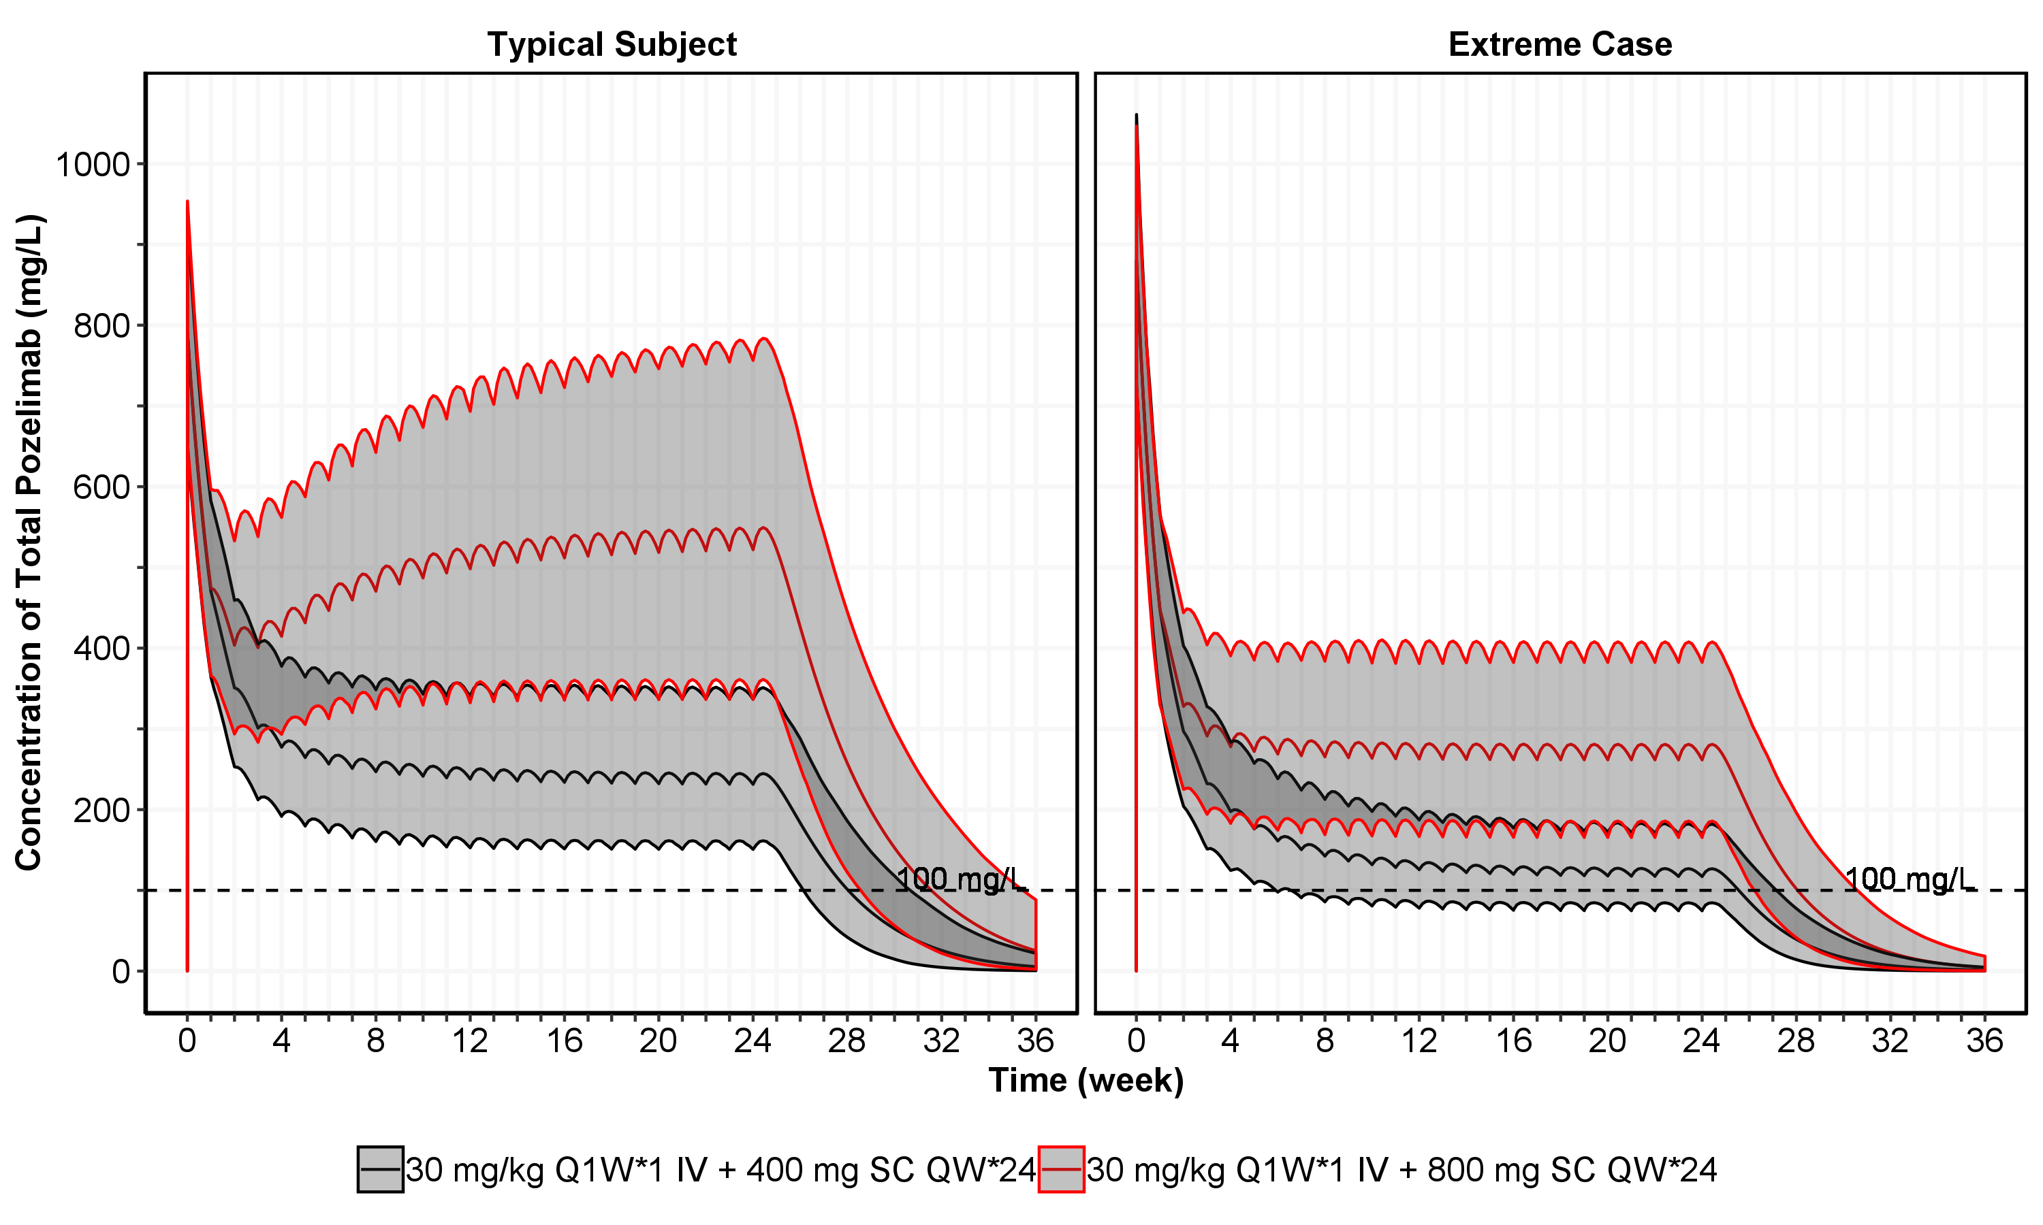

Note a typical subject with a body weight of 70 kg and baseline C5 of 80 mg/L. The extreme subject indicate a subject with body weight of 108 kg and baseline C5 level of 108 mg/L, the highest observed in the treated subject in Study R3918-HV-1659. The 3 lines for each dose regimen represent the 2.5%, median and 97.5% percentile of the predicted total Pozelimab.

Figure : Simulated Concentration-Time Profile (95%CI) of Pozelimab at 400 mg and 800 mg SC QW, Based on Preliminary PopPK Model (Each has 1,000 Simulated Patients)

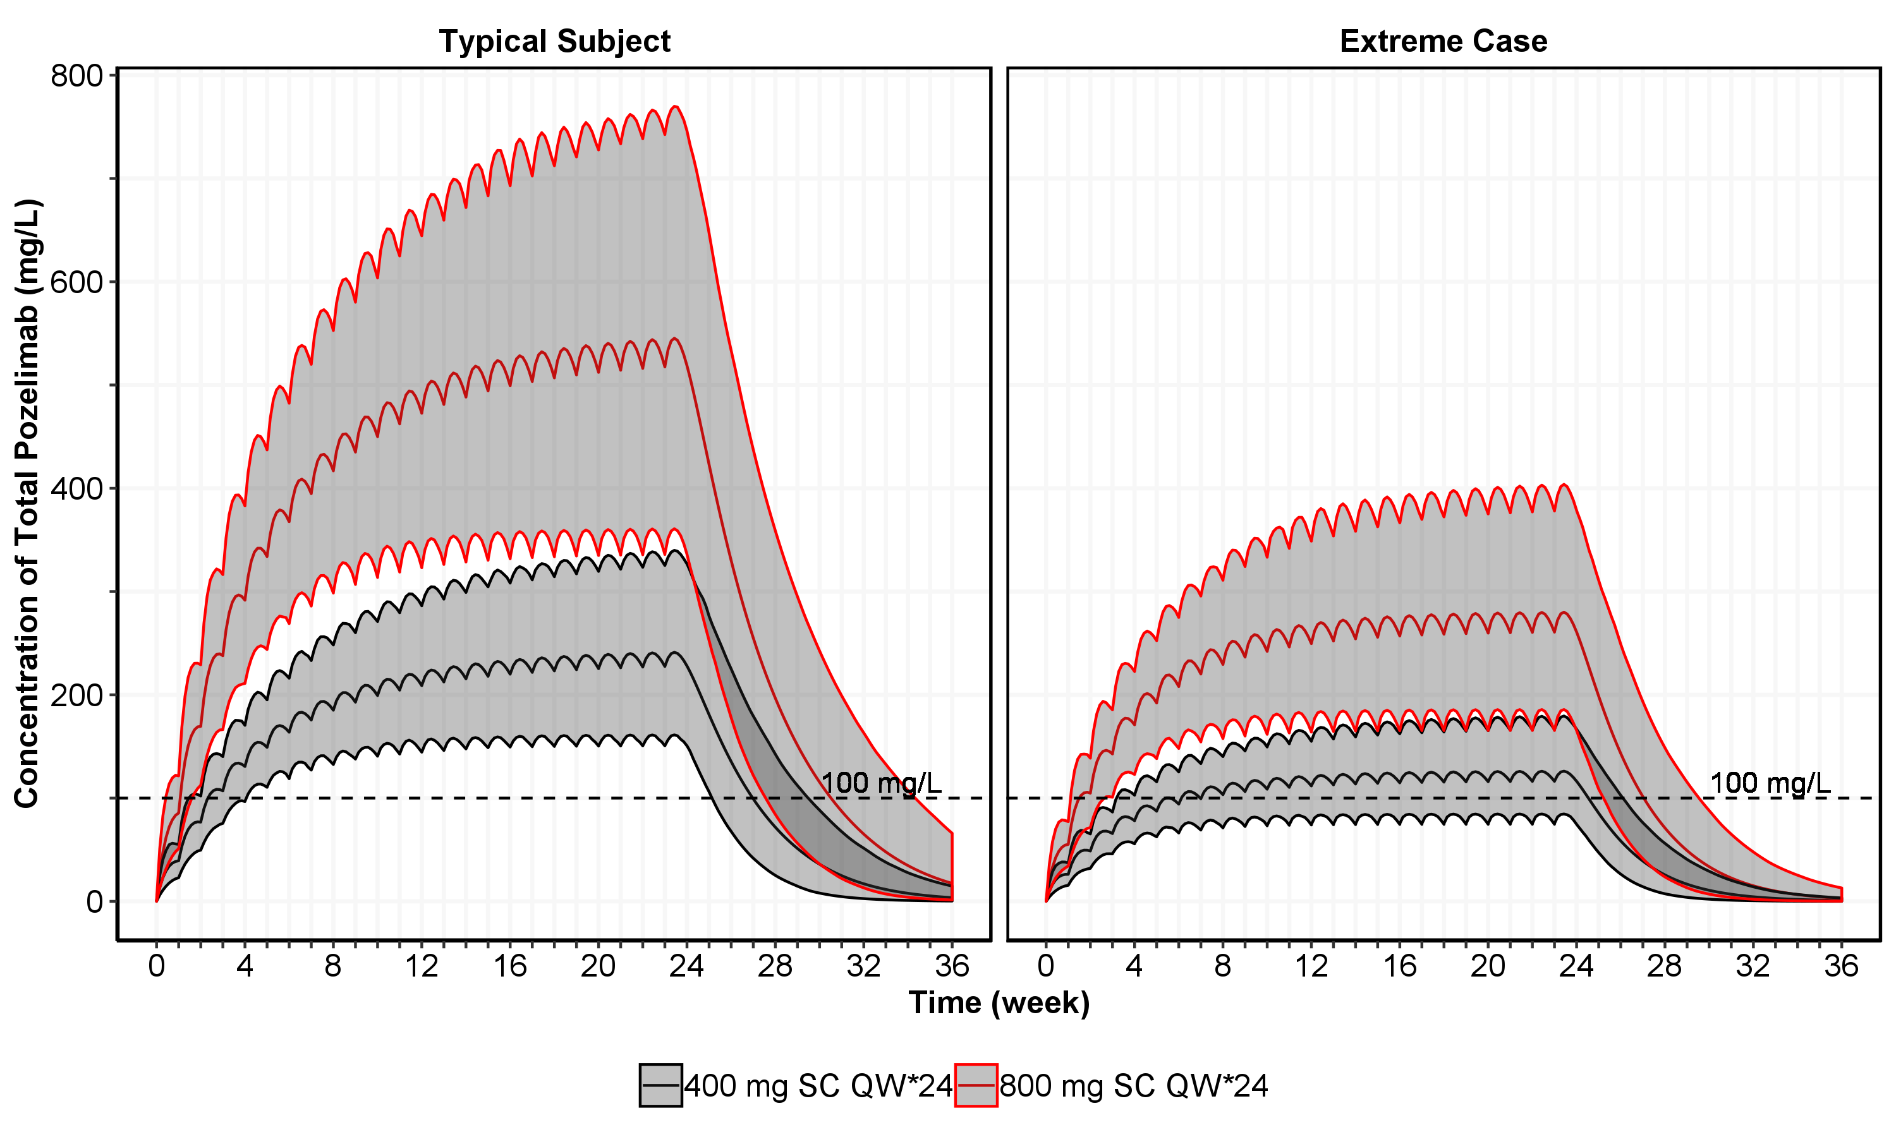

Note a typical subject with a body weight of 70 kg and baseline C5 of 80 mg/L. The extreme subject indicates a subject with body weight of 108 kg and baseline C5 level of 108 mg/L, the highest observed in the treated subject in Study R3918-HV-1659. The 3 lines for each dose regimen represent the 2.5%, median and 97.5% percentile of the predicted total Pozelimab.

Figure : Simulated Concentration-Time Profile (95%CI) of Pozelimab at 400 and 800 mg SC QW With an IV Loading Dose of 30 mg/kg, Based on Preliminary PopPK Model (Each has 1,000 Simulated Patients)

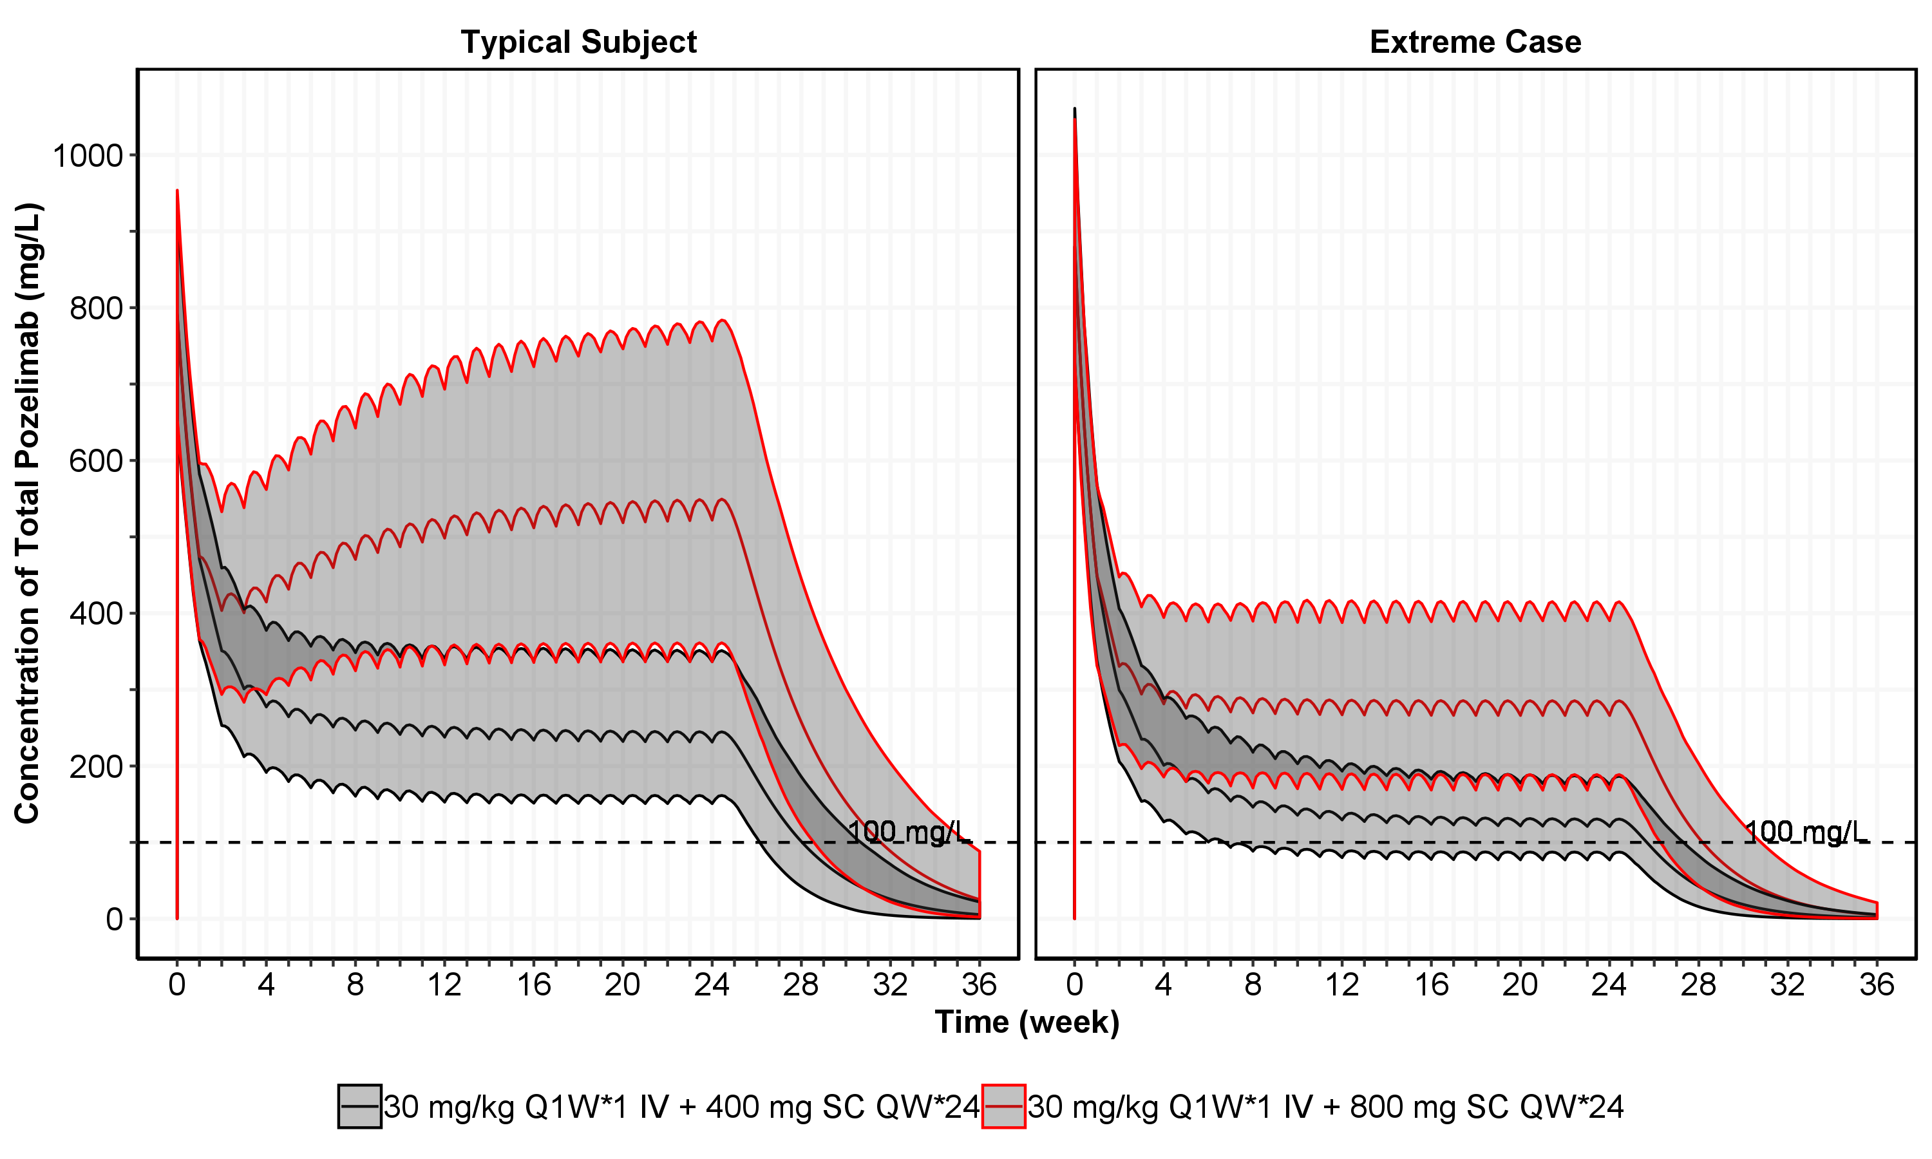

Note a typical subject with a body weight of 70 kg and baseline C5 of 80 mg/L. The extreme subject indicates a subject with body weight of 108 kg, the highest observed in the treated subject in Study R3918-HV-1659. The 3 lines for each dose regimen represent the 2.5%, median and 97.5% percentile of the predicted total Pozelimab.

Figure : Simulated Concentration-Time Profile (95%CI) of Pozelimab at 400 mg and 800 mg SC QW, Based on Preliminary PopPK Model (Each has 1,000 Simulated Patients)

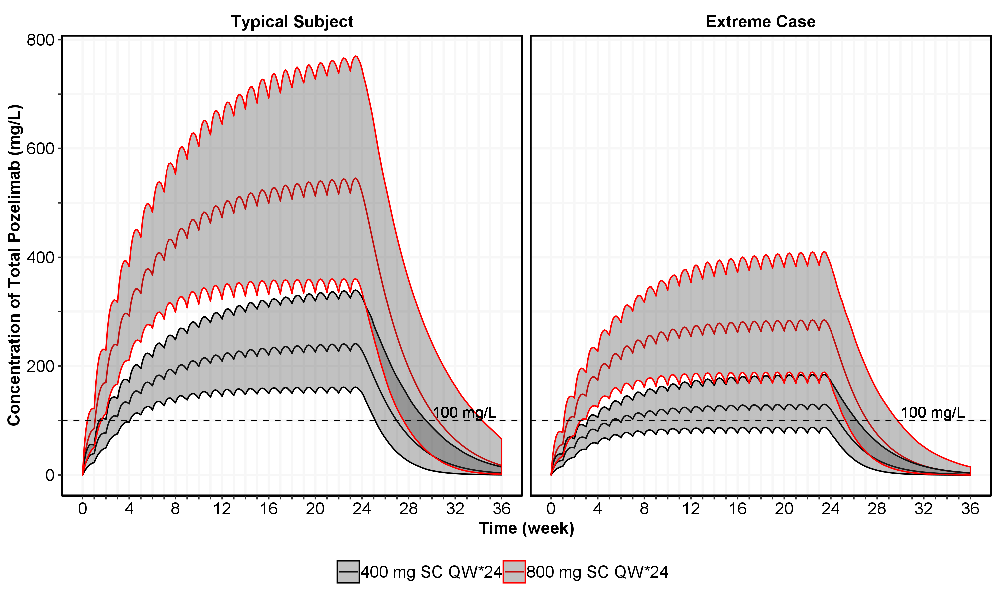

Note a typical subject with a body weight of 70 kg and baseline C5 of 80 mg/L. The extreme subject indicates a subject with body weight of 108 kg, the highest observed in the treated subject in Study R3918-HV-1659. The 3 lines for each dose regimen represent the 2.5%, median and 97.5% percentile of the predicted total Pozelimab.

1. References

Bioanalytical Report [Insert Reference]

1. Model Development
   1. Structural Model

A two-compartment model with parallel linear and nonlinear (Michaelis-Menten) elimination was selected as a starting model structure. Figure 26 provides a schematic for the initial two-compartment structural PK model with parallel linear and nonlinear (Michaelis-Menten) elimination.

Figure : A General Structural Representation of a Two-compartment Model with Parallel Linear and Michaelis-Menten Elimination for both IV and SC Administration

Vmax, km

ke

F1, ka

Peripheral

Central

IV

SC

k32

k23

Depot (A1)

V2

(A2)

V3

(A3)

Note: SC = subcutaneous; IV = intravenous; F1 = F = bioavailability; ka = absorption rate constant; V2 = Vc = volume of distribution (central compartment); V3 = Vp = volume of distribution (peripheral compartment); Q = inter-compartmental clearance between the central and peripheral compartments; k23, k32 – inter-compartmental rate constants; ke – elimination rate constant; Vm – maximum target-mediated rate of elimination; km – Michaelis-Menten constant. A1 is the amount of drug dosed via SC route (subject to bioavailability F1), A2is the amount of drug in the central compartment with a volume V2, A3 is the amount of drug in the peripheral compartment with a volume V3.

This structural model was parameterized in terms of clearance (*CL*), central volume of distribution (*V2*), peripheral volume of distribution (*V3*), inter-compartmental clearance (*Q*), with log-normal random effect distributions. In the model with both parallel linear and nonlinear elimination, Vmax (maximum rate in nonlinear elimination) and Km (Michaelis-Menten constant) were introduced.

This diagram representation can be mathematically expressed as the following ODE equations:

$$\frac{dA_{1}}{dt}=-k_{a}A_{1}$$

$$\frac{dA_{2}}{dt}=-k_{e}A_{2}+k_{a}A_{1}-k_{23}A_{2}+k_{32}A_{3}+\frac{V_{max}*\frac{A_{2}}{V_{2}}}{k_{m}+\frac{A_{2}}{V_{2}}}$$

$$\frac{dA_{3}}{dt}=k_{23}A_{2}-k_{32}A_{3}$$

where A1 A2A3, ka, ke, k23, k32, Vmax, and km are explained in the footnote of Figure 26.

* 1. Diagnostic Plots

Inspection of the goodness-of-fit plots suggests good agreement between observed data and model predictions for most conditions. Goodness-of-fit plots including dependent variable (DV) versus population predicted value (PRED) and DV versus individually predicted value (IPRED) of pozelimab by dose group are given in Figure 27. Goodness-of-fit plots IPRED versus conditional weighted residual (CWRES), TIME versus CWRES, patient ID versus CWRES, quantile plots of CWRES are presented in Figure 28. IPRED, PRED and observed pozelimab concentrations versus time by dose group are presented in Figure 29 (linear-scale) and Figure 30 (log-scale). The representative model fitting of predicted concentration-time profiles of pozelimab vs observed profiles is presented in Figure 31.

Goodness-of-fit plots including DV versus PRED and DV versus IPRED of CH50 by dose group are given in Figure 32. Goodness-of-fit plots IPRED versus CWRES, TIME versus CWRES, patient ID versus CWRES, and quantile plots of CWRES versus etas, are presented in Figure 33. IPRED, PRED and observed CH50 versus time by dose group are presented in Figure 34. Representative plots of predicted concentration-time profiles of CH50 vs observed profiles are presented in Figure 35.

Plots for key covariate variables (body weight, baseline C5 and baseline CH50) versus etas are provided in Figure 26, Figure 28, and Figure 30, respectively.

The NONMEM® control stream for the final model and associated dataset are in Appendix B.

* + 1. Population Pharmacokinetic Analysis

Figure : Population Predicted (PRED) and Individual Predicted (IPRED) versus Observed (DVOR) Pozelimab Concentration Obtained from the Final Model (Log, and non-log)

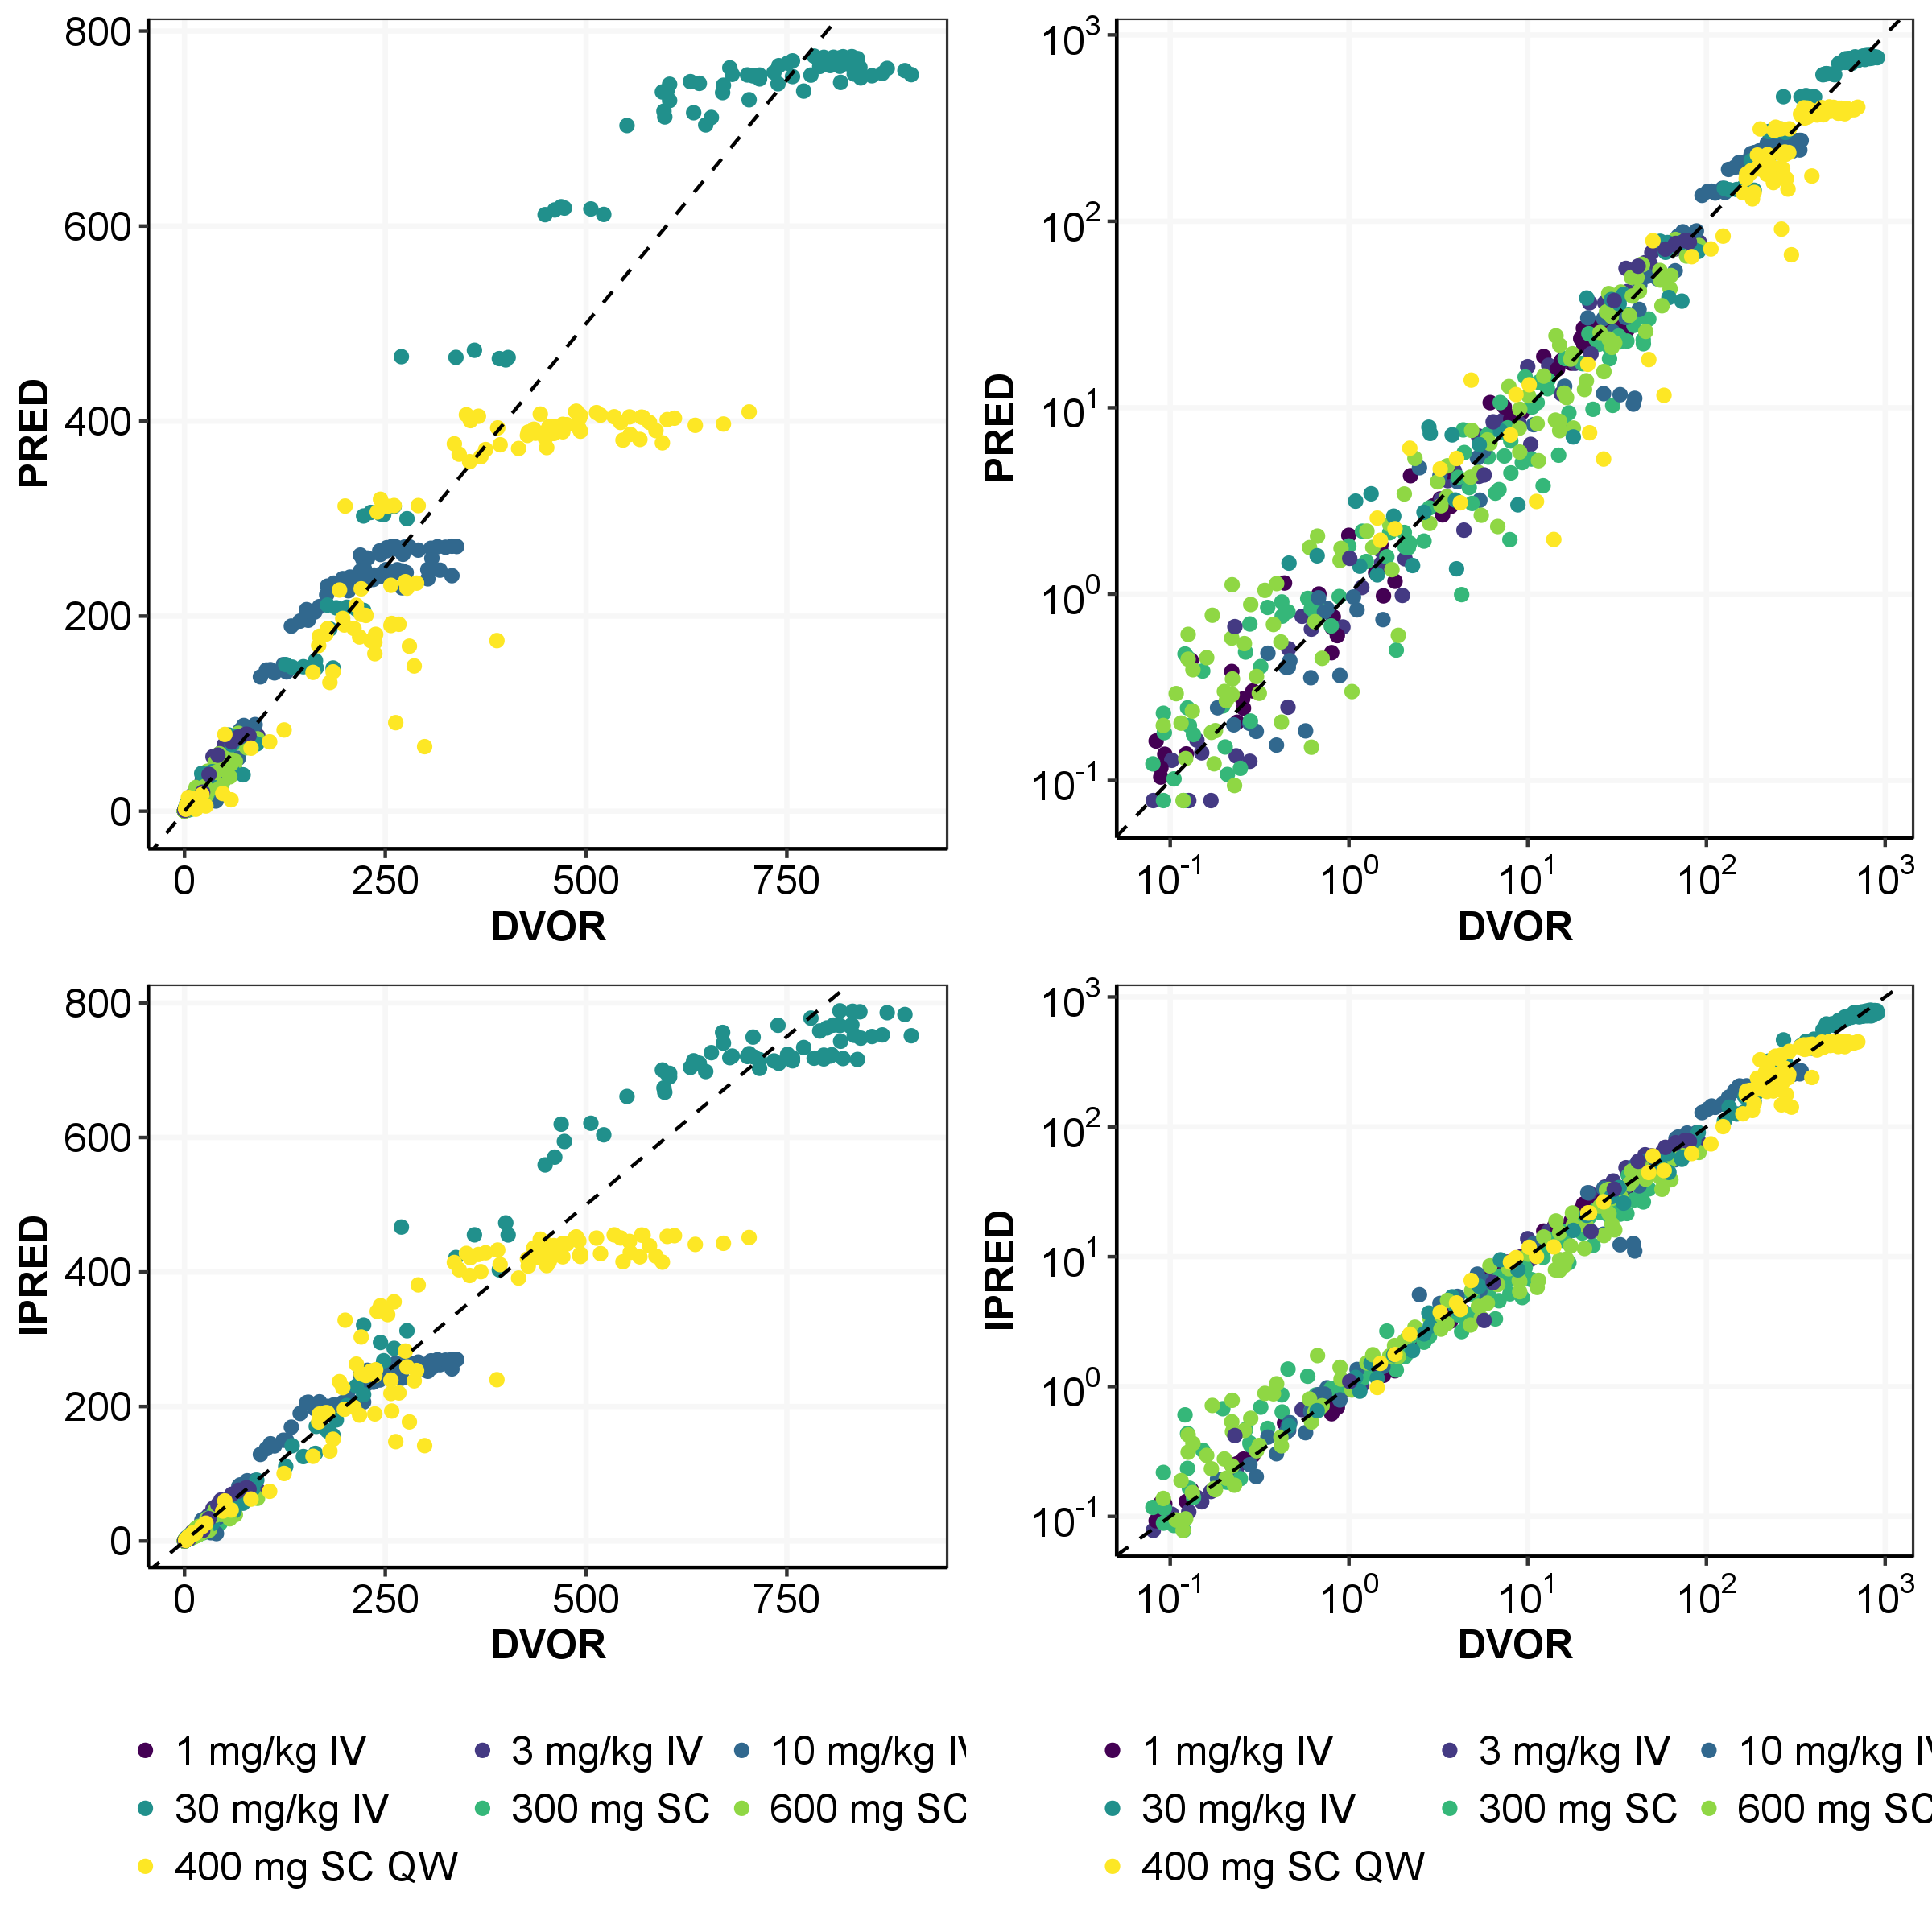

Figure : Conditional Weighted Residuals of Pozelimab vs Time, IPRED and ID from the Final Model

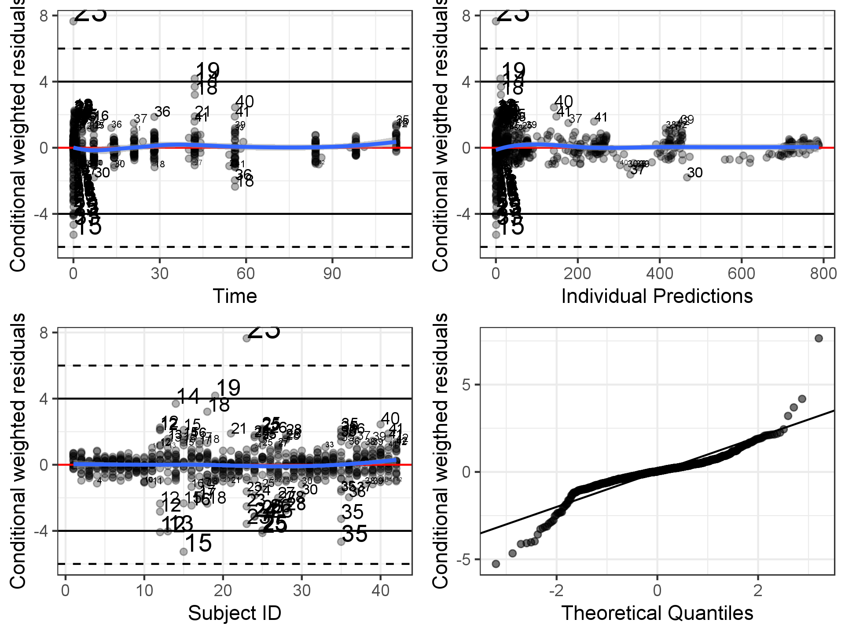

Figure 29: Predicted Concentration-time Profiles of Pozelimab Overlay with Observed Concentration by Dose Group in Linear Scale

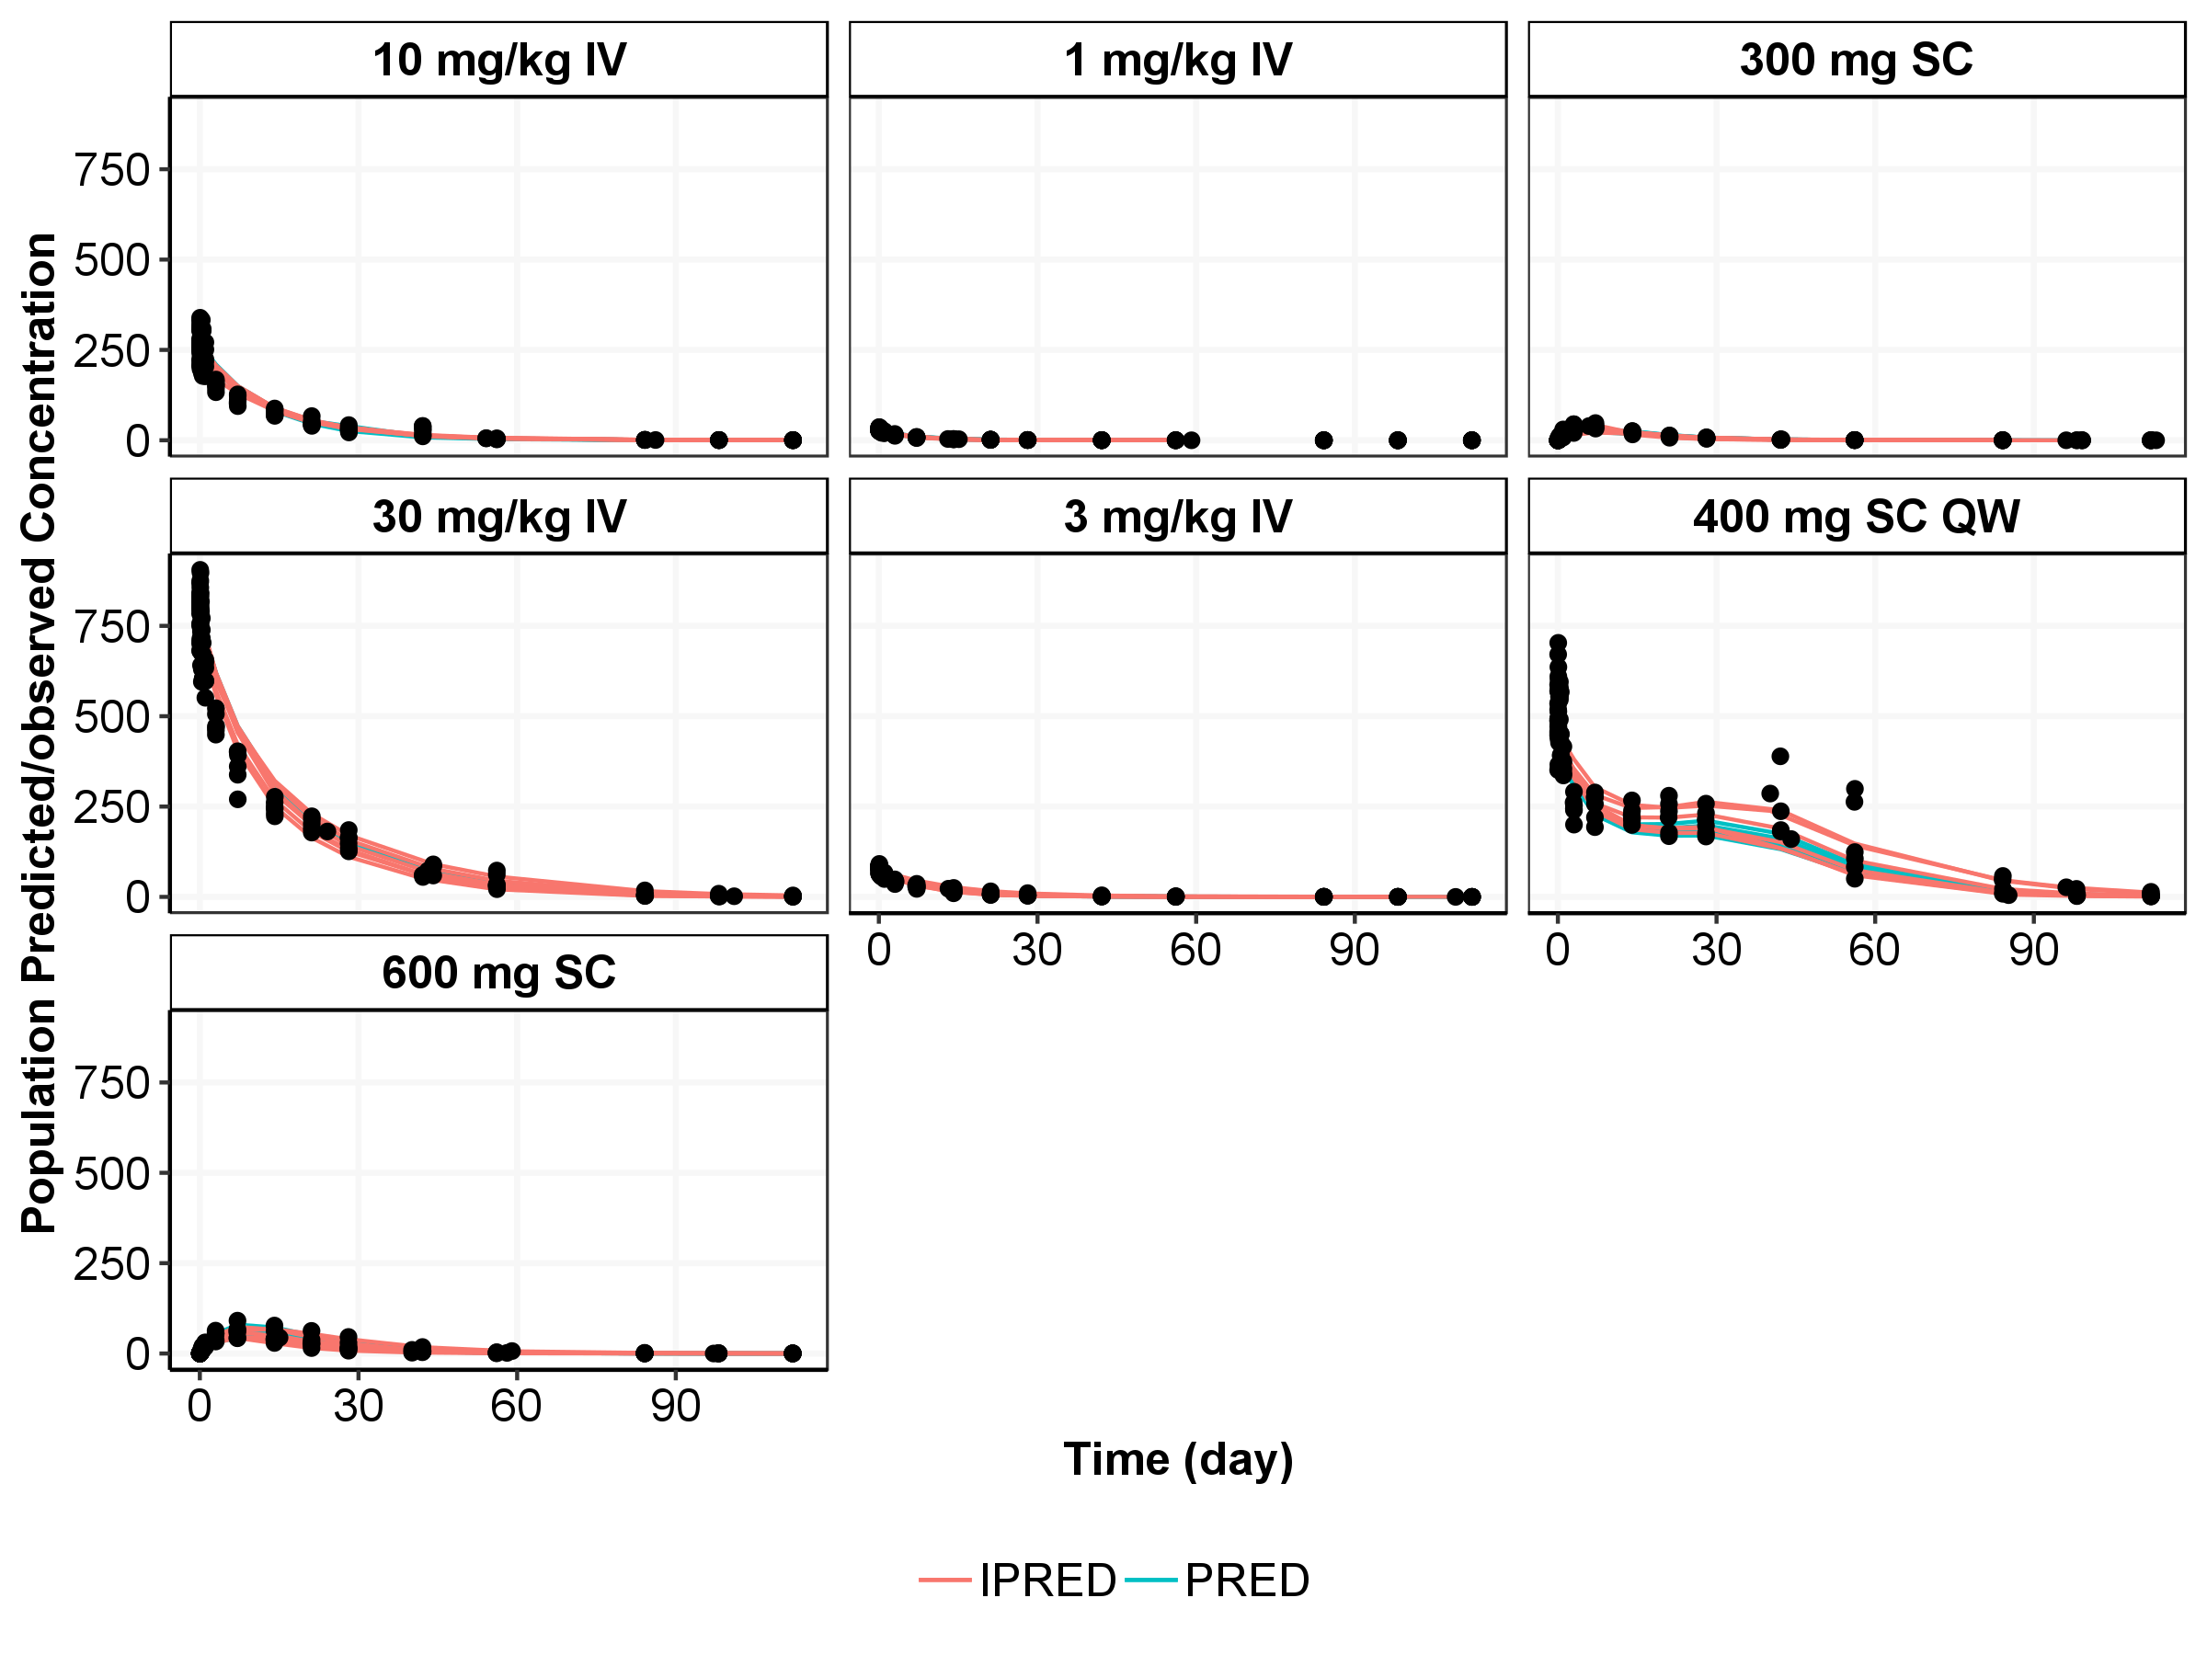

IPRED = Individual predictions; PRED = Population mean predictions

Figure 30: Predicted Concentration-time Profiles of Pozelimab Overlay with Observed Concentration by Dose Group in Semi-log Scale

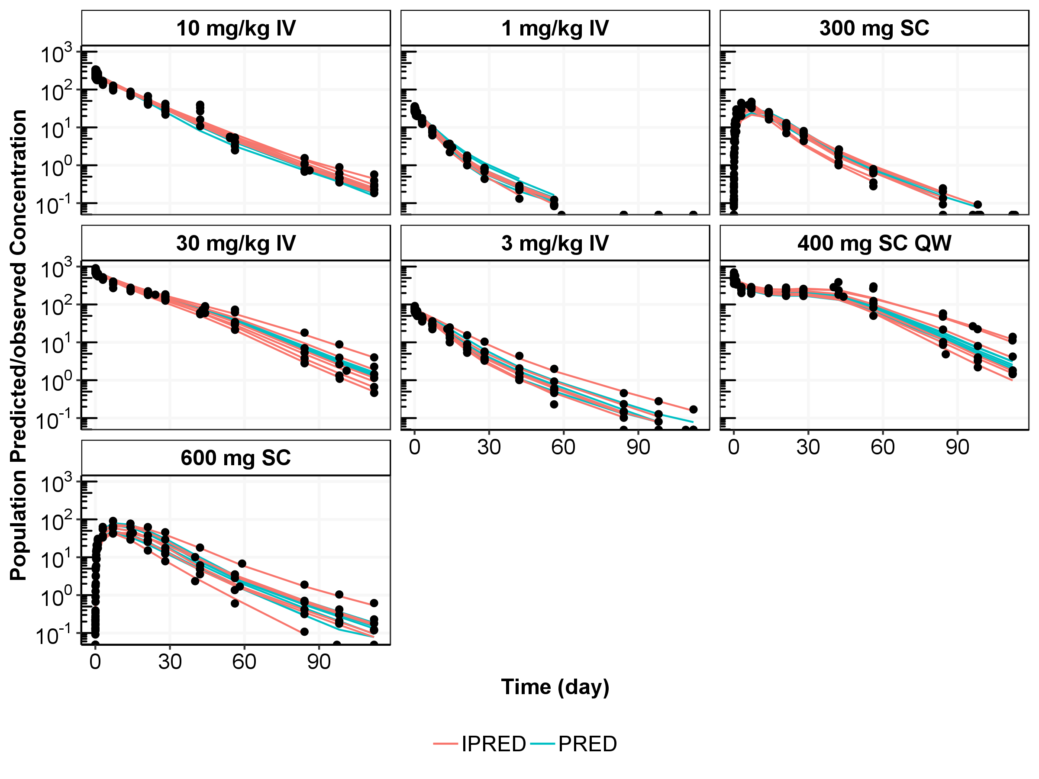

IPRED = Individual predictions; PRED = Population mean predictions

Figure : Representative Model Fitting of Predicted Concentration-time Profiles of Pozelimab vs Observed Profiles in Study R3918-HV-1659

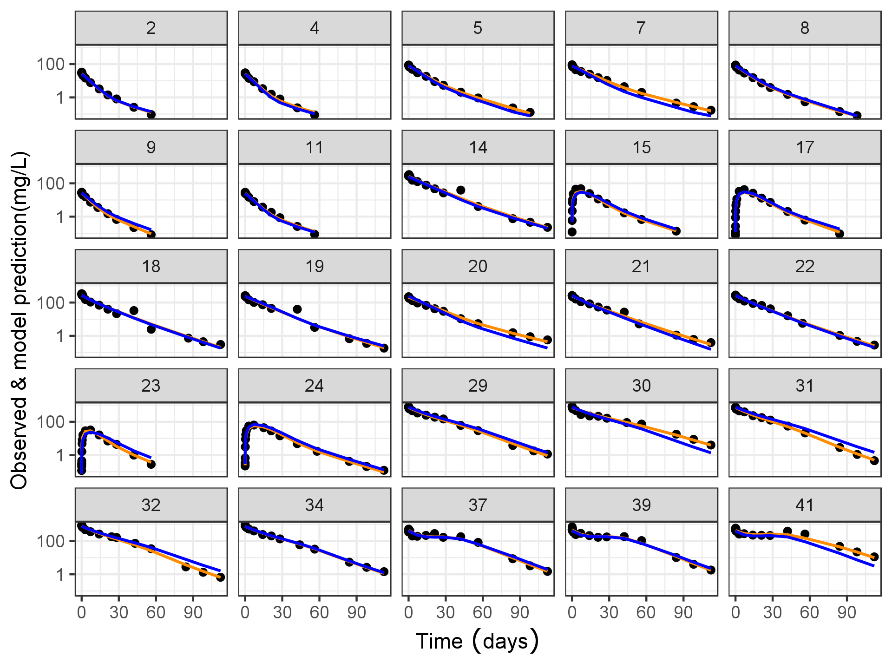

Note: Patients were randomly selected from the overall population. Each black dot represents the observe data; blue line represents the population mean prediction; the yellow line represents the individual prediction.

* + 1. Population Pharmacokinetic/Pharmacodynamic Analysis

Figure : Population Predicted (PRED) and Individual Predicted (IPRED) versus Observed (DVOR) CH50* Obtained from the Final Model (Log, and non-log)

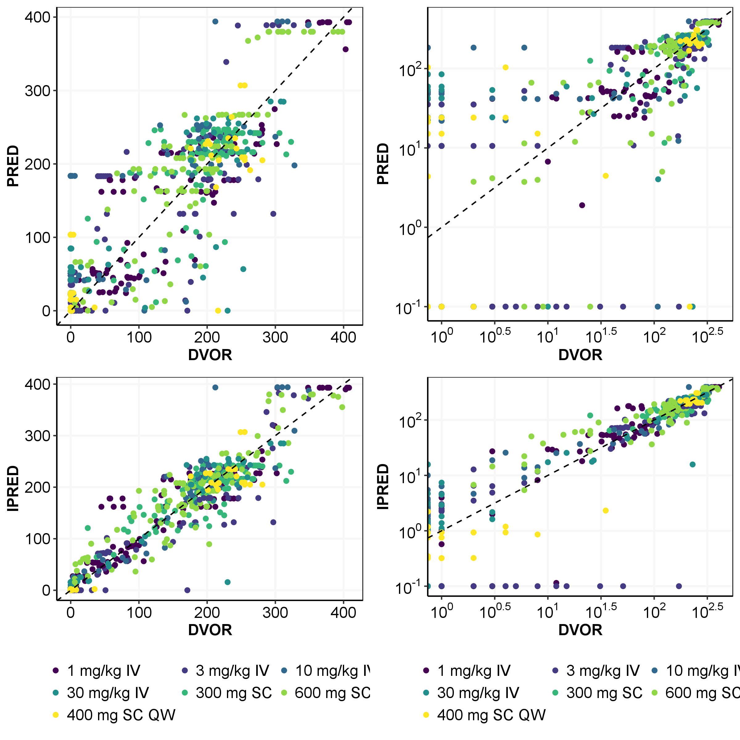

Note: the black dashed line is the unity line.

*CH50: Assay of hemolytic activity

Figure : Conditional Weighted Residuals of CH50* vs Time, IPRED and ID from the Final Model

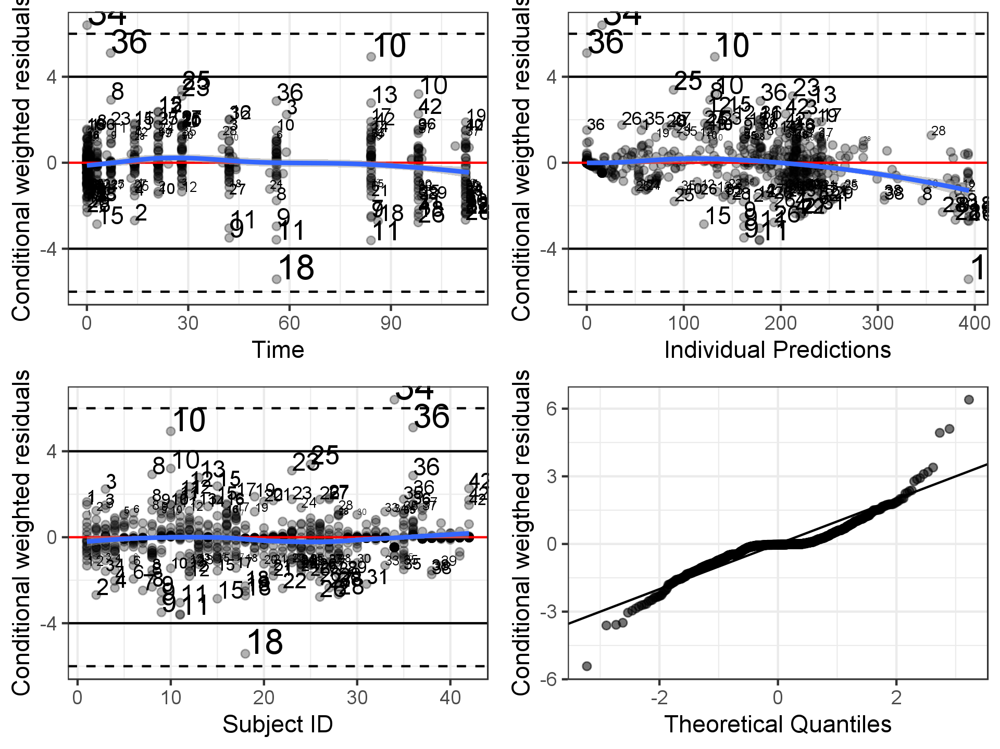

*CH50: Assay of hemolytic activity

Figure 34: Predicted and Observed Percent of Change in CH50* vs. Time in Linear Scale

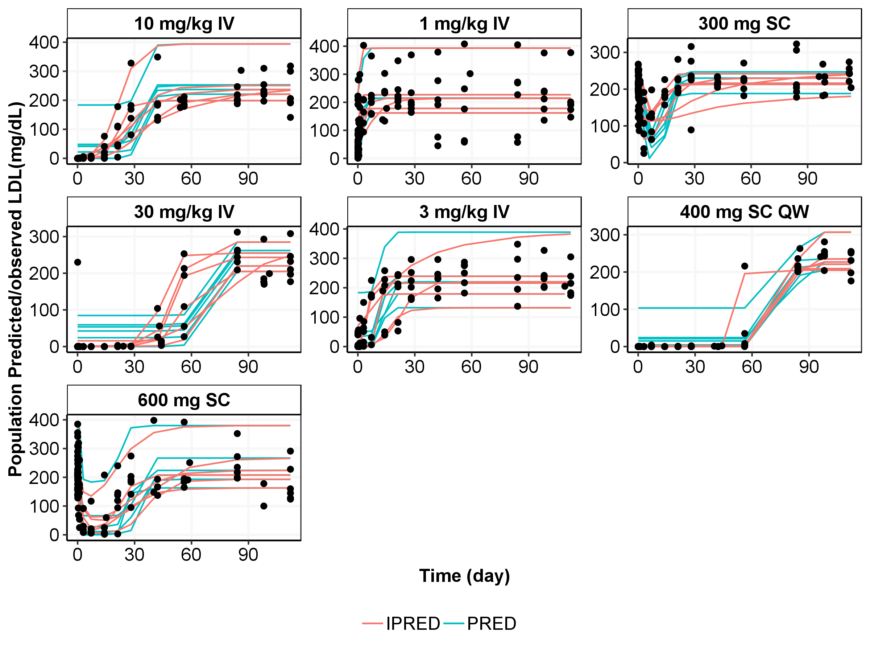

*CH50: Assay of hemolytic activity

Figure : Representative Model Fitting of Predicted Percent Change from Baseline in CH50* vs Observed Profiles in Study R3918-HV-1659

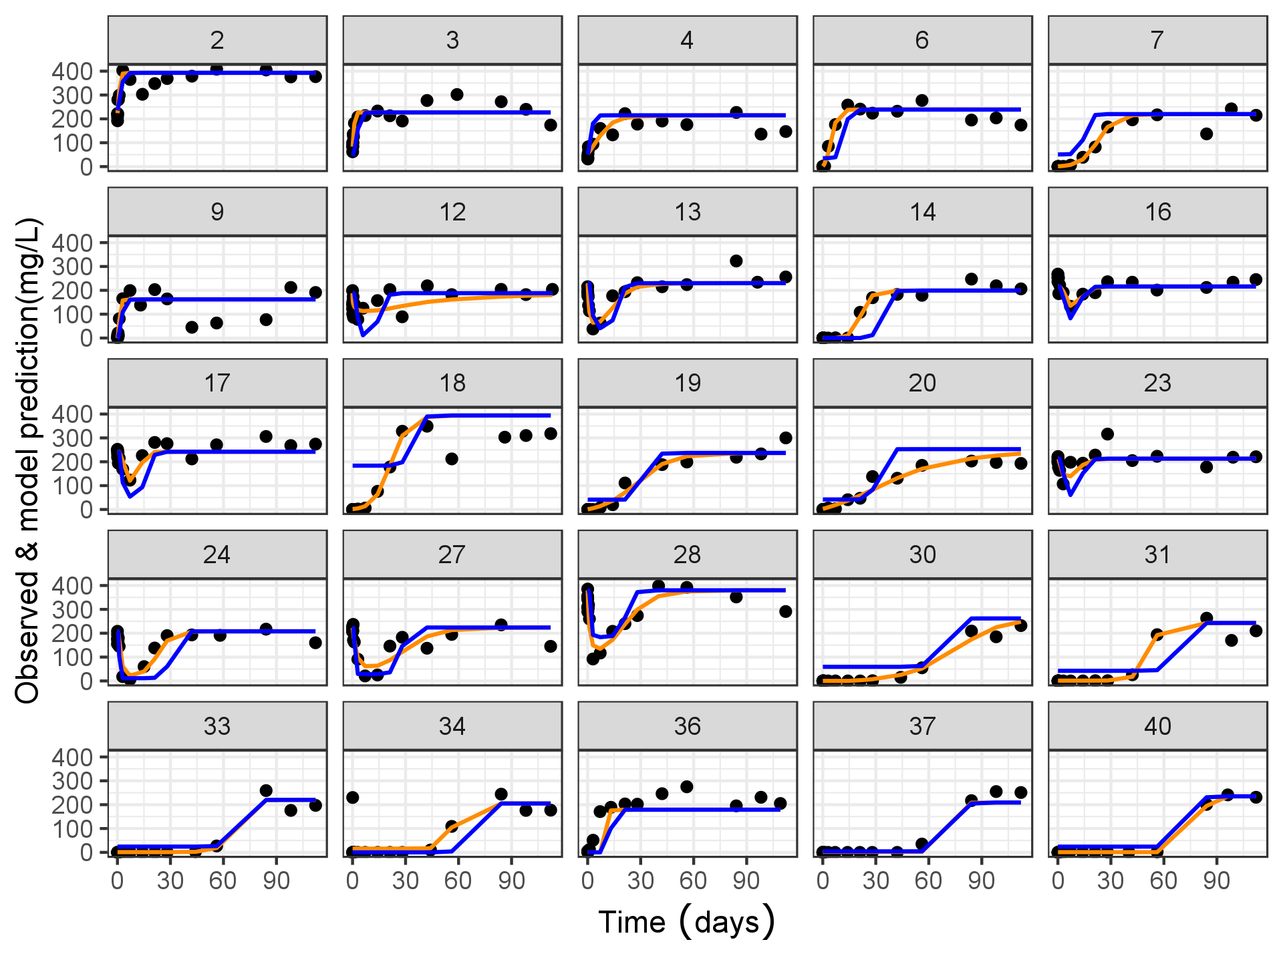

Note: Patients were randomly selected from the overall population. Each black dot represents the observe data; blue line represents the population mean prediction; the yellow line represents the individual prediction.

*CH50: Assay of hemolytic activity

* + 1. Covariate Assessment

Figure : Scatter Plot of a Few Key PK and PD Parameters vs Baseline Body Weight (kg) in Study R3918-HV-1659

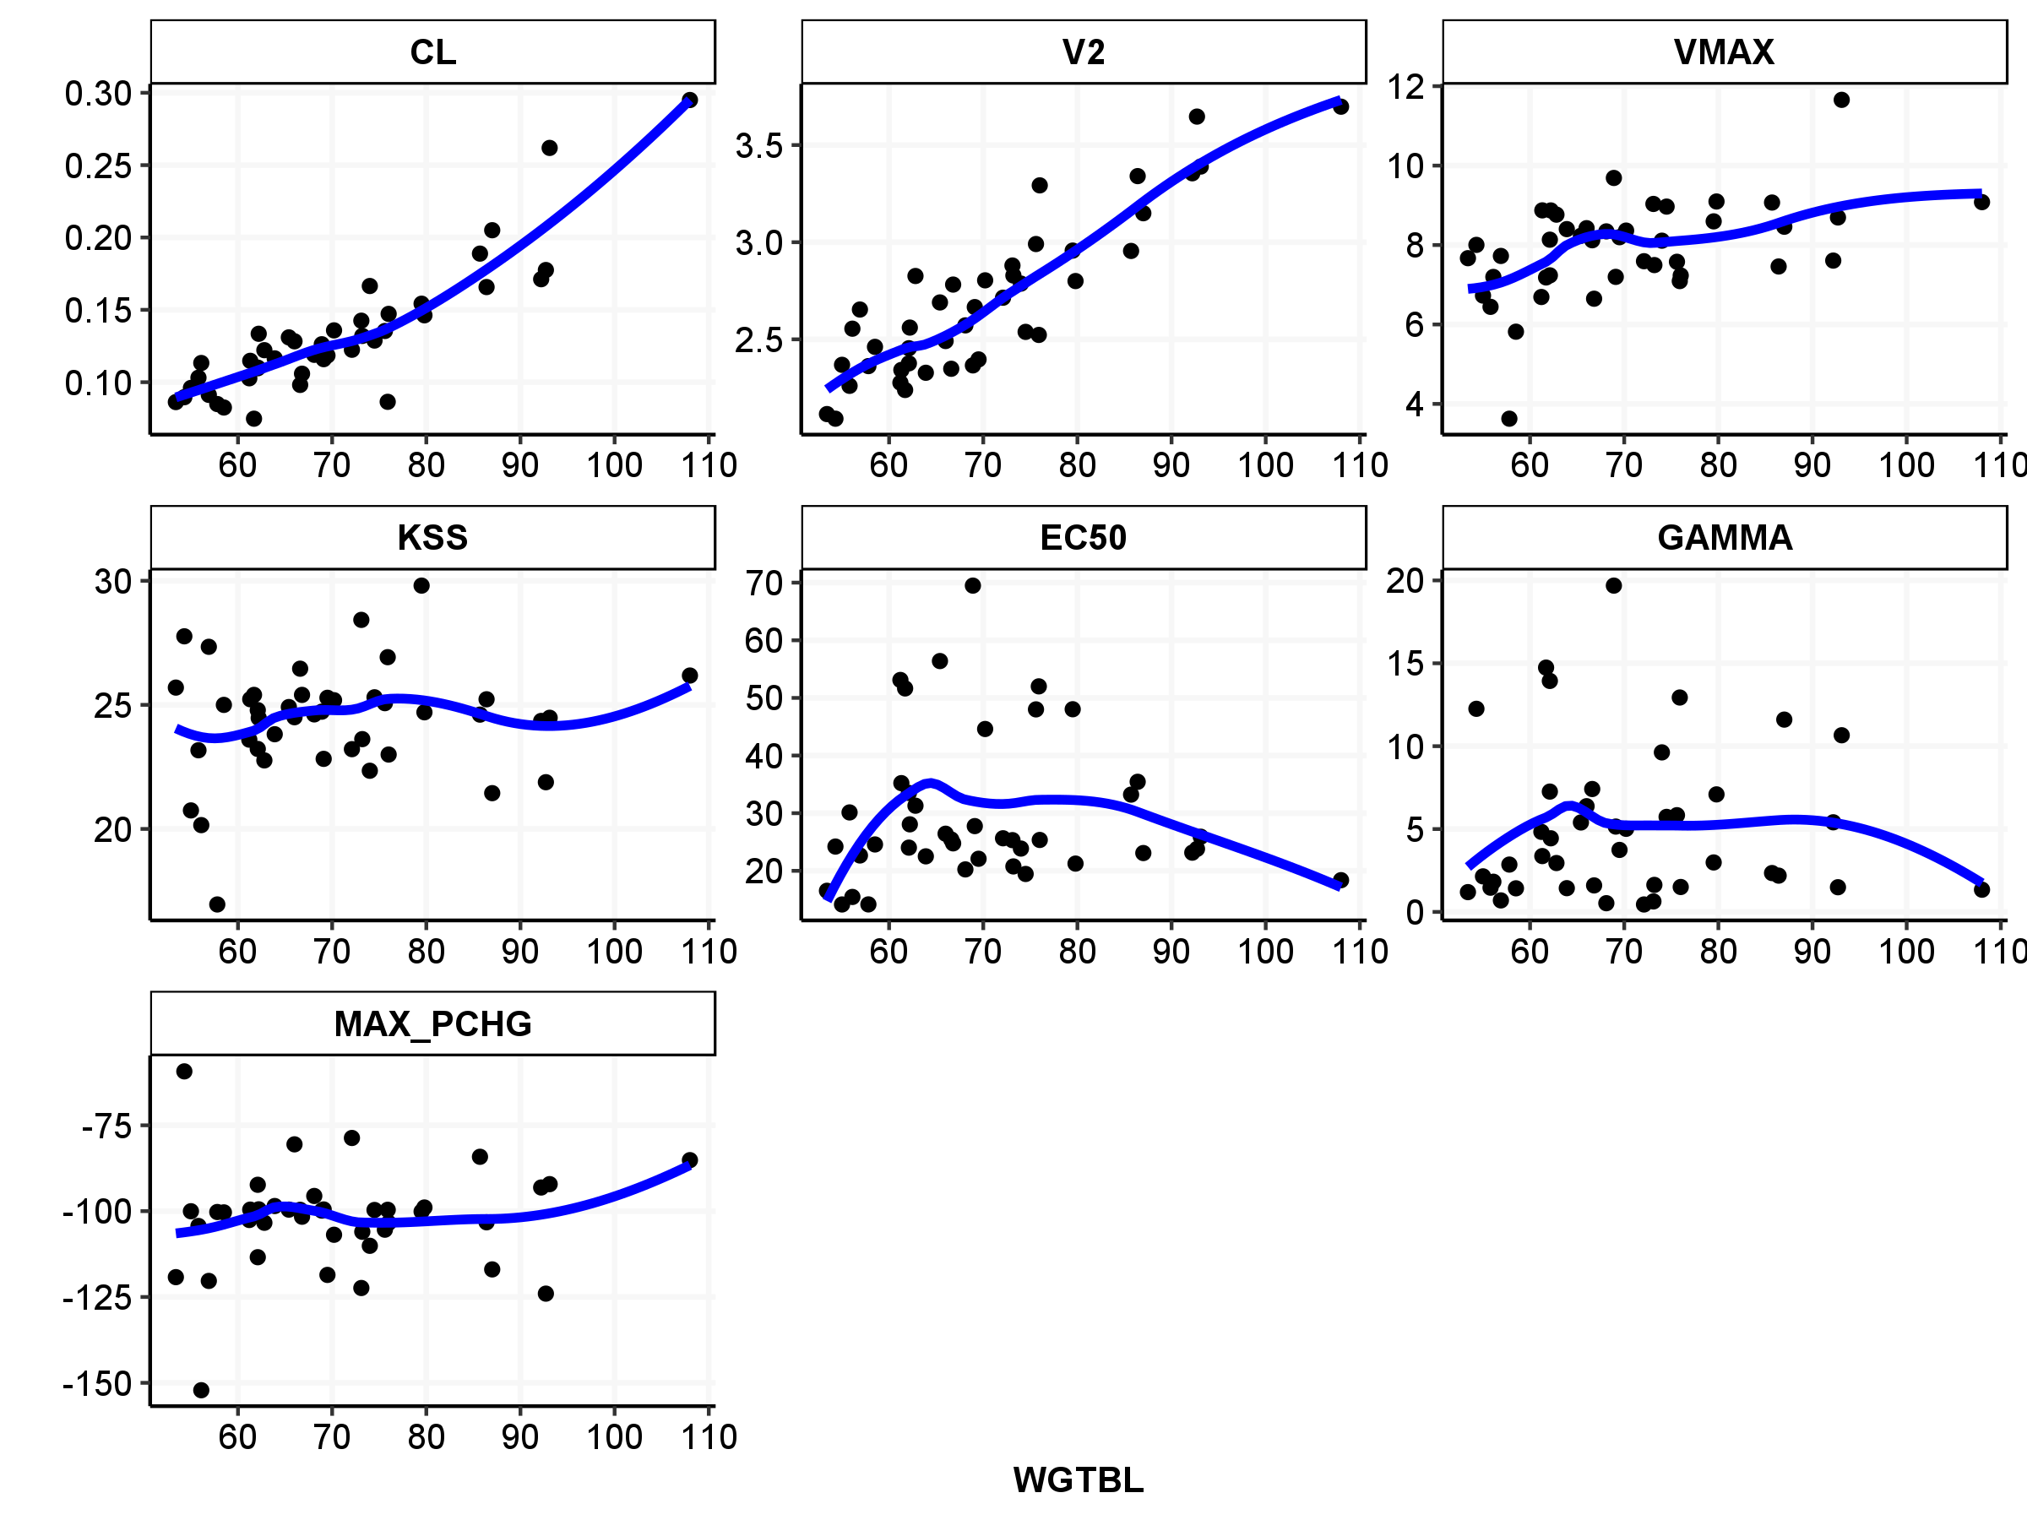

Note: the blue line represents the loess fit.

Figure : Baseline Body Weight as Covariate Impacting on Model Parameters in the Final Model

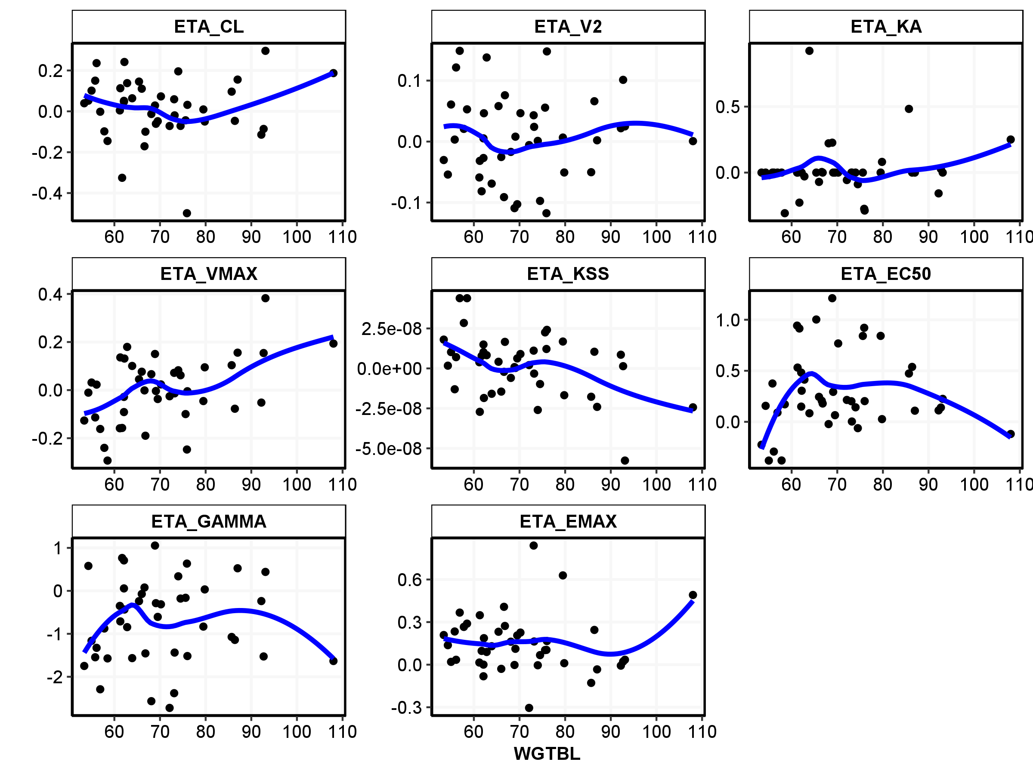

Note: the blue line represents the loess fit.

Figure : Scatter Plot of a Few Key PK and PD Parameters vs Baseline Total C5 (mg/L) in Study R3918-HV-1659

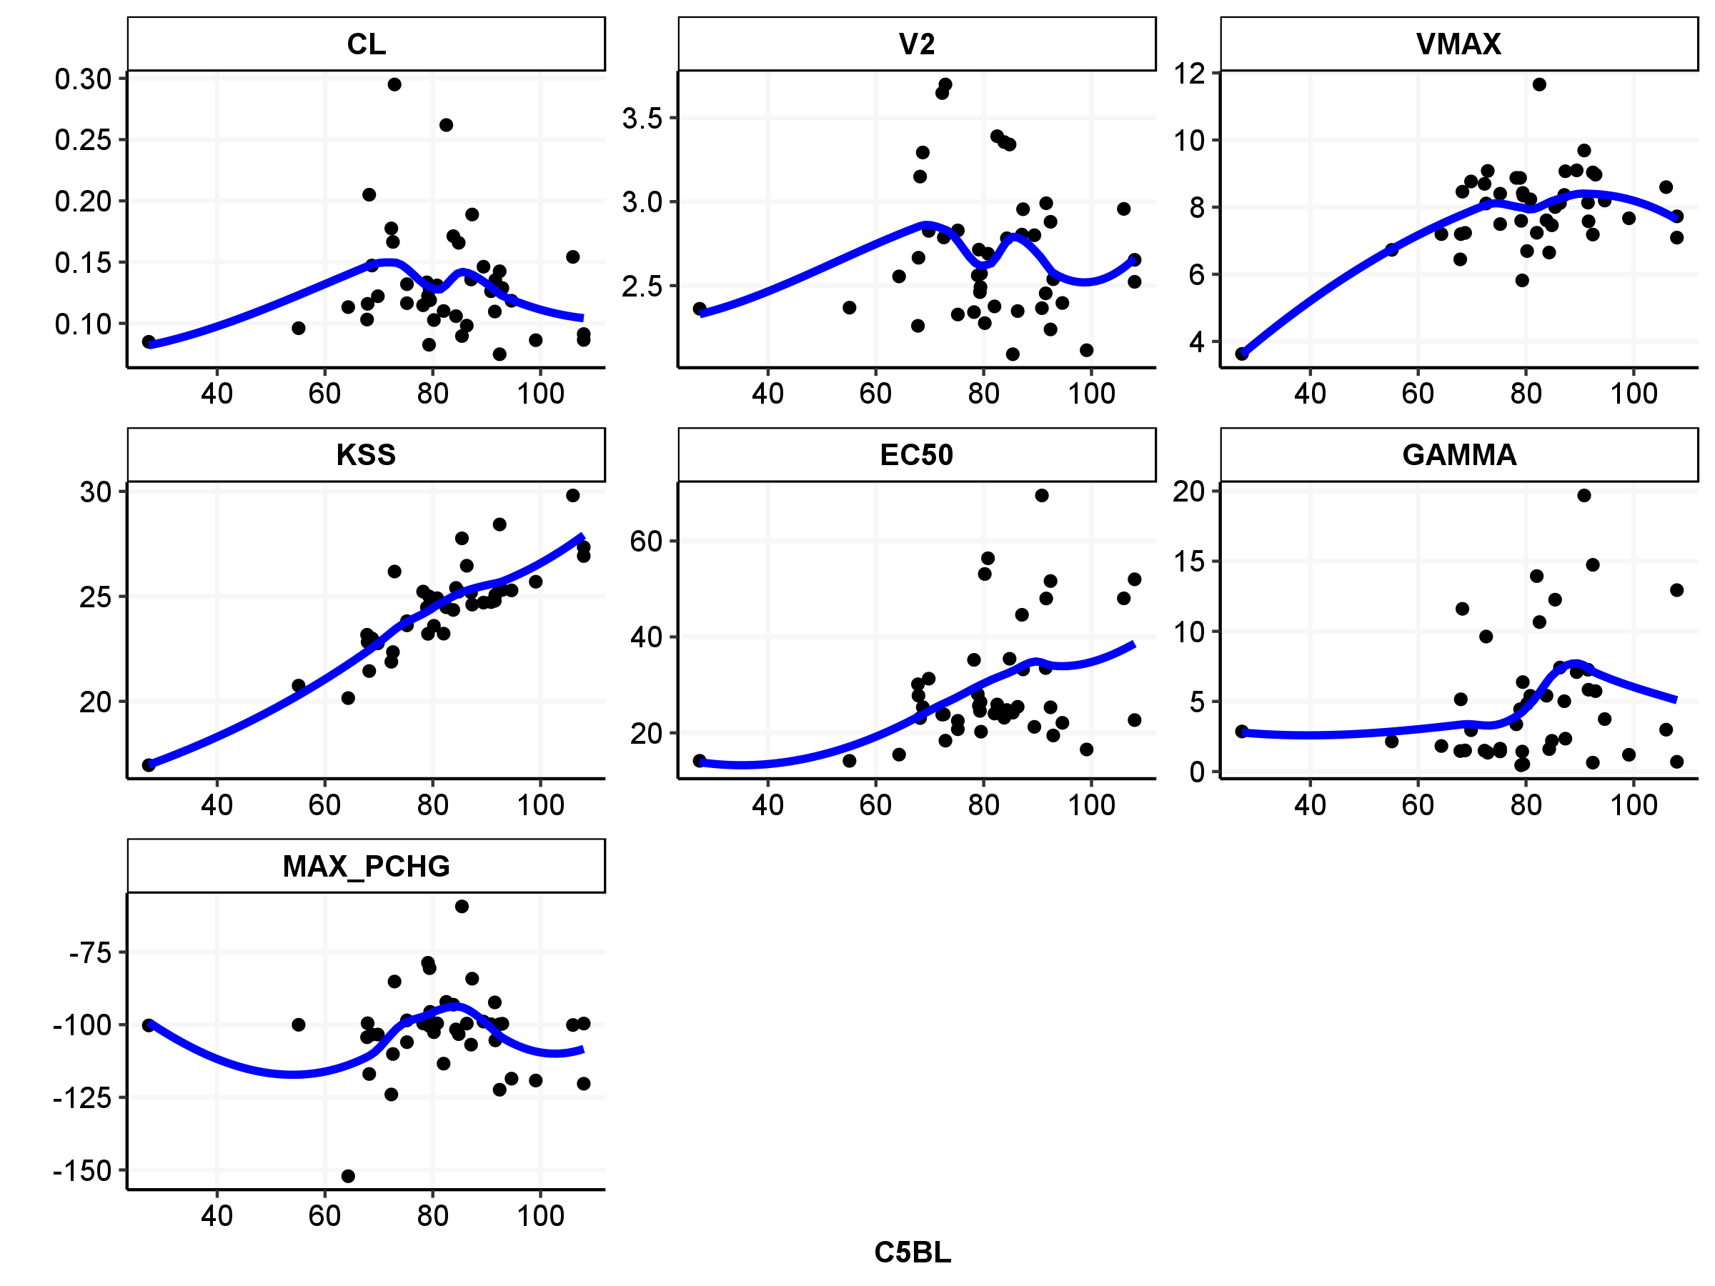

Note: the blue line represents the loess fit.

Figure : Baseline C5 as Covariate Impacting on Model Parameters in the Final Model

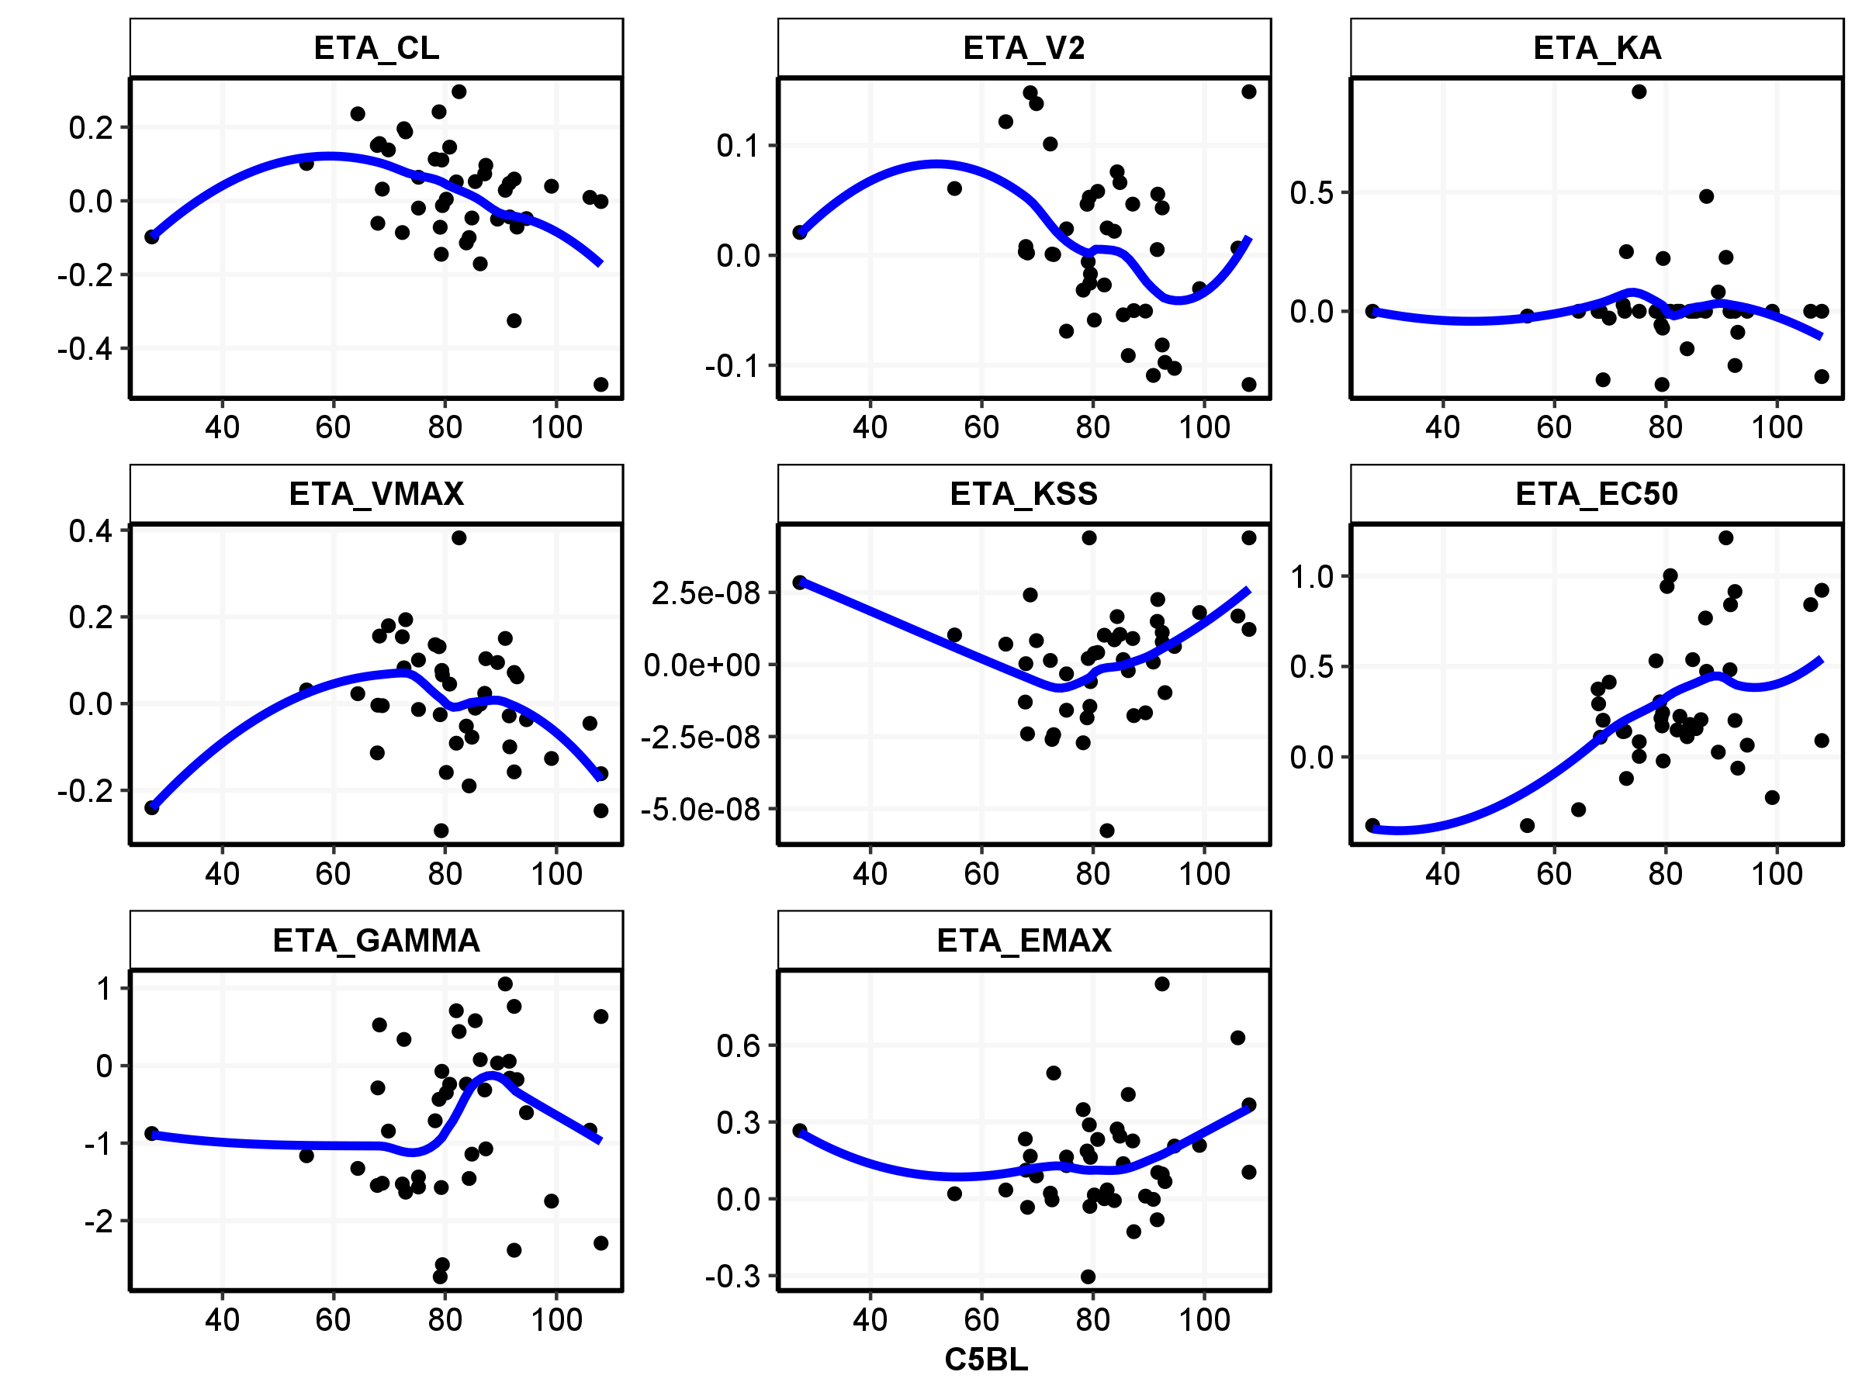

Note: the blue line represents the loess fit.

Figure : Scatter Plot of a Few Key PK and PD Parameters vs Baseline CH50 (U/mL) in Study R3918-HV-1659

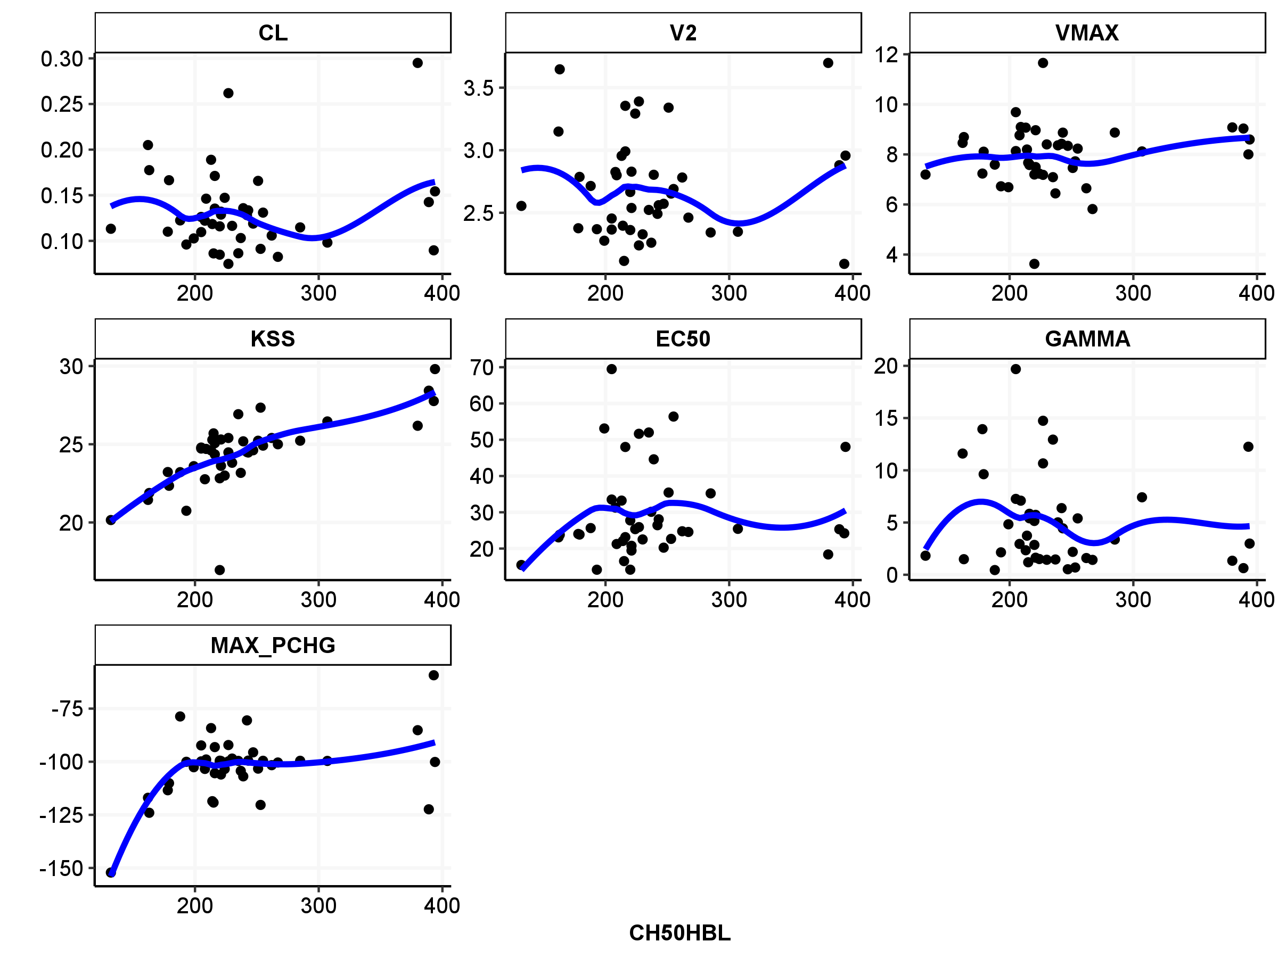

Note: the blue line represents the loess fit.

Figure : Baseline CH50 as Covariate Impacting on Model Parameters in the Final Model

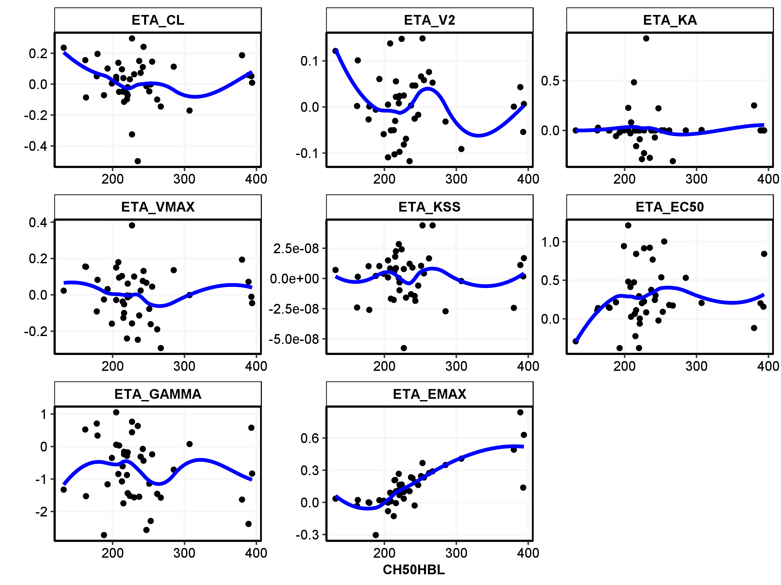

Note: the blue line represents the loess fit.

1. Dataset and Control Stream

See nonmem model here



See nonmem dataset here

